Media and Politics Sources

Document 1 (Station 1): Number of Corporations that Control a Majority of US Media, http://www.corporations.org/media/media-ownership.gif

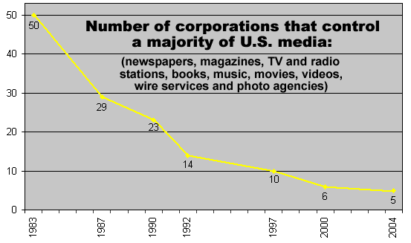

Document 2 (Station 2): Newspaper examples of Yellow Journalism, http://origins.osu.edu/sites/origins.osu.edu/files/newspapers%204_0.jpg

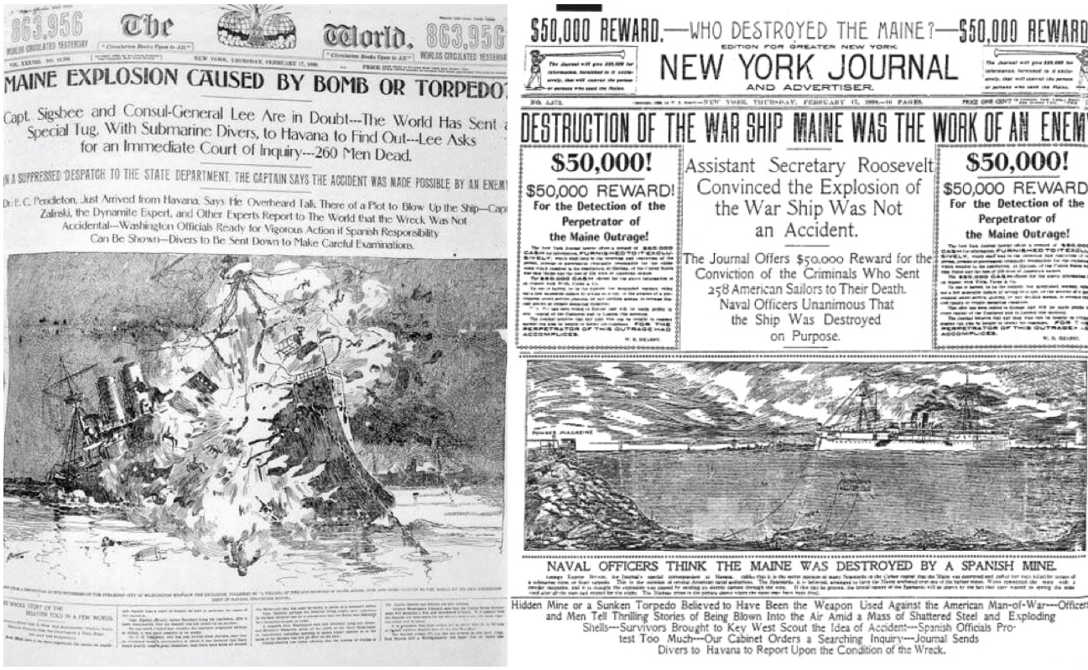
Two of the most infamous examples of “yellow journalism,” Joseph Pulitzer’s New York World (left) and William Randolph Hearst’s New York Journal (right) competed for sales by sensationalizing conditions in Cuba in the lead up to the Spanish-American War in 1898.

What came to be called “yellow journalism” in the late 19th century featured salaciousness, dishonest reporting, and sensationalism as a way to sell papers.

Document 3 (Station 3): Selection from Origins Article, http://origins.osu.edu/article/media-and-politics-age-trump/page/0/0 - How politics have impacted the media example.

The rules of this new media were officially codified by the 1934 Communications Act, which established the main regulatory agency for broadcast media, the Federal Communications Commission (FCC). The FCC was preceded by the Federal Radio Commission (FRC), a temporary agency founded in 1927 to provide regulatory stability, particularly around technical issues, for the increasingly contested airwaves.

The 1940s were a critical juncture for American media. In 1943, the FCC took anti-monopoly measures against chain broadcasters, which forced NBC to divest itself of a major network (which became ABC). Two years later, the Supreme Court issued an antitrust ruling affirming the need for “diverse and antagonistic sources” against the Associated Press.

In 1946 the FCC published its “Blue Book,” which mandated broadcasters’ public service responsibilities. The Hutchins Commission on Freedom of the Press established journalism’s democratic benchmarks in 1947. And finally, in 1949, the FCC issued its Fairness Doctrine outlining key public interest obligations for broadcasters.

(The Blue Book’s) purpose was to mandate that broadcasters devote time to local, noncommercial, and experimental programming, and cut down on excessive advertising. But broadcasters fought it as if it posed an existential threat, and the Blue Book gradually fell into obscurity.

Not all of these initiatives were successful, but they all sought to reorient the balance between profit and service in the American news media.

Taken together, these policy interventions composed a broader impulse, one defined by a social democratic vision of media that emphasized its public service mission instead of treating it as only a business commodity.

Document 4 (Station 4): Selection from Origins article, http://origins.osu.edu/article/media-and-politics-age-trump/page/0/1 How the media has impacted politics example.

Critiques of campaign coverage are well known. Election-related news typically focuses on the horse-race aspects of politics, with an emphasis on who’s ahead and what the polls are saying with each changing minute. Campaign strategies, the most recent embarrassing gaffes, and outrageous insults that one candidate hurled at another, are the stuff of standard election news commentary—not historical context or information about substantive policy differences that may affect voters’ daily lives.

Typical news coverage often treats the election like a dramatic football game to be consumed by passive audiences instead of a democracy-sustaining act of citizenship.

While it’s tempting to blame the audience for lapping up this coverage, it’s actually more of a supply-side problem. Media do not simply give people what they want. They’re also produced to satisfy advertisers’ and media owners’ needs. Screen-to-screen coverage of Trump does not just reflect audience desires; rather, it serves as bait for their attention. Because the audience’s attention is the coveted product that media deliver to advertisers. And to keep our attention, media must entertain us.

Trump performs this role wonderfully. He keeps ratings high and ad sales strong. He is pure gold for their bottom line. Conflict and controversy attract eyeballs, and our hyper-commercialized media system cares most about what sells advertising, not what informs or enriches our democratic discourse. Most commercial media organizations—cable news, broadcast news, newspapers, and digital news outlets—profit most by serving up audiences to advertisers who pay handsomely.

