Stations Handout The Evolution of the Treatment of Mental Illness
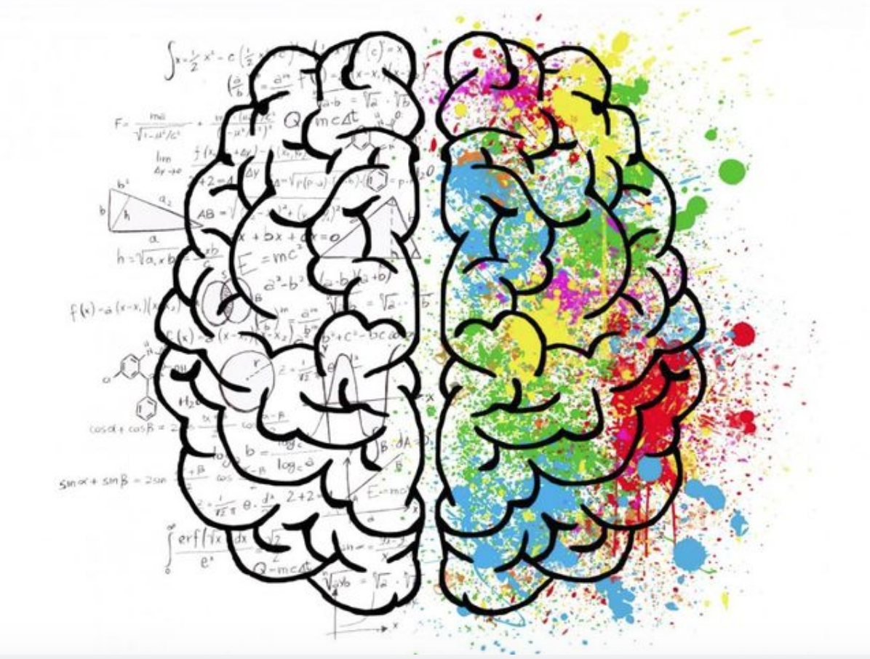
As you go through each station, read and analyze the source and answer the questions that correspond. Remember to keep in mind message, purpose, context, and perspective when analyzing each source. Use your group members as a resource!!
Document A: Electroconvulsive Therapy

- What is ECT?

- In what circumstances is ECT typically used?

- What are some side effects of ECT?

- What is the success rate of ECT?

Document B: The Pros and Cons of Prescription Drugs: Antidepressants

- What are some of the biological causes behind depression?

- What are some consequences of long-term use of antidepressants?

- How can gut health influence mental health?

- How do antidepressants work differently in adolescents?

Document C: Insulin Coma Therapy in Schizophrenia

- What is the argument behind using insulin shock therapy?

- How long did the treatments continue?

- Where was DICT adopted quickly? Who introduced it?

- What did Dr. Harold Bourne say about insulin shock therapy?

Document D: The Strange and Curious History of Lobotomy

- How would surgeons perform a lobotomy?

- Why were lobotomies such a popular practice? What was seen as the alternative?

- What did Henry Marsh say about patients who received a lobotomy 30-40 years prior?

Why does Henry Marsh refer to lobotomies as “bad science”?

Document E: What is Psychotherapy?

- What is psychotherapy? What can it do?

- What are some of the basic characteristics of therapy?

- What has research shown as a result of going to psychotherapy in people who struggle with mental illness?

- What are some of the different types of psychotherapy?

