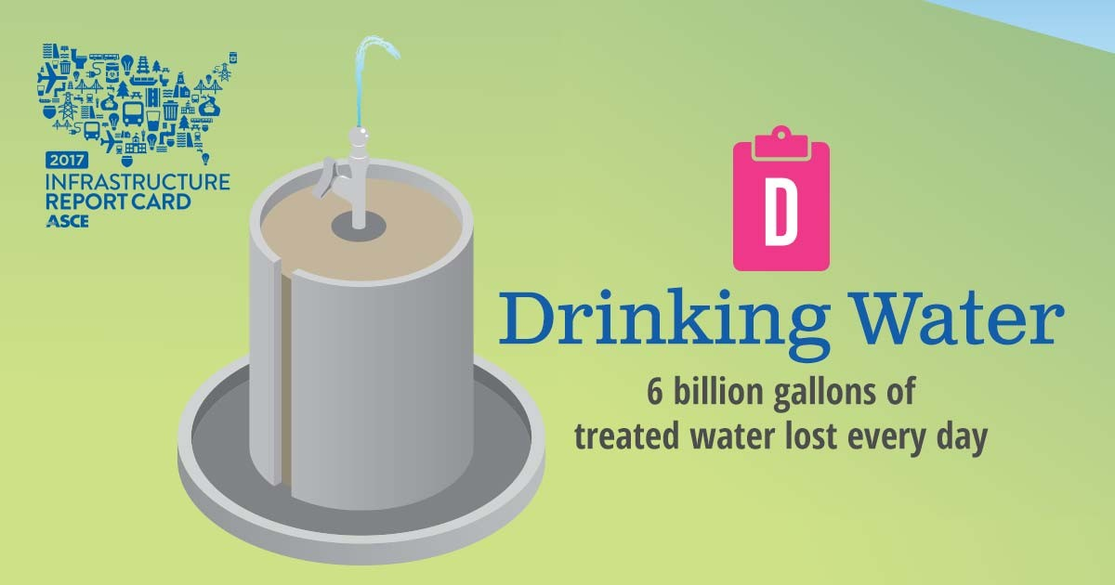

OVERVIEW
Drinking water is delivered via one million miles of pipes across the country. Many of those pipes were laid in the early to mid‐20th century with a lifespan of 75 to 100 years. The quality of drinking water in the United States remains high, but legacy and emerging contaminants continue to require close attention. While water consumption is down, there are still an estimated 240,000 water main breaks per year in the United States, wasting over two trillion gallons of treated drinking water. According to the American Water Works Association, an estimated $1 trillion is necessary to maintain and expand service to meet demands over the next 25 years.

CAPACITY AND CONDITION
The United States uses 42 billion gallons of water a day to support daily life from cooking and bathing in homes to use in factories and offices across the country. Around 80% of drinking water in the U.S. comes from surface waters such as rivers, lakes, reservoirs, and oceans, with the remaining 20% from groundwater aquifers. In total, there are approximately 155,000 active public drinking water systems across the country. Most Americans – just under 300 million people – receive their drinking water from one of the nation’s 51,356 community water systems. Of these, just 8,674 systems, or approximately
17%, serve close to 92% of the total population, or approximately 272.6 million people. Small systems that serve the remaining 8% of the population frequently lack both economies of scale and financial, managerial, and technical capacity, which can lead to problems of meeting Safe Drinking Water Act standards.

Drinking water is delivered via one million miles of pipes across the country. Many of those pipes were laid in the early to mid‐ 20th century with a lifespan of 75‐100 years. With utilities averaging a pipe

replacement rate of 0.5% per year, it will take an estimated 200 years to replace the system – nearly double the useful life of the pipes.

Because America’s drinking water infrastructure provides a critical service, significant new investment and increased efficiencies are needed as filtration plants, pipes, and pumps age past their useful life. Every day, nearly six billion gallons of treated drinking water are lost due to leaking pipes, with an estimated 240,000 water main breaks occurring each year. It is estimated that leaky, aging pipes are wasting 14 to 18% of each day’s treated water; the amount of clean drinking water lost every day could support 15 million households.

To address deteriorating water infrastructure, asset management provides utility managers and decision‐ makers with critical information on capital infrastructure assets and timing of investments. Some key steps for asset management include making an inventory of critical assets; evaluating their condition and performance; developing plans to maintain, repair, and replace assets; and funding these activities.

FUNDING
While drinking water infrastructure is funded primarily through a rate‐based system, the investment has
been inadequate for decades and will continue to be underfunded without significant changes as the revenue generated will fall short as needs grow. According to the American Water Works Association, upgrading existing water systems and to meeting the drinking water infrastructure needs of a growing population will require at least $1 trillion.

The majority of funding for drinking water infrastructure comes from revenue generated by rate payers. In the nation’s largest 50 cities, the rate users pay varies greatly; the lowest average monthly water bill is
$14.74 in Memphis, while Seattle residents pay the most at $61.43. This large gap exemplifies the varied approaches to rate structure, as well as the contrast of need and investment across the country. While higher rates that reflect the true cost of service are important, public assistance programs should be considered for low income populations. Between 2009 and 2014, state and local governments decreased capital spending for both drinking water and wastewater by 22%; at the same time, federal capital spending did not change significantly.

The federal government offers financial support to local governments and utilities in the form of loans through the Drinking Water State Revolving Fund, which provides low‐interest loans to state and local water infrastructure projects. The Environmental Protection Agency (EPA) provides an allotment of funding for each state, and each state provides a 20% match. Since the program’s inception, $32.5 billion of low‐interest loans have been allocated. However, with needs far surpassing the program’s budget, it is unable to meet all investment needs or fund every deserving project.

In 2014, Congress authorized a new mechanism to fund primarily large water infrastructure projects over
$20 million through the Water Infrastructure Finance and Innovation Act (WIFIA). In 2016 Congress appropriated $17 million in funds for the program. It is estimated that using WIFIA’s full financial leveraging ability that a single dollar injected into the program can create $50 dollars for project lending. Under current appropriations, EPA estimates that current budget authority may provide more than $1 billion in credit assistance and may finance over $2 billion in water infrastructure investment.

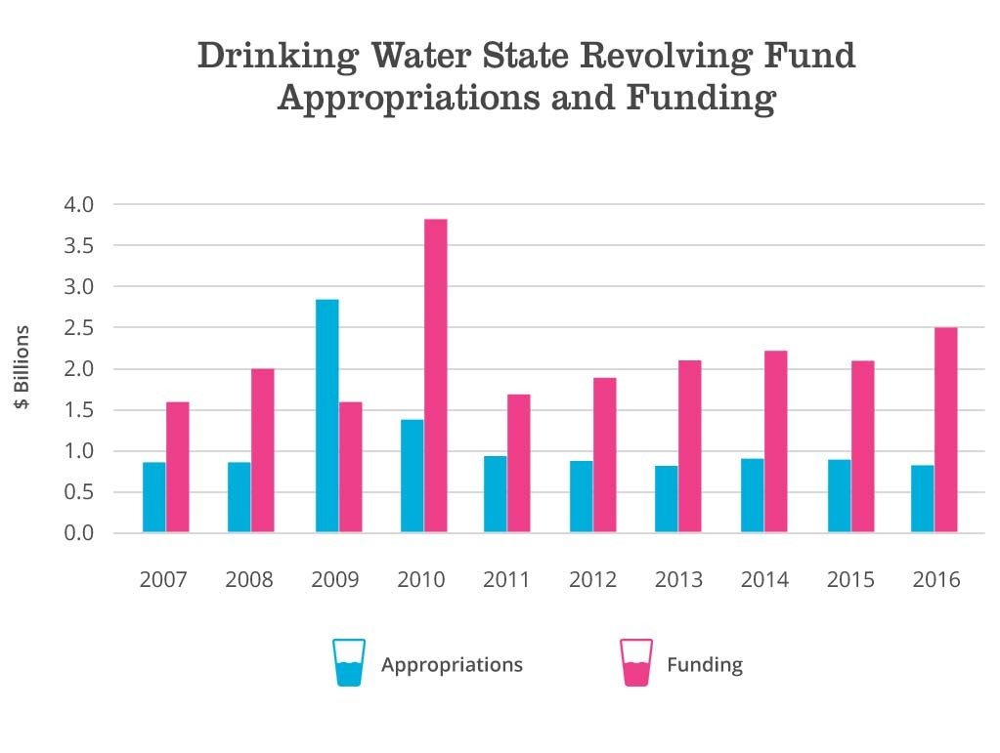

FUTURE NEED
Municipal drinking water consumption in the United States has declined by 5% this decade, marking the first time in nearly 40 years that water use at home has decreased. Total freshwater withdrawals this decade continue to decline in almost every sector including agriculture, industrial, domestic, and thermoelectric. This is primarily due to increased efficiencies and the reduction in withdrawals for retired coal‐fired power plants.

Drinking water needed for public supply in the United States has been relatively flat since 1985 even as the population has increased by approximately 70 million people over the same period. Water conservation efforts, including through water efficient fixtures, have had a significant impact in reducing per capita water usage. Importantly, while per capita demand has fallen, population trends have significantly challenged how cities manage water. For example, the Government Accountability Office estimates that 99 of 674 midsized cities in the U.S. are shrinking. This poses significant challenges to utility managers; fewer rate payers and a declining tax base make it difficult to raise funds for capital infrastructure plans. To respond, utilities must raise rates, often in cities where jobs and pay have not kept pace with the economy, putting a burden on those who can least afford rate increases. Conversely,
in areas of the country that are growing, such as the West and Southwest, water managers must respond to increased overall demand.

PUBLIC SAFETY
Drinking water quality in the United Sates remains the safest in the world. The EPA sets legal limits for over 90 contaminants in drinking water. The Safe Drinking Water Act (SDWA) allows states to set and enforce their own drinking water standards as long as the standards meet or exceed EPA’s minimum

national standards. Smaller systems that serve under 10,000 people report that a lack of resources and personnel can limit the frequency of testing, monitoring, maintenance, and technical capability in their systems. With sufficient funding and proper oversight, these risks can be mitigated and water quality can remain safe.

RESILIENCE AND INNOVATION
America’s drinking water infrastructure doesn’t stop at pipe, reservoir, pump station, and treatment plant upgrades; many threats to drinking water infrastructure can be attributed to the sources of drinking water, such as polluted water bodies, depleted aquifers, and inadequate storage. As watersheds continue to be impacted by shifting migration patterns, land use changes, consumption trends, and extreme weather, water infrastructure upgrades will be required to meet new demands. With proper planning, education, and conservation utilities are making strides to ensure demand is met for decades to come. Water conservation and improvements in water‐use efficiency appear to have gained a general acceptance among water utilities as a sensible practice of water management.

According to the American Water Works Association, a majority of utilities –74%– have a formal conservation program, and 86% consider conserved water as one of their water supply alternatives. Additionally, many communities that have separate drinking water and wastewater departments are beginning to work together or even consolidate, creating “one water” utilities that manage water more holistically.

RECOMMENDATIONS TO RAISE THE GRADE
• Reinvigorate the State Revolving Loan Fund (SRF) program under the Safe Drinking Water Act through permanent reauthorization and tripling the amount of annual appropriations.
• Fully fund the Water Infrastructure Finance and Innovation Act (WIFIA) at its authorized level.
• Preserve tax exempt municipal bond financing. Low‐cost access to capital helps keep lending for drinking water upgrades strong and accessible for communities large and small.
• Establish a federal Water Infrastructure Trust Fund to finance the national shortfall in funding of infrastructure systems under the Clean Water Act.
• Eliminate the state cap on private activity bonds for water infrastructure projects to bring an estimated $6 to $7 billion annually in new private financing.
• Encourage utilities to take regional approaches for water delivery to take advantage of economies of scale.
• Increase federal support and funding for green infrastructure, watershed permitting, and other programs that promote the concept of “one water” to protect source watersheds.
• Encourage utilities to conduct revenue forecasting models to determine the necessary rate revenues over a period of time and then institute rates that reflect the true cost of supplying clean, reliable drinking water.
• Encourage utilities to undertake asset management programs.
• Increase federal and local support for vocational training in the drinking water sector as engineers, operators, and maintenance staff begin to retire in large numbers.

• Support and advance conservation ballot measures that protect source water through dedicated funding to land and water protection.
• Utility managers must remain diligent to ensure science‐based decisions control operations and facility function. While lead and other contaminants post significant health concerns when ignored, with proper funding safe and clean drinking water can be ensured.

DEFINITIONS
Non‐community Water System is a public water system that is not a community water system and that
regularly serves at least 25 of the same people over six months/year. These may include systems that
provide water to schools, day care centers, government/military installations, manufacturers, hospitals or nursing homes, office buildings, and other facilities.

SOURCES
American Water Works Association, Buried No Longer: Confronting Americas Water Infrastructure
Challenge, February 2012

American Water Works Association, State of the Water Industry, March 2016

Black and Veatch, 50 Largest City Water/Wastewater Utility Rate Survey, April 2013

Congressional Budget Office, Public Spending on Transportation and Water Infrastructure, 1956 to 2014, March 2015

Environmental Protection Agency, Drinking Water Infrastructure Needs Assessment, Fifth Report to
Congress (2011), April 2013

Environmental Protection Agency, Drinking Water Action Plan, US EPA, November 2016

Center for Neighborhood Technology, The Case for Fixing the Leaks: Protecting people and saving water while supporting economic growth in the Great Lakes region, November 2013

U.S. Geological Survey, Estimated Use of Water in the United States in 2010, November 2014 http://water.usgs.gov/edu/wateruse‐total.html

Environmental Protection Agency, The Clean Water State Revolving Fund, 2015. https://www.epa.gov/sites/production/files/2016‐03/documents/cwsrfinfographic‐030116.pdf

Environmental Protection Agency, Investing in America’s Water Infrastructure – Answering the “How to Pay” Question, July 26, 2016. https://blog.epa.gov/blog/2016/07/investing‐in‐americas‐water‐ infrastructure‐answering‐the‐how‐to‐pay‐question/

