Timeline HIV: Past & Present

Place the events in the correct order on the Timeline below:
First report of AIDS epidemic in US

- AIDs becomes main cause of death among US men ages 25-44
- PrEP drug issued to prevent the transmission of HIV

- Woman possibly cured of HIV
- Estimated 56,300 new cases of HIV each year

2022

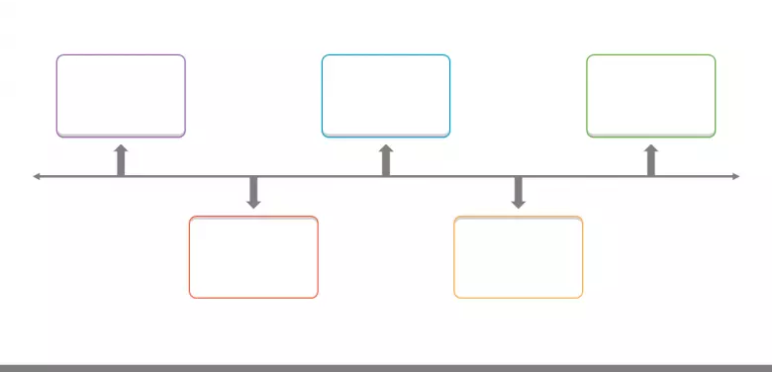
2022
2011
1992
2008
1981

K-W-L Chart HIV: Past & Present

First,
Know: Write 2 facts you know about the HIV crisis.
Want to Learn: Write 3 things you want to learn about the HIV crisis.

Second,
Read the article, A Century of HIV
Learn: Write 3 facts you learned from the article, A Century of HIV.

K-W-L Chart
KNOW:

1.

2.

LEARNED:

1.

2.

3.

WANT TO LEARN:

1.

2.

3.

Stations- Two-Way Table HIV: Past & Present
Formula for finding percentages:
$$\frac{Total \# Affected by HIV}{Estimated Population}$$

- Analyze primary and secondary sources at each station.
- Write the percentage of positive HIV case for each demographic listed in the Two-Way Table.
- You will be documenting two percentages per demographic: past and present. (Hint: you might need to use the formula above to calculate the percentage of positive cases)
Demographic
Present
Past
Station one: LGBTQ+ Community
Station two: Black Community
Station three: Latinx Community
LGBTQ+ Community
Station four: White Community
Black Community

Latinx Community

White Community

Use the space below to find calculations:

Exit Ticket HIV: Past & Present

(CQ): How did the action or inaction of the United States government impact the HIV epidemic during the 1980s to present?

Describe how this impact differs by demographic.

First Choice: The action of the United States government impacted the HIV epidemic during the 1980’s to present by… ____________________________________________________________________________________________________________________________________________________________
______________________________________________________________________________
______________________________________________________________________________
______________________________________________________________________________
______________________________________________________________________________

Second Choice: The inaction of the United States government impacted the HIV epidemic during the 1980’s to present by… ____________________________________________________________________________________________________________________________________________________________
______________________________________________________________________________
______________________________________________________________________________
______________________________________________________________________________
______________________________________________________________________________

This impact differs by demographic because…
______________________________________________________________________________ _____________________________________________________________________________
______________________________________________________________________________
______________________________________________________________________________
______________________________________________________________________________
______________________________________________________________________________

