Think-Pair-Share Handout The Evolution of the Treatment of Mental Illness

What are your thoughts on the Think, Pair, Share prompt?

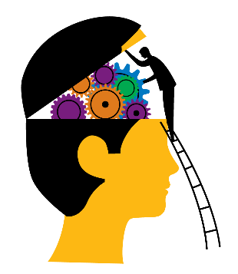

What are your peers’ thoughts on the Think, Pair, Share prompt? How does this compare to your own?

What are the class’s thoughts on the Think, Pair, Share prompt? How does this compare to your peers’? How does this compare to your own?

