Sources Influenza Pandemics Now, Then, and Again

Document A: Influenza Pandemics Now, Then, and Again Excerpt, Citation: Sealey, A. (2010). Influenza Pandemics Now, Then, and Again. Origins: Current Events in Historical Perspectives, 3(8).

With the early warning provided by the WHO in 1957, however, the American government decided to gear up to vaccinate more widely. Negotiations with vaccine producers immediately proved difficult. They were hesitant to produce an expensive product when there was no proof the pandemic would reach the U.S. When they at last agreed to make the vaccines—because evidence could no longer be ignored that the pandemic had indeed grown—it was essentially too late.
Although the U.S. managed to vaccinate a larger percentage of the population than ever before, it was only after a period of panic that there would not be enough available. With vaccine production starting late in the game, the American vaccination program also came at the cost of many unused vials of vaccine that came off the production lines after the pandemic had essentially passed. Not much was learned from these experiences and a similar pattern of events occurred in 1968.

Document B: On March 13, Trump held a press conference with 18 people packed closely behind him., Citation: Craighead, S. (2020). [Photograph]. Retrieved from https://www.businessinsider.com/trump-crowded-coronavirus-press-conferences-photos-2020-3

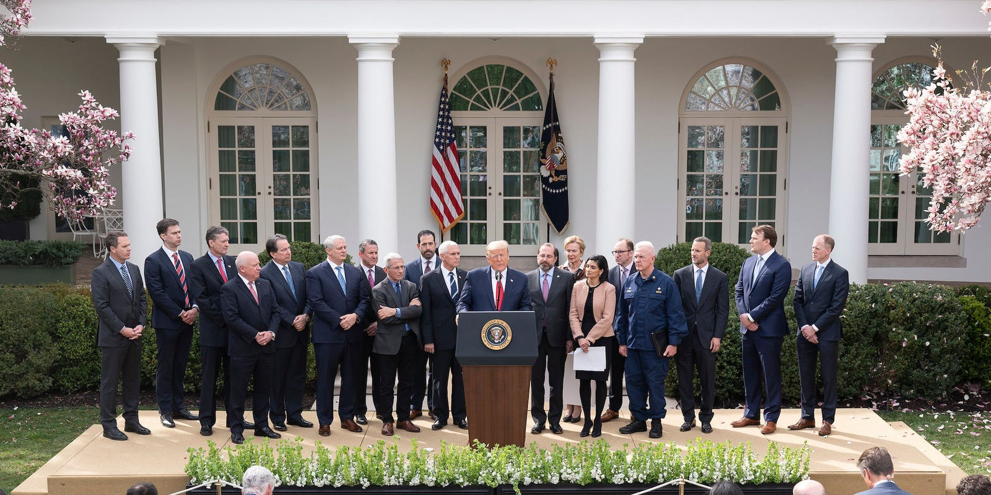

Document C: CNBC Article Excerpt, Citation: Breuninger, K. (2020). “Trump wants ‘packed churches’ and economy open again on Easter despite the deadly threat of coronavirus.” CNBC.
President Donald Trump said Tuesday he wants the U.S. economy to “open” back up by Easter Sunday, despite expert warnings about the deadly threat of the coronavirus.
Easter is April 12, less than three weeks away.
Trump’s remarks in a Fox News “virtual town hall” event at the White House came as more states imposed extreme measures, including shutting down businesses and ordering residents to stay home, to try to slow the spread of the disease.
“We’re opening up this incredible country. Because we have to do that. I would love to have it open by Easter,” Trump said.
“I would love to have that. It’s such an important day for other reasons, but I’d love to make it an important day for this. I would love to have the country opened up, and rarin’ to go by Easter.”
In a second interview with Fox that aired Tuesday afternoon, Trump said he offered the holiday as a deadline because “Easter’s a very special day for me.”
“Wouldn’t it be great to have all the churches full?” Trump asked. “You’ll have packed churches all over our country … I think it’ll be a beautiful time.”
Trump added that “I’m not sure that’s going to be the day,” but “that would be a beautiful thing.”
At a press briefing Tuesday evening, Trump appeared to back off the idea even further. “We’ll only do it if it’s good,” Trump said, adding that he is “very much in touch” with White House experts. “I just think it would be a beautiful timeline.”
“Our decision will be based on hard facts and data as to the opening” of the economy, Trump said in that presser. “Every decision is grounded solely in the health, safety and wellbeing of our citizens.”

Document D: Speakers and reporters sitting farther apart from one another than usual during the multi-ministry task force's press conference on March 13, as an example of social distancing., Citation: Cheong, M. (2020). [Photograph]. Retrieved from https://www.straitstimes.com/singapore/gan-kim-yong-and-lawrence-wong-sit-1-metre-apart-at-covid-19-presser-as-part-of-social

Document E: Exchanged between Reporter and Reagan’s Press Secretary., Citation: Lopez, G. (2016). “The Reagan administration's unbelievable response to the HIV/AIDS epidemic.” Vox.
Lester Kinsolving: Does the president have any reaction to the announcement by the Centers for Disease Control in Atlanta that AIDS is now an epidemic in over 600 cases?
Larry Speakes: AIDS? I haven't got anything on it.
Lester Kinsolving: Over a third of them have died. It's known as "gay plague." [Press pool laughter.] No, it is. It's a pretty serious thing. One in every three people that get this have died. And I wonder if the president was aware of this.
Larry Speakes: I don't have it. [Press pool laughter.] Do you?
Lester Kinsolving: You don't have it? Well, I'm relieved to hear that, Larry! [Press pool laughter.]
Larry Speakes: Do you?
Lester Kinsolving: No, I don't.
Larry Speakes: You didn't answer my question. How do you know? [Press pool laughter.]
Lester Kinsolving: Does the president — in other words, the White House — look on this as a great joke?
Larry Speakes: No, I don't know anything about it, Lester.

…

Larry Speakes: Lester is beginning to circle now. He's moving up front. Go ahead.
Lester Kinsolving: Since the Centers for Disease Control in Atlanta report is going to… [Press pool laughter.]
Larry Speakes: This is going to be an AIDS question.
Lester Kinsolving: …that an estimated…
Larry Speakes: You were close.
Lester Kinsolving: Can I ask the question, Larry? That an estimated 300,000 people have been exposed to AIDS, which can be transmitted through saliva. [This is false; HIV can only be transmitted through blood, semen, pre-cum, rectal fluids, vaginal fluids, and breast milk.] Will the president, as commander in chief, take steps to protect armed forces, food, and medical services from AIDS patients or those who run the risk of spreading AIDS in the same manner that they bed typhoid fever people from being involved in the health or food services? [Through this question, laughter can be heard coming from the press pool.]
Larry Speakes: I don't know.
Lester Kinsolving: Is the president concerned about this subject, Larry?
Larry Speakes: I haven't heard him express concern.
Lester Kinsolving: That seems to have evoked such jocular reaction here. [Press pool laughter.]
Unidentified person: It isn't only the jocks, Lester.
Unidentified person: Has he sworn off water faucets now?
Lester Kinsolving: No, but I mean, is he going to do anything, Larry?
Larry Speakes: Lester, I have not heard him express anything. Sorry.
Lester Kinsolving: You mean he has expressed no opinion about this epidemic?
Larry Speakes: No, but I must confess I haven't asked him about it.
Lester Kinsolving: Will you ask him, Larry?
Larry Speakes: Have you been checked? [Press pool laughter.]
Unidentified person: Is the president going to ban mouth-to-mouth kissing?
Lester Kinsolving: What? Pardon? I didn't hear your answer.
Larry Speakes: [Laughs.] Ah, it's hard work. I don't get paid enough. Um. Is there anything else we need to do here?

Document F: Princess Diana shakes hands with an AIDS Patient, Citation: Redman, J. (1987). [Photograph]. Retrieved from https://www.insider.com/photo-princess-diana-shaking-hand-aids-patient-1987-2017-8

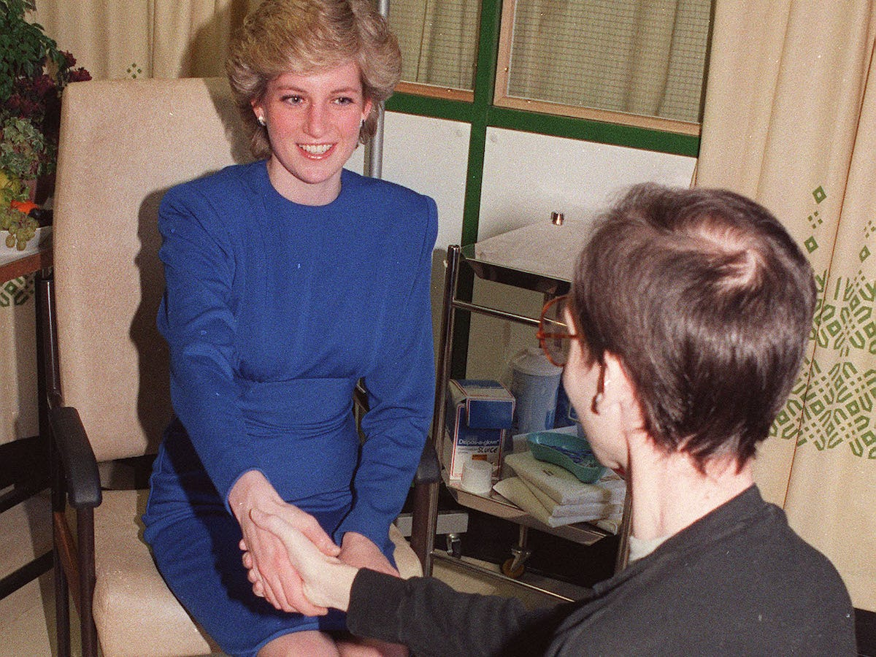

Document G: Pandemics Now, Then, and Again Excerpt, Citation: Sealey, A. (2010). Influenza Pandemics Now, Then, and Again. Origins: Current Events in Historical Perspectives, 3(8).
The worldwide system for determining and monitoring pandemics is a relatively recent invention. In 1918 there was no planet-wide health organization like the WHO, and, while there were radios and telegraphs to spread information, there was no CNN to report its findings to a waiting world or obviously no internet. The only international system for coordinating disease, the Paris-based International Public Health Office, was all but shut down as a result of World War I.
To make matters worse, the war slowed down the spread of crucial information about the disease in other ways. Anxious to avoid giving away potential military advantage, states involved in World War I refused to release flu data. This is why the 1918 pandemic was referred to as the Spanish Flu. Spain didn't participate in World War I, so it published its disease statistics internationally while other nations did not.

Document F: Spanish Influenza has endangered the prosecution of the War in Europe, Citation: N.P. (1918). [Photograph] Retrieved from https://maxdisclosure.com/2018/09/12/own-signs-and-dont-spit-in-1918/

