Name:

Extension Document:
The Euphronios Krater is originally from Greece, but was found in an Etruscan tomb in Italy. Given that the Etruscans almost certainly stole the vase in the first place, some people believe the vase should go to Greece. The vase was eventually returned to Italy, however, which claims the vase as its own cultural heritage.

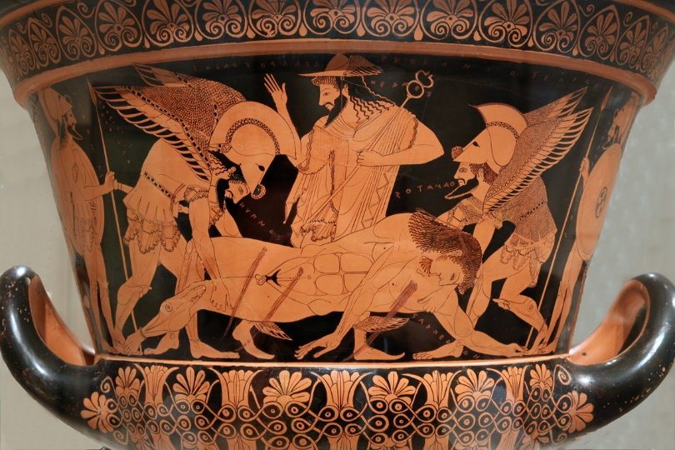
How long do you think an artifact has to be in one group’s possession for it to become part of their cultural heritage? Does it matter if, like the Italians and the Euphronios Krater, people do not know that the artifact is in their possession until after it has been stolen? Why or why not? Respond with at least 3 complete sentences.

