Sources The Creation of Student Loan Debt in the United States

Document A: Chart showing the percentage increase of different costs in the United States, 1982-2008, including the dramatic increase in college costs http://origins.osu.edu/sites/origins.osu.edu/files/3-12-chart990.gif
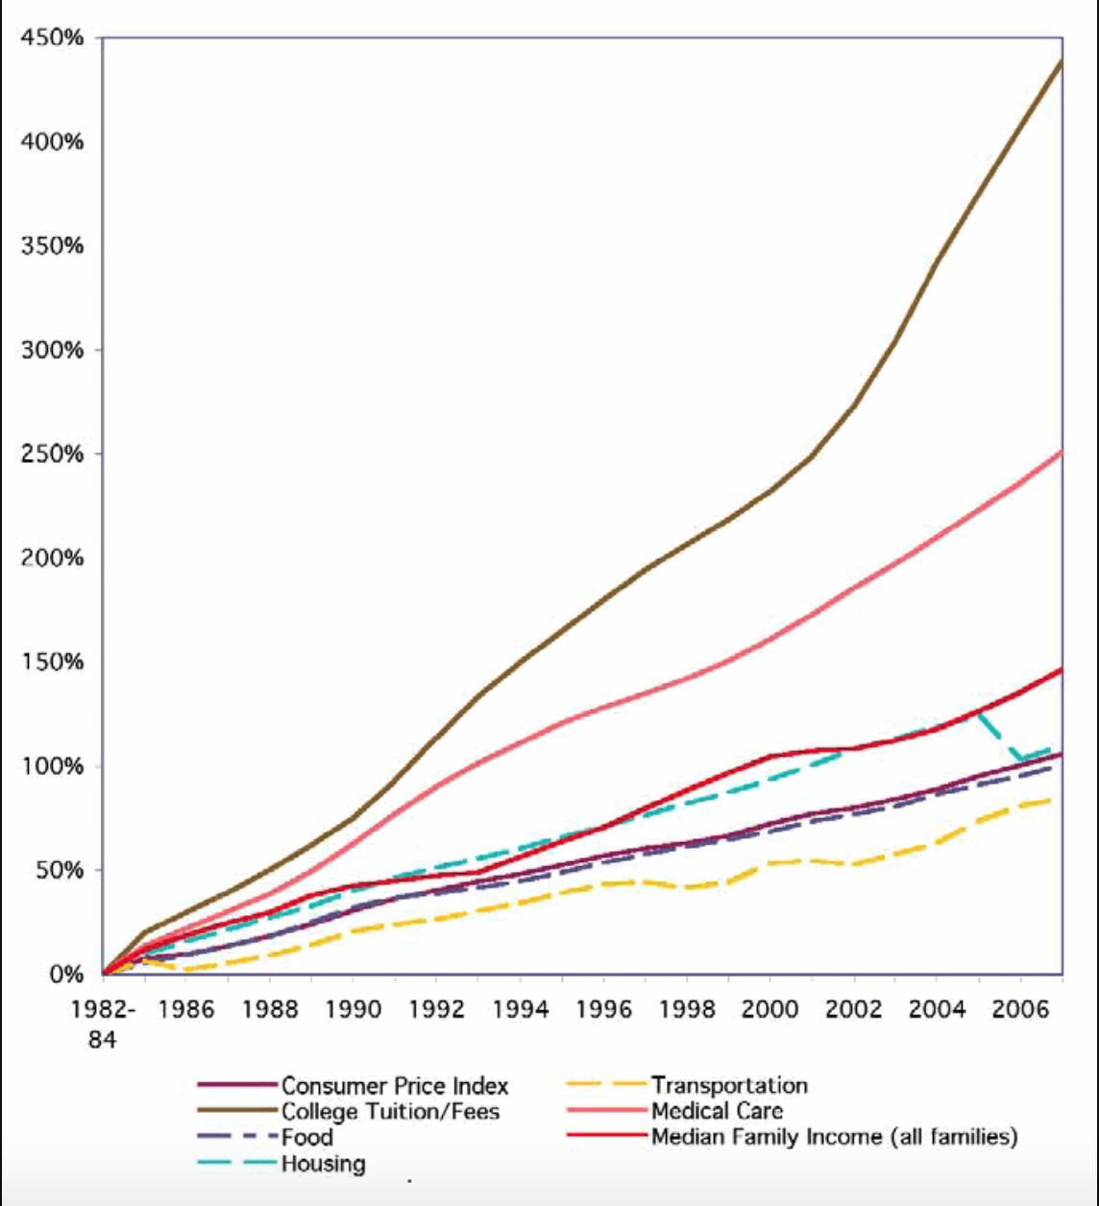

Document B: The Far-Reaching Impact of the Student Debt Crisis https://scholarshipamerica.org/blog/the-far-reaching-impact-of-the-student-debt-crisis/

A trillion dollars. That’s a massive number. To put this figure into perspective, it’s larger than the gross domestic product of 175 countries. No company in the Fortune 500 produces even half that much in annual revenue. The franchises in all four major American pro sports are worth barely 10 percent of a trillion dollars, combined. And a trillion dollars is also how much America’s college graduates owe on their student loans.
To say that student loan debt is a crisis is an understatement. According to the most recent figures from the Project on Student Debt, seven out of ten college graduates leave school with loan debt. A decade ago, their average debt level was around $17,000 — but, as of last year, that figure had climbed close to $30,000, directly impacting 37 million student borrowers and creating a trillion-dollar problem that affects just about everyone in the nation.
Overall, we know that students from low-income backgrounds still face the greatest struggle when it comes to earning college degrees. Unstable home lives, lower-quality high schools and other frequent corollaries of low-income neighborhoods present plenty of obstacles even before loan debt becomes an issue.
For students from middle-class backgrounds, the road to a degree seems easier. Their families often have money saved; their schools and support systems tend to prepare them well for the next step. Nevertheless, we’ve learned in the past year that middle-class students actually shoulder more student loan debt than anyone after graduating. According to Dartmouth sociology professor Jason Houle’s study:
“’Children from middle-income families make too much money to qualify for student aid packages, but they do not have the financial means to cover the costs of college’ … The study found that students from families earning between $40,000 to $59,000 per year racked up 60 percent more debt than lower-income students and 280 percent more than their peers whose families earned between $100,000 and $149,000 per year. A similar trend held for more affluent middle-income families earning up to $99,000 annually.”
When graduates who are looking for their first post-college job are already $30,000 in debt, the negative effect on the economy is considerable.
Despite their qualifications, grads often have to settle for lower-paying, lower-skill jobs just so they can start paying their loan bills right away. As a result, graduates in debt often miss out on the benefits that come with a degree. ProgressNow found that students with outstanding loan payments were 36 percent less likely to purchase a house, and other research indicates that “Those with student loan debt also are less likely to have taken out car loans. They have worse credit scores. They appear to be more likely to be living with their parents.”
Defaults and delinquencies are also more common with student loan debt than just about any other kind. While credit card default rates have dropped under 10 percent thanks to stricter borrowing guidelines, the rate of student loans in “serious delinquency” has gone up to 11.5 percent. What’s worse, according to Rohit Chopra of the Consumer Financial Protection Bureau, is that many of these borrowers aren’t even graduating. “This [statistic] suggests that borrowers who default are overwhelmingly non-completers … These borrowers take on some debt but do not benefit from the wage increase associated with a degree.”
Last but not least, the prospect of such overwhelming debt is making an increasing number of students, especially low-income students, think twice about attending college at all — a decision that will compound the already-impending shortage of educated employees facing the U.S. workforce.

Document C: Chart showing different student loan burdens by state
http://origins.osu.edu/sites/origins.osu.edu/files/3-12-chart981.jpg

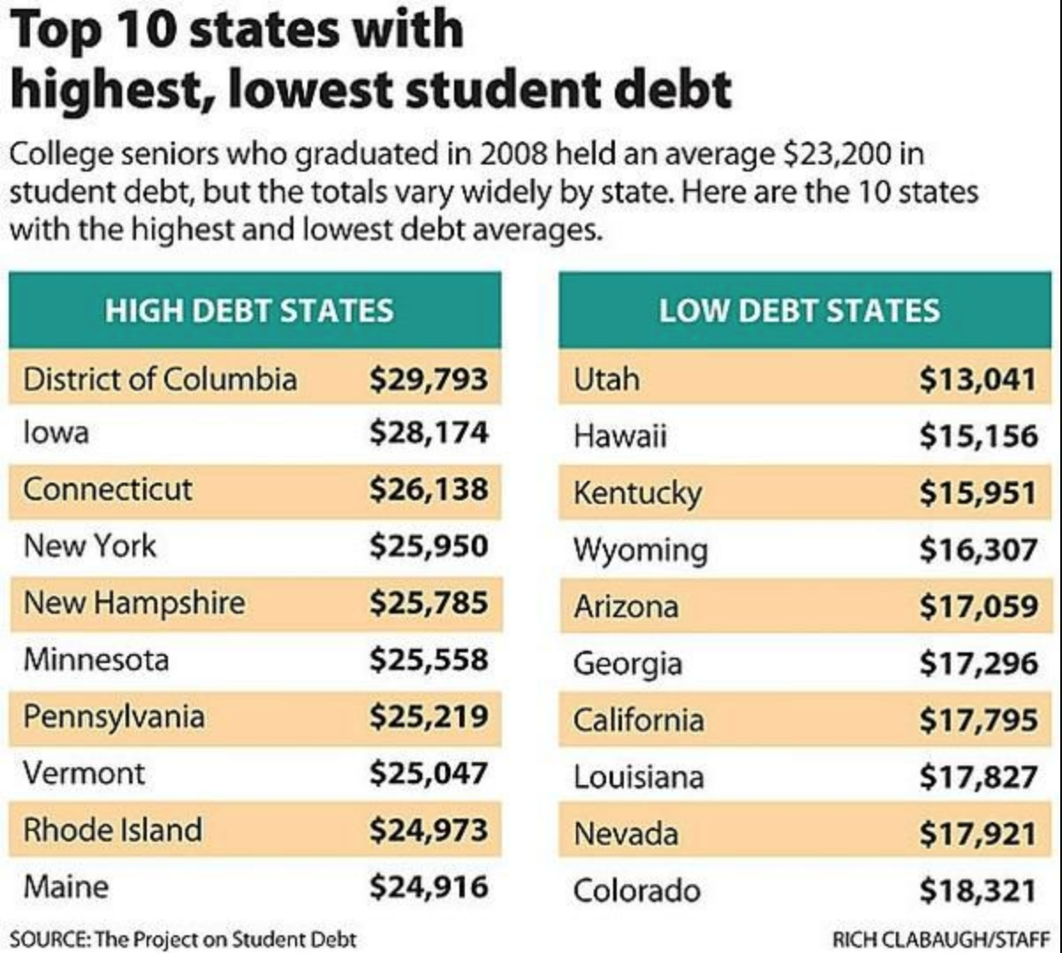

Document D: Why a College Education is Worth the Cost

https://www.ivywise.com/ivywise-knowledgebase/newsletter/article/why-a-college-education-is-worth-the-cost/

In a survey conducted by IvyWise and Next Step Magazine, 50% of families are now limiting their child’s college choices to less expensive options and 54% of families are considering in-state, public colleges, in response to the economic downturn.
This is no surprise, as 32% of families reported their financial situation has changed in the past six months. Another 38% said they are concerned about the economy and are now seeking more affordable college options. Surprisingly, only 17% of families considered the reputation of the college or university as the most important factor when researching colleges.
We are well aware of how the changing economic climate can affect a student’s college aspirations. Although the initial impulse to conserve resources is important, it is also important to understand a few realities:

- A college education is an investment that will pay off financially. There are significant long-term benefits to going to college. According to the U.S. Census, over an adult’s working life, high school graduates earn an average of $30,000 a year. Those with bachelor’s degrees earn an average of $51,000 a year. And the more you learn, the more you earn: those with a professional degree earn on average $100,000 a year. Also, according to the Bureau of Labor Statistics, college graduates had an unemployment rate of 2.2%. High school graduates had an unemployment rate of 4.4%.
- Attending a residential college has a positive impact on a student’s social development. Attending a residential college can lead to increased professional/personal mobility and a better quality of life for your offspring (Institute for Higher Education Policy, 1998). Also, students who attend residential colleges are more likely to interact with individuals with diverse social and political points-of-view (Pascarella, E. & Terenzini, P., 2006).
- A liberal arts education provides the greatest flexibility in a changing global economy. According to Seifert and Wolniak (2008), compared to business majors, liberal arts majors develop more cross-cultural and professional skills, especially those associated with management and entrepreneurship. Although business majors may develop more technical skills, these technical skills are also more likely to be outsourced.

In conclusion, families should invest even more resources in finding a college that matches their child’s personal and professional goals.

“Getting into college has become more competitive over the years, and now paying for it will be a bigger challenge for many families,” said Katherine Cohen, PhD., Founder and CEO of IvyWise, the Manhattan-based college counseling boutique. As Dr. Kat notes, “when families are forced to look for more economical options, it pays to consult experts who can help them identify potential financial resources and the schools that would be a good fit for the student. Families need to be determined, not discouraged, at a time like this.”

Document E: Earnings and unemployment rates by education
https://uwm.edu/chancellor/why-college-is-still-worth-the-money/
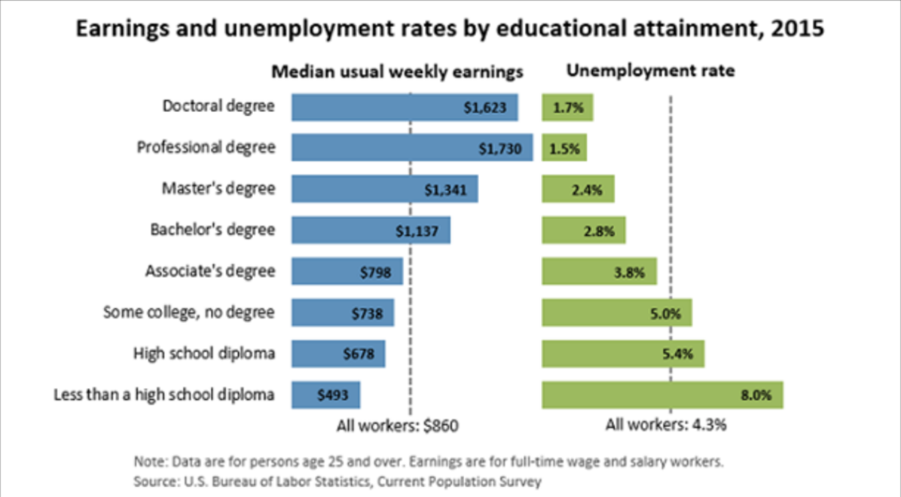

Alternative Sources The Creation of Student Loan Debt in the United States

Document F: Percent of Full-Time, Full-Year
http://origins.osu.edu/sites/origins.osu.edu/files/3-12-chart985.jpg
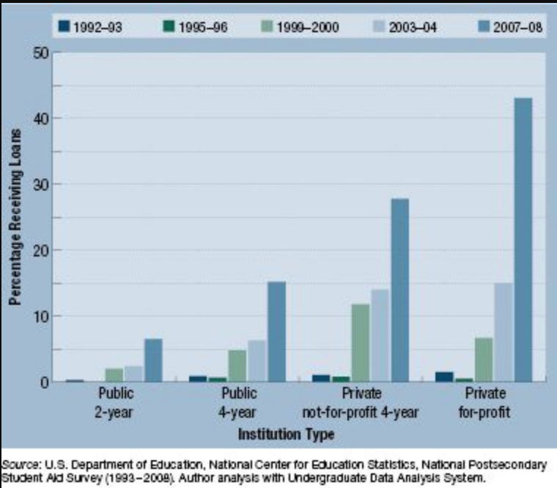

Document G: College is Worth the Cost. Here’s How Schools Can Prove it. https://www.realcleareducation.com/articles/2018/01/05/college_is_worth_the_cost__heres_how_schools_can_prove_it_110245.html

A growing number of people want to know if a college education is a worthwhile investment. Many prospective students, especially those who would be the first in their families to go to college, doubt the value of a college degree. A recent Wall Street Journal/NBC News poll showed that 57 percent of people without college degrees think college isn't worth it.
That's a frightening statistic – competing in a global economy increasingly requires a college degree. Schools need to better demonstrate the return on investment in higher education so that potential students don't wonder, "What am I getting for all this money?"
Research shows the value of a college education. According to a Georgetown University study, college graduates earn $1 million more in lifetime earnings than high school graduates. The choice of a college major is critical as well. There is a difference of $3.4 million in lifetime earnings between the highest and lowest paying college majors.
Students who come from families with college graduates see the benefits of a college education every day through their parents and community. But for students from less privileged backgrounds, figuring out the benefits of college can be daunting.
Colleges and universities are failing to demonstrate to these students that their degrees lead to job placements and higher future salaries. To restore belief in the value of higher education, colleges should offer a baseline level of information, in a concise manner, which demonstrates the outcomes of their academic programs. The information would include the following: the cost of a degree, the likely job prospects and salary outcomes for particular programs in particular markets, which courses are needed to graduate and the likely debt burden a student would take on. With this information, students can make informed choices.
As president and CEO of Adtalem Global Education, a network of colleges and universities, I led our institutions through an arduous, year-long process to develop and implement our Student Commitments, a set of practices designed to demonstrate the academic quality and value of our programs. The Commitments include a one-page disclosure with information on program performance metrics, such as program costs, debt and default rates, undergraduate earnings by program and, for healthcare and medical programs, licensure data.
This information helps students decide whether a particular academic program is right for them and gives them the support they need once they matriculate. We intend to review and refresh our Student Commitments each year.
To date, no other schools have undertaken such initiatives. That needs to change.
Restoring students' belief in the value of a college education should be educators' top priority. It'd be tragic if institutions of higher education fail to demonstrate the value of college to those who would benefit the most from earning a degree.

Document H: New Report Finds Student Debt Burden Has ‘Disastrous Domino Effect’ on Millions of Americans
https://www.forbes.com/sites/dianahembree/2018/11/01/new-report-finds-student-debt-burden-has-disastrous-domino-effect-on-millions-of-americans/#6bc6ca9412d1

Like many other student loan borrowers, Sean Vaillancourt of Phippsburg, Maine, found student debt has forced him and his wife to put their lives on hold year after year.
“Student debt has been difficult for my marriage as we are both working mainly to pay off this debt,” Vaillancourt reported. “We are waiting to have children and buy a home because our combined student debt is more than a mortgage on a home. This debt has been a huge burden and point of contention throughout our last 10 years. “
“I often imagine what life would look like for us if we were not imprisoned by debt to our current life,” he added.
Vaillancourt is one of 7,095 borrowers who participated in a 50-state survey for the new report “Buried in Debt,” a national research study on the state of student loan borrowers in 2018 by the social impact startup Summer and the nonprofit organization Student Debt Crisis.
As total outstanding student loan debt soars past the $1.5 trillion mark -- a figure that has tripled since 2005 -- the new report examines the toll that unrelenting stress and financial strain from high monthly payments have taken on the lives of borrowers nationwide.
Among those responding to the survey, borrowers owed an average of $87,500 in debt but made an average annual income of $60,000. (The average student loan debt nationwide is lower, with students from the class of 2016 carrying an average of $37,172 in student debt, according to 2016 statistics.)
Faced with seemingly insurmountable debt, some borrowers have had to postpone marriage, buying a home and other life decisions indefinitely. “Regularly, I contemplate selling everything and living in my car to help free up money to pay off the debt sooner,” wrote a female respondent from Texas. She had had to put off having children, marrying or purchasing a home, she reported, due to the high costs of student debt repayment.
Natalia Abrams, executive director of Student Debt Crisis, says these stories are all too common. “We do get stories of borrowers who are struggling with the idea of suicide,” she said. “These are not people who tried to get rich quick; these are not people looking for a handout. It’s so disheartening that they have not only received no help from the current administration, it has been rolling back or eliminating programs designed to protect them.”
Student debt has had “a disastrous domino effect for millions of Americans,” according to Abrams. “The reality of the day-to-day crisis is staggering. The average borrower has under $1,000 in savings, and 80% cannot save for retirement. And we are not just talking young people -- we’ve talked to many borrowers in their sixties who are still trying to pay off their student loans and are worried they will never have enough to retire.”
The study found that student loan debt interfered in people's plans for marriage and families, leading 19% of respondents to delay getting married and 26% to put off having children.
Student debt also cast a shadow over everything from financial security to philanthropy. Overwhelming debt prevented 80% of borrowers from saving for retirement, 56% from buying a home, 42% from buying a car, and 50% from contributing to charity, according to the report. More than 85% said student loan debt was a major source of stress, and one in three said such debt is the biggest stress in their lives.
Some of the other key findings from “Buried in Debt” include:
-- Nearly nine of 10 student loan borrowers are struggling to make payments. One in five borrowers reports they cannot make the next loan payment, and 44% say it would be a struggle.
-- Most borrowers reported they have less than $1,000 in their bank account, with high student loan payments partly to blame. Meanwhile, 58% of borrowers have taken a hit to their credit, with 10% failing a credit check for a job interview and 13% failing a credit check for an apartment.
-- Six percent of borrowers have had their Social Security payments or wages seized.
-- 18% report being in default on at least one student loan. This is the same percentage of borrowers federal agencies show are in default in the United States: 18%, or 8 million out of 44 million.
-- One in three of the borrowers report their student loan bill is higher than their rent or mortgage bill, with 65% saying their monthly student loan bill is more than their food budget for the month.
--Nearly 40% of borrowers report they have been unable to achieve their career goals. As for becoming their own bosses, 28% said their student debt prevented them from starting a business.
“These survey results reveal that student loan borrowers are on thin ice, and many are falling through without a lifeline,” said Will Sealy, the founder and CEO of Summer, a start-up dedicated to helping student loan borrowers repay their loans, in a written statement. “That means that millions of Americans face financial calamity, with all the limitations and stress that comes with it.” (Sealy formerly worked to protect students against predatory lenders as part of the Consumer Financial Protection Bureau.)
To make things worse, a troubling number of student loan companies have been prosecuted for predatory practices, such as abusive loan terms or convincing a borrower to accept unfair terms through deception or coercion.
According to the report, nearly 60% of borrowers reported that their loan servicer has given them “confusing” or “unhelpful” advice about their loans. A quarter of the respondents had confronted a surprise additional fee from their servicing company, 57% had experienced unexpected demands after a sudden change in the loan servicer, and 42% had trouble negotiating a change to the repayment plan when they had financial hardships.
“My loan are now almost equal to my rent, but once were nearly double my rent,” reported respondent Melissa Mills of Fort Worth, Texas. “I have begged multiple time for Sallie Mae to assist in lowering the monthly payments when a medical event happens, to which they have told me to quit my job and find a better-paying one.”
Meanwhile, borrowers continue to default on student loans every 28 seconds, according to Student Debt Crisis -- something that contributes to wage seizure and an ongoing spiral of debt that could hold back economic growth in the country. Small wonder that Federal Reserve Chairman Jerome Powell suggested that borrowers should be able to discharge student debt in bankruptcy. And a study by Bard College’s Levy Economics Institute found that simply forgiving all student debt would boost the U.S. economy by $1 trillion.
As the debate continues, a survey respondent from Pennsylvania identified as “Colleen” discussed her plight in a passage echoed by many others. “My student loans have prevented me from really living,” she wrote. “They stress me out more than I can explain. I pay and pay and pay, and the balance never seems to go down. Two of my loans have interest rates of 15%, and I have a third loan at 12%. I put almost two full paychecks towards my loans a month. It’s frustrating and honestly makes me feel completely defeated.”

