Time it Was Sources for Stations Activity

Document C: People’s World. (2018, October 1). This week in history: The Tlatelolco Massacre. Retrieved from https://www.peoplesworld.org/article/this-week-in-history-the-tlatelolco-massacre/

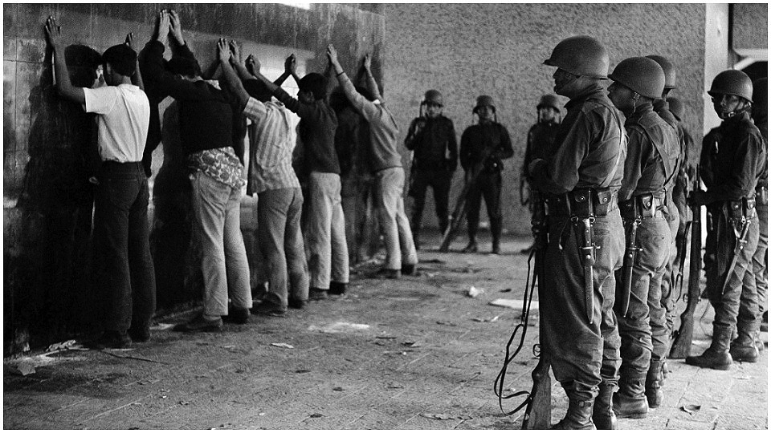

Document D: Boston, B. (n.d.). An antiwar demonstrator places flowers into the barrels of rifles while blocking the Pentagon. photograph. October 27th, 1967. Retrieved from https://www.washingtonpost.com/news/retropolis/wp/2017/10/19/the-day-anti-vietnam-war-protesters-tried-to-levitate-the-pentagon/

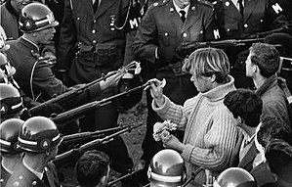

Document E: Victim of the Police Action in Front of the German Opera in West Berlin’s Charlottenburg Neighborhood.(n.d.). Retrieved from http://ghdi.ghi-dc.org/sub_image.cfm?image_id=2390

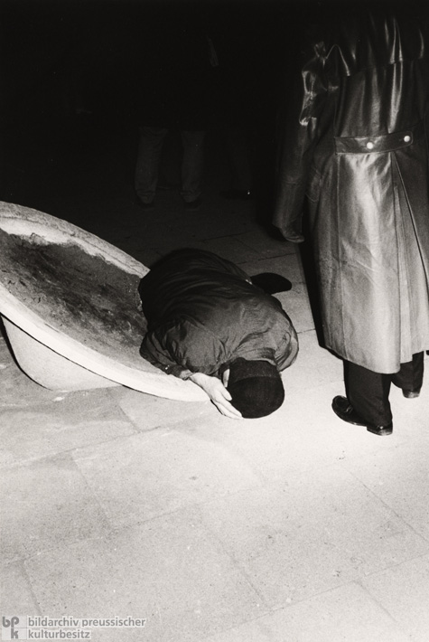

Document F: National Advisory Commission. (1968, January 1). Report of the National Advisory Commission on Civil Disorders: Summary of Report. Retrieved from https://www.hsdl.org/?abstract&did=35837

The summer of 1967 again brought racial disorders to American cities, and with them shock, fear and bewilderment to the nation.
The worst came during a two-week period in July, first in Newark and then in Detroit. Each set off a chain reaction in neighboring communities.
On July 28, 1967, the President of the United States established this Commission and directed us to answer three basic questions: What happened? Why did it happen? What can be done to prevent it from happening again?

To respond to these questions, we have undertaken a broad range of studies and investigations. We have visited the riot cities; we have heard many witnesses; we have sought the counsel of experts across the country. This is our basic conclusion: Our nation is moving toward two societies, one black, one white—separate and unequal.

Reaction to last summer’s disorders has quickened the movement and deepened the division. Discrimination and segregation have long permeated much of American life; they now threaten the future of every American.
This deepening racial division is not inevitable. The movement apart can be reversed. Choice is still possible. Our principal task is to define that choice and to press for a national resolution.

To pursue our present course will involve the continuing polarization of the American community and, ultimately, the destruction of basic democratic values. The alternative is not blind repression or capitulation to lawlessness. It is the realization of common opportunities for all within a single society. This alternative will require a commitment to national action—compassionate, massive and sustained, backed by the resources of the most powerful and the richest nation on this earth. From every American it will require new attitudes, new understanding, and, above all, new will. The vital needs of the nation must be met; hard choices must be made, and, if necessary, new taxes enacted.

Violence cannot build a better society. Disruption and disorder nourish repression, not justice. They strike at the freedom of every citizen. The community cannot—it will not—tolerate coercion and mob rule. Violence and destruction must be ended—in the streets of the ghetto and in the lives of people.

Segregation and poverty have created in the racial ghetto a destructive environment totally unknown to most white Americans.
What white Americans have never fully understood—but what the Negro can never forget—is that white society is deeply implicated in the ghetto. White institutions created it, white institutions maintain, and white society condones it.

It is time now to turn with all the purpose at our command to the major unfinished business of this nation. It is time to adopt strategies for action that will produce quick and visible progress. It is time to make good the promises of American democracy to all citizens—urban and rural, white and black, Spanish-surname, American Indian, and every minority group.

