Who Owns the Past Sources

Document A: Euphronios (Sarpedon) Krater,
Brodie, N. (2012, September 6). Euphronios (Sarpedon) Krater. Retrieved March 31, 2020, from https://traffickingculture.org/encyclopedia/case-studies/euphronios-sarpedon-krater/
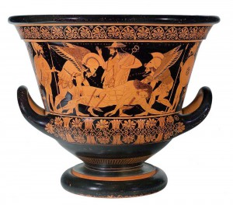
“The Euphronios (Sarpedon) krater is a red-figure calyx krater made in Athens circa 515 BC, signed by Euxitheos as potter and Euphronios as painter. It was bought by the Metropolitan Museum of Art in 1972 for the then record-breaking price of $1 million, and is now thought to have been excavated illegally in Italy in 1971. In 2006, the Metropolitan restored ownership of the krater to Italy.”

Document B: Who Owns the Past?, Henry, L., Rhodes, E. M., & Van Beurden, S. (2019, January). Retrieved from http://origins.osu.edu/transcripts/museums

“Dr. Steven Conn:
If we were to look at what the Soviet Union took out of Eastern Europe during and in the wake of the Second World War out of private collections, but also even out of national museums in places like Poland and Hungary and whatnot, I don't think the Soviet Union, now Russia, has been particularly forthcoming about any of that. So while we talk, you mentioned a moment ago, Lauren, the question of looted Nazi art, we've talked a lot less about things that were looted by the Soviet Union. And that may be another frontier in this conversation in the coming decades, depending on the politics that go on in Russia.

Lauren Henry:
And I think what's interesting there, again, is that we have this in the same way that the Metropolitan Museum repatriated something to Italy that had then been looted from Greece, I know that for example, Priam's Treasure which is the famous collection that the Soviet Union took out of Berlin in 1945, was itself the product of an archaeological dig in Turkey. And I believe that those materials are still with the exception of some which were returned to East Germany, I think in the 1960s are being held, I think, as collateral in a very sort of interesting debate about restitution for the losses that the Soviet Union suffered during the Second World War.”

Document C: Egypt Called; It Wants Its Rosetta Stone Back, Hansen, L., Ulaby, N., Campbell, T., Hawass, Z., Gerstenblith, P., & Garcia, T. (2010, November 14). Retrieved from https://www.npr.org/templates/story/story.php?storyId=131309154

“LIANE HANSEN, Host:
Unidentified Man: King Tut, the golden pharaoh.
NEDA ULABY: This mummy has been a celebrity for almost a century. But, says Thomas Campbell, director of the Metropolitan Museum of Art, let's be real about the 19 artifacts returning to Egypt.
THOMAS CAMPBELL: We have to keep this in perspective. These are not kind of gold faced masks, and vast sarcophagi.
ULABY: So, what are they?
CAMPBELL: Fragments. They are bits of wood, bits of textile, a little vase with some gunk in it.
ULABY: And some cooler things, like a teeny tiny sphinx and a little bronze dog - hardly the stuff of blockbuster exhibitions. Still, the fact that the Met voluntarily gave them back, although the museum was under no legal obligation to do so, was a triumph for the Egyptian antiquities department.
(SOUNDBITE OF BEEPING)
ULABY: You'd also like to try to repatriate the Rosetta Stone from the British Museum. Do you really think that's going to happen?
ZAHI HAWASS: Yes. I am - you will hear soon some good news. I need these unique objects back and I will fight to return them back.
ULABY: Many Egyptians believe these objects are significant to their national heritage, and their presence in European museums is a monument to the days of colonialist looting and exploitation.
HAWASS: Anything that left illegally, it should be back to Egypt.
ULABY: But legalities are difficult to pin down with objects taken 100 or 200 years ago.
PATTY GERSTENBLITH: My guess is that it's relatively unlikely that those will be returned.
ULABY: But Terry Garcia has a little more confidence in Dr. Hawass's powers of persuasion. Garcia works for the National Geographic Society. He says, still, objects like the Rosetta Stone come with their own sets of ethical and legal dilemmas.
TERRY GARCIA: The legal consequences or the claims that might be asserted against the countries or museums holding these objects be is much less clear. It's very murky.
ULABY: Neda Ulaby, NPR News.”

Document D: Everything You Ever Wanted to Know about the Rosetta Stone, Everything you ever wanted to know about the Rosetta Stone. (2017, July 14). Retrieved March 31, 2020, from https://blog.britishmuseum.org/everything-you-ever-wanted-to-know-about-the-rosetta-stone/

“What is the Rosetta Stone?
The Rosetta Stone is one of the most famous objects in the British Museum. But what is it?
The Stone is a broken part of a bigger stone slab. It has a message carved into it, written in three types of writing (called scripts). It was an important clue that helped experts learn to read Egyptian hieroglyphs (a writing system that used pictures as signs).
Why is it important?
The writing on the Stone is an official message, called a decree, about the king (Ptolemy V, r. 204–181 BC). The decree was copied on to large stone slabs called stelae, which were put in every temple in Egypt. It says that the priests of a temple in Memphis (in Egypt) supported the king. The Rosetta Stone is one of these copies, so not particularly important in its own right.
The important thing for us is that the decree is inscribed three times, in hieroglyphs (suitable for a priestly decree), Demotic (the native Egyptian script used for daily purposes, meaning ‘language of the people’), and Ancient Greek (the language of the administration – the rulers of Egypt at this point were Greco-Macedonian after Alexander the Great’s conquest).
…
The importance of this to Egyptology is immense. When it was discovered, nobody knew how to read ancient Egyptian hieroglyphs. Because the inscriptions say the same thing in three different scripts, and scholars could still read Ancient Greek, the Rosetta Stone became a valuable key to deciphering the hieroglyphs.
…
When was it found?
Napoleon Bonaparte campaigned in Egypt from 1798 to 1801, with the intention of dominating the East Mediterranean and threatening the British hold on India. Although accounts of the Stone’s discovery in July 1799 are now rather vague, the story most generally accepted is that it was found by accident by soldiers in Napoleon’s army. They discovered the Rosetta Stone on 15 July 1799 while digging the foundations of an addition to a fort near the town of Rashid (Rosetta) in the Nile Delta. It had apparently been built into a very old wall. The officer in charge, Pierre-François Bouchard (1771–1822), realised the importance of the discovery.

On Napoleon’s defeat, the stone became the property of the British under the terms of the Treaty of Alexandria (1801) along with other antiquities that the French had found. The stone was shipped to England and arrived in Portsmouth in February 1802.”
Document E: A Guide to Africa’s ‘Looted Treasures’, Lime, A. (2018, November 23). A guide to Africa's 'looted treasures'. Retrieved March 31, 2020, from https://www.bbc.com/news/world-africa-45406557

“During colonial rule in Africa, thousands of cultural artefacts were plundered. African countries want them back and major museums across Europe have agreed to loan the famous Benin Bronzes back to Nigeria. Now France has launched a report calling for thousands of African art in its museums to be returned to the continent.

…

Maqdala treasures
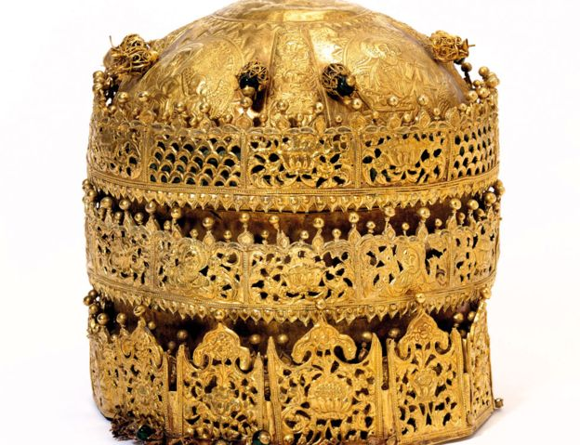Image copyrightV&A MUSEUMImage captionThis crown is admired for its filigree designs and religious embossed images
The Maqdala treasures include an 18th Century gold crown and a royal wedding dress, taken from Ethiopia (formerly Abyssinia) by the British army in 1868.
Historians say 15 elephants and 200 mules were needed to cart away all the loot from Maqdala, Emperor Tewodros II's northern citadel capital.
The British raided Maqdala in protest at the detention of its consul when relations between the two powers deteriorated.
Some of the treasures were later deposited at the UK's Victoria and Albert Museum.
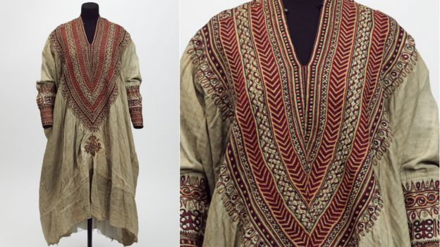Image copyrightV&A MUSEUMImage captionMade in the 1860s, this wedding dress is thought to have belonged to Queen Woyzaro Terunesh
The crown, admired for its silver and copper filigree designs and religious embossed images, and royal wedding dress are significant symbols of the Ethiopian Orthodox Church.
Scholars believe the crown was commissioned in the 1740s by Empress Mentewwab and her son King Iyyasu and given as a gift to a church in Gondar, together with a solid gold chalice.
The dress and jewellery belonged to Emperor Tewodros II's widow, Queen Woyzaro Terunesh.

Ethiopia lodged a claim in 2007 for the return of the antiquities. In April this year, the V&A offered to return the treasures to Ethiopia on loan.”

Document F: A Guide to Africa’s ‘Looted Treasures’, Lime, A. (2018, November 23). A guide to Africa's 'looted treasures'. Retrieved March 31, 2020, from https://www.bbc.com/news/world-africa-45406557

“Zimbabwe bird
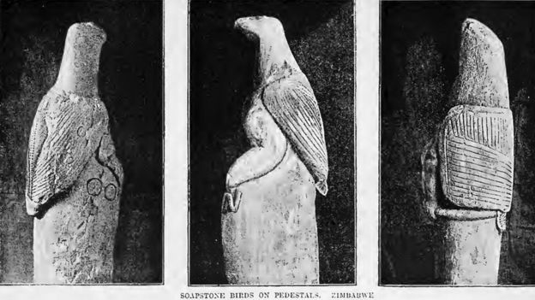Image copyrightWIKICOMMONS
A soapstone sculpture of a fish eagle is Zimbabwe's main national emblem. Eight of the Zimbabwe Birds were looted from the ruins of an ancient city.Only eight of the birds were ever recovered. They stood on the walls and monoliths of the ancient city built between the 12th and 15th Centuries by the ancestors of the Shona people.
Seven of the carvings are in Zimbabwe since 2003 when the bottom section of one was returned by Germany.
It had ended up in the hands of a German missionary who sold it to the Ethnological Museum in Berlin in 1907. Then after Soviet troops invaded Germany at the end of the World War Two, it was moved from Berlin to Leningrad and remained there to the end of the Cold War and then returned to Germany.
The eighth remains in the old bedroom of 19th Century British imperialist Cecil Rhodes, whose home in the South African city of Cape Town is now a museum. He had taken a number of birds from Great Zimbabwe to South Africa in 1906. South Africa returned four of them in 1981, a year after Zimbabwe gained its independence.”

