Military Drone Sources

Station 1/Source 1: NYPD Drone, Houghs, K. (2013) Retrieved from:
http://origins.osu.edu/article/aerial-torpedoes-buzz-bombs-and-predators-long-cultural-history-drones/page/0/0

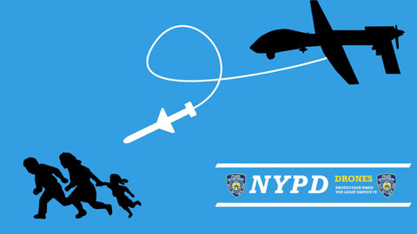

Station 1 Source 2: Pros and Cons of Military Drones
http://grinddrone.com/review/pros-and-cons-of-military-drones

Pros:
- Saves Lives: The most obvious advantage of military drones is that they greatly reduce putting military personnel in harm's way or in combat. This is because a lot of these drones are unmanned and therefore there is not human life in danger.
- Low Cost: The second most obvious advantage of drones is their low cost, because they are significantly cheaper to purchase, fuel, and maintain than regular airplanes.
- Low Risk: Since drones are smaller and can fly lower than traditional airplanes, there is less risk to military hardware. This ensures that the expensive military hardware are only deployed as and when it is very necessary.
- Operational Hours: Without a human pilot, drones can stay in operation for significantly longer hours of operation without fatigue. Additionally, drone pilots or operators can easily hand off controls of a drone without any operational downtime.
- Accuracy: Drones can have more pinpoint accuracy from greater distances, thus reducing collateral damage to civilians and infrastructure. This works well in terms of ensuring accountability in the military ranks.
- Lethal: Drones are as lethal to enemy combats as regular airplanes. This means that it is easier to neutralize enemy power using a drone with minimal human casualties.
- Spying: Years before drones were used in combat; drones have proven to increase surveillance, reconnaissance, and general military intelligence. Because of their stealth nature, it is difficult for the enemy to notice a drone operation.
- Deployment: Drones are significantly easier and faster to deploy than most alternatives. Some drones can be deployed by hand while others can simply take off like a normal aircraft.
- Saves time: Drones also play an important role in saving the time needed to neutralize an enemy because they are always ready to be deployed.

Cons:
- Limited Abilities: Drones have obvious limitations. For example, they cannot communicate with civilians for more detailed intelligence. Drones cannot capture surrendering military personnel, abandoned hardware, or military bases.
- Civilian Losses: Drone warfare often causes collateral damages in civilian lives and property, as well as traditional warfare too. This is because they do not have the capacity to make judgment on whether to deploy or not.
- Counterproductive and Destabilizing: Civilian opinions about drones are typically negative, since they are viewed as an invasion force. The mere presence of drones has been known to convert civilians into military combats. Furthermore, when drones cause collateral damage, such as killing civilians and damaging civilian property, the opinions of civilians decrease even more so.
- Too Easy: By making drone warfare very similar to video games, drone warfare makes combat too easy by diminishing ethical decisions. To many, it always seems like a game simulation when using a drone and therefore the possibility of making sound ethical judgment may not always be there.
- Work and Personal Life Balance: Some drone pilots or operators have difficulty switching between combat mode at work and civilian mode while not working. This is especially difficult when drone pilots have minimal transition periods between work and personal, if any at all.
- Take Over: The worst case scenario is when drones or a fleet of drones have been commandeered or taken control by the enemy. While security measures help make this possibility more difficult, it will never be impossible.
- Can be shot down: Drones can always be shot down by the enemy and this possibility grows by the day. This leaves a vacuum when the drone has been shot down and leaves the military vulnerable.
- Costly: Drone technology has not come without a cost. It is increasingly becoming expensive for the military to invest and research on drones since this is the next frontier in terms of modern warfare. Countries that lack significant military spending may not utilize fully the power of drone warfare and this

Station 2/Source 1: Shadows Over England, (n.d.) Retrieved from:

https://www.germanpostalhistory.com/php/viewitem.php?itemid=55120

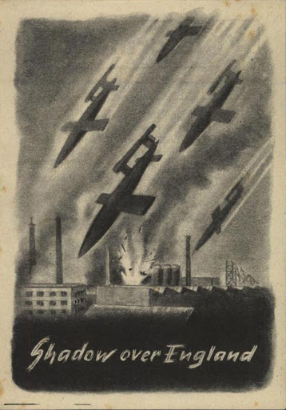

Source 2/Source 2: German V Weapons: Desperate Measure, (n.d.) Retrieved from: https://www.nationalmuseum.af.mil/Visit/Museum-Exhibits/Fact-Sheets/Display/Article/196145/german-v-weapons-desperate-measures/

"I am informed by the Fuhrer for the first time that the big rocket bomb weighs 14 tons. This, of course, is a devastating murder weapon. I suspect that when the first projectiles plunge down into London, the English public will panic."
- Josef Goebbels, Nazi propaganda minister
"The employment of this weapon represents a new effort by the enemy to shake the morale of our civilian population. In doing so, they have false hopes of preventing the threatened defeat on the field by that means."
- Winston Churchill, British prime minister
Near the end of World War II, Germany used "vengeance weapons" (Vergeltungswaffe) against the Allies to strike terror into civilian populations and disrupt military operations. V-weapons could not be used effectively to strike with precision or support advancing troops -- they were terror weapons that could only hamper Allied operations behind the front and affect civilian morale. V-weapons included the self-guided V-1 Buzz Bomb and the V-2, the world's first rocket-powered long-range ballistic missile.
As waves of Allied bombers struck Germany with increasing effect in 1944-1945, the Germans -- having lost the ability to bomb Great Britain effectively -- sought revenge by launching V-weapons at Allied population centers and strategic ports. V-1 and V-2 attacks did inspire public fear as intended, but inaccuracy made them militarily ineffective. Also, the ever-increasing Allied strength in Europe following the June 1944 invasion of France made the V-weapon mission practically hopeless from the beginning. Germany could not perfect the weapon fast enough or produce enough of them to avoid defeat in WWII.
German V-weapons killed more than 15,000 people and wounded another 47,000 in England, Belgium, Poland, France and Germany. Main V-weapon targets included London, Antwerp, Brussels and Liege. By the end of the WWII, a total of more than 15,000 V-1s and V-2s struck England and Belgium, but flak and fighters destroyed another 6,000 Buzz Bombs before they reached their targets. The Nazis used forced labor to build V-weapons and an estimated 20,000 people died producing them in brutal work-camp conditions.

Station 3/ Source 1: Kettering Bug, (n.d.) Retrieved from: https://www.airplane-pictures.net/photo/55429/unknown-kettering-aerial-torpedo/

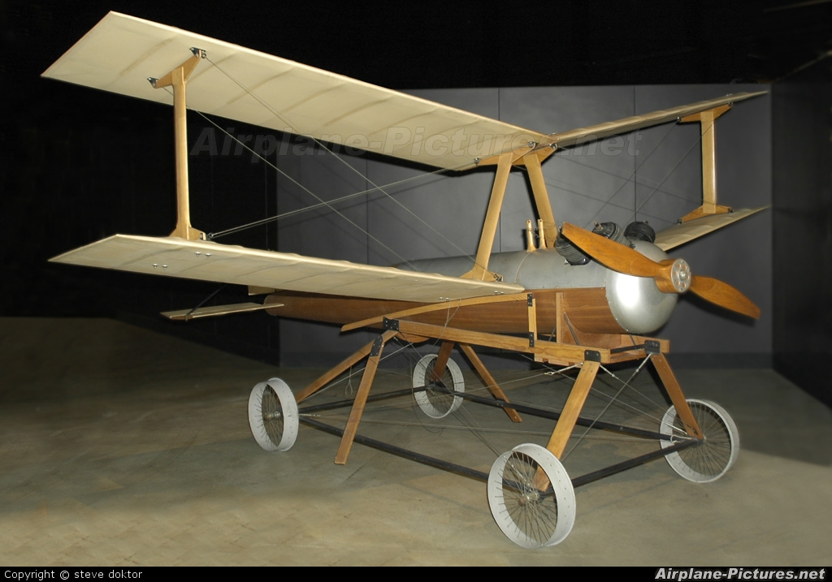

Station 3/ Source 2: World War I and Interwar Drone Fantasies, Houghs, K. (2013) Retrieved from:
http://origins.osu.edu/article/aerial-torpedoes-buzz-bombs-and-predators-long-cultural-history-drones/page/0/0
The Aerodrome’s importance and lethality existed principally in the imaginations of newspaper editors, and Langley’s device was largely forgotten in the wake of the Wright Brothers’ manned ascent in 1903.
With rapid advances in manned aviation, including military aircraft, the possibility of armed drones once again surfaced.
Well before Europe’s fracturing into myriad battlefields in 1914, speculative fiction depicted unmanned “aerial torpedoes” as part of the mechanized future of war. An imaginary drone was the star of a 1909 short film, The Airship Destroyer (aka The Battle in the Clouds). It depicted German dirigibles attacking England, a premise lifted from H.G. Wells’ novel The War in the Air (1908). The “airship destroyer” performs better than manned planes and heroically spares the world such horrors as the bombardment of British homes, churches, and civilians by zeppelins.
Copying this storyline, D.W. Griffith’s 1916 film The Flying Torpedo shows another citizen inventor saving California from a Japanese invasion with his wireless flying bombs. Both Airship Destroyer and The Flying Torpedo were screened widely and rereleased many times even as the “war to end all wars” raged around their viewers.
Indeed, soon after the U.S. entered World War I, remotely piloted vehicles moved from the silver screen to drawing boards of arms manufacturers in the hopes of saving American lives with explosive UAVs sent deep into German territory. Perhaps inspired by Hollywood, Secretary of the Navy Josephus Daniels’ Naval Consulting Board (NCB) enlisted private scientists and engineers in the “war of technological surprises.”
Headed by Thomas Edison, the board induced Elmer Ambrose Sperry, inventor of the stabilizing gyroscope, to join them. Sperry’s gyroscope became the major component of the NCB’s “most audacious and forward-looking project”: the Curtis-Sperry Aerial Torpedo.
The military investigated several such drones during the war, including the “Kettering Bug” or “Liberty Eagle” flying bomb, designed by Charles F. Kettering (future lead research engineer for General Motors) and built by Orville Wright’s Dayton Wright Airplane Company.
The idea behind each of these drones was simple, if their execution was not: once launched, the diminutive, explosive-laden planes were stabilized and guided by a combination of gears, pneumatics, and gyros. After a predetermined number of engine revolutions, their engines would stall and the UAVs would plunge in a terminal dive upon whatever unlucky object or person lay beneath.
Though neither drone was perfected in time for combat, the Curtis-Sperry Aerial Torpedo became the first purpose-built attack drone to make a successful flight. And despite its poor performance, the Kettering Bug impressed the army enough to become the first mass-produced drone in history.
Drone strikes were not a part of the Great War’s appalling destruction, but the U.S. military kept its UAV projects going well into the 1920s, hoping unmanned “death engines” might inoculate the U.S. against the evils of future wars.
Popular images of radio-controlled drones also endured in the interwar years, as media reports kept the public abreast of drone developments. These stories mixed hope about eliminating American war casualties with caution for possible domestic peril.
In 1924, Literary Digest suggested the newly formed Geneva Convention should prohibit the “manless airplane,” lest “this winged brood of destruction” spell the “final and utter destruction of the race and its civilization.” A remorseful Kettering later hoped blueprints for his Liberty Eagle would remain locked up “for all time.”
A similar if sillier pessimism crept into the 1936 cartoon Plane Dippy, which pitted Porky Pig, a newly enlisted Army Air Corps cadet, against an unruly experimental robot plane. With Porky trapped on board, the malfunctioning drone carves a path of destruction through the air base and a nearby town, before the portly Looney Tunes star can escape to a life of safe boredom in the infantry.

