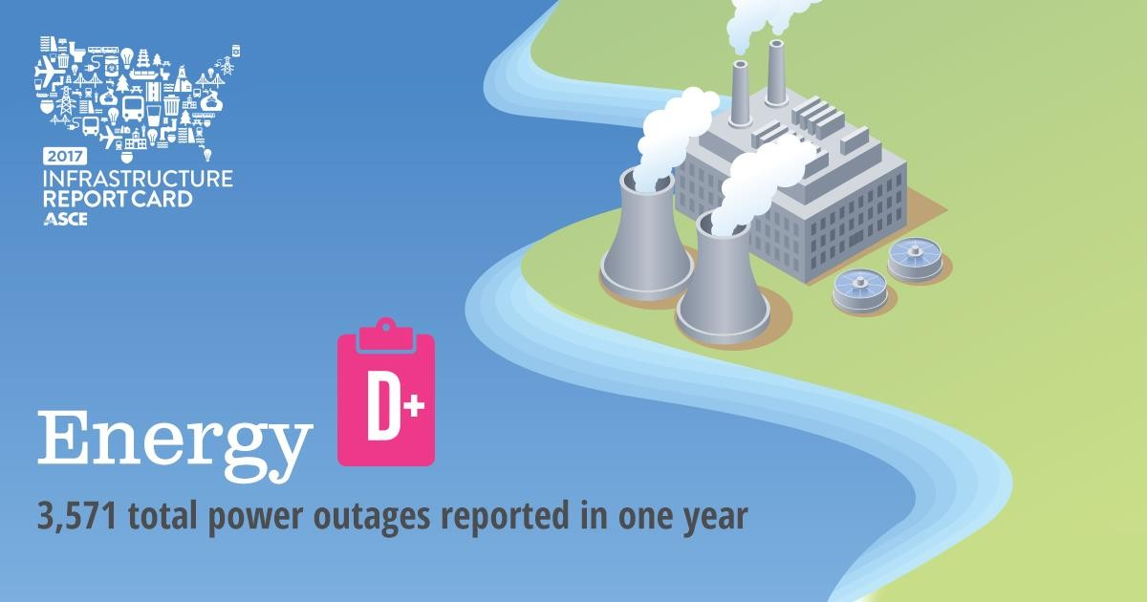
OVERVIEW
Much of the U.S. energy system predates the turn of the 20th century. Most electric transmission and
distribution lines were constructed in the 1950s and 1960s with a 50-year life expectancy, and the more than 640,000 miles of high-voltage transmission lines in the lower 48 states’ power grids are at full capacity. Energy infrastructure is undergoing increased investment to ensure long-term capacity and sustainability; in 2015, 40% of additional power generation came from natural gas and renewable systems. Without greater attention to aging equipment, capacity bottlenecks, and increased demand, as well as increasing storm and climate impacts, Americans will likely experience longer and more frequent power interruptions.

CAPACITY & CONDITION
Near-term, U.S. energy systems are projected to deliver sufficient energy to meet national demands in the near term, as energy consumption fell slightly, from 98 quadrillion British thermal units (Btu) in 2014 to 97.7 quadrillion Btu in 2015, and is estimated to grow at a modest rate, averaging 0.4% per year from
2015 through 2040. In general, the capacity and condition of energy systems depend on ownership and geographic region, with privately-owned sources in the best position to invest. Reduced electric demand, changing delivery costs, and new regulations, including those focused on reducing environmental impact, have prompted transformations across the sector in recent years, with growth in natural gas, solar, and wind generation. In 2015, 40% of additional power generation came from natural gas and renewable systems, a trend that continues. However, little consideration has been given to
long-term energy sustainability. Fossil fuels and uranium have limited reserves, leaving them unable to meet future power generation and delivery needs. Electricity and oil and gas delivery via well- maintained wires and pipelines remain the most efficient and safe supply chains; new distributed technologies may play an increasingly important long-term role particularly as cities grow in population.

ELECTRICITY
Electricity delivery in the U.S. depends on an aging and complex patchwork system of power generation facilities, transmission and distribution (T&D) grids, local distribution lines, and substations, owned by an array of investor- and publicly-owned utilities, independent power producers, and governmental agencies. While investor-owned utilities make up only 6% of the number of electricity providers, they serve 68% of electric customers.

Some parts of the U.S. electric grid predate the turn of the 20th century. Most T&D lines were constructed in the 1950s and 1960s with a 50-year life expectancy, and were not originally engineered to meet today’s demand, nor severe weather events. With more than 640,000 miles of high-voltage transmission lines across the three interconnected electric transmission grids – the Eastern Interconnection, Western Interconnection, and Texas Interconnection – the lower 48 states’ power grid is at full capacity, with many lines operating well beyond their design. The resulting congestion raises concerns with distribution, reliability, and cost of service, producing constraints for delivering power from remote generation sites, specifically from renewable sources, to consumers. Often a single line cannot be taken out of service to perform maintenance as it will overload other interconnected lines in
operation. Grids operating in Alaska and Hawaii are similarly congested and physically islanded from the other states. As a result of aging infrastructure, severe weather events, and attacks and vandalism, in
2015 Americans experienced a reported 3,571 total outages, with an average duration of 49 minutes.

OIL & GAS
America’s 2.6 million miles of oil and gas pipelines connect sources such as wells and import/export
terminals with processing facilities and consumers. Over two-thirds of the lower 48 states depend on interstate pipelines for delivery of natural gas. Most lines are owned by private utilities or municipalities.

Consumption of natural gas has increased by over 24% between 2005 and 2015 and continues to rise. Since 2013, oil and natural gas pipeline construction has continued at a fairly brisk pace to address new sources, with 2016 to 2019 construction expected to modestly increase over the previous five-year period. Despite recent construction, a large percentage of higher-pressure natural gas transmission lines were installed before 1980. On average, oil refineries have operated around or over 90% capacity since
1985, with limited new additions; existing facility upgrades have kept up with demand for gasoline, other fuels, and raw products for manufacturing. Periodic failures in existing oil and gas pipelines and quality concerns in new construction point to the need for increased monitoring and maintenance spending. The concentration of processing plants on the shores of southern states creates significant exposure to future storm and climate change impacts.

FUNDING & FUTURE NEED
Due to private ownership, national security concerns, and costs of service, there is limited public visibility into infrastructure investment levels and need across electricity, oil and gas, and alternative energy sources. Increased investment in alternative sources of energy for power generation, heating and cooling, transportation, and process industries is needed for a sustainable future, but investment in this area lags, principally due to a lack of federal energy policy.

Permitting processes present a particular challenge to energy infrastructure, amounting to substantial expenses and causing significant delays in the construction of critical lines necessary to bring renewable energy into the grid. Operations and maintenance spending by pipeline owners will continue to expand as new regulatory guidelines aimed at increased safety are issued by states and the federal U.S. Department of Transportation’s Pipeline and Hazardous Material Safety Administration (PHMSA) and as pipeline miles increase.

For electricity – including generation facilities and T&D infrastructure – the cumulative investment gap between 2016 and 2025 is estimated to be $177 billion. Funding is generally not an issue for building new T&D lines. At the same time, utilities face considerable pressure to cover maintenance and system
upgrade costs through regulator-capped rate increases, and thus struggle to justify more reliable lines or make long-term investments. Industry players including Edison Electric Institute, representing electric utilities, and market research firm SNL Energy predict a modest reduction in T&D spending in years 2017 to 2020, while spending on new generation is expected to be flat, driven by older generation replacement and expanded renewable energy.

Investment in oil and gas infrastructure is driven by changing sources, increasing demand, and commodity pricing fluctuations, as well as physical condition, failure events, and regulation. In geographic regions where demand approaches or exceeds existing supply, commodity pricing is elevated and funding is justified; when commodity pricing is low, infrastructure investment declines.

PUBLIC SAFETY, RESILIENCE, & INNOVATION
The U.S. energy sector faces significant challenges as a result of aging infrastructure, including supply, security and reliability, and resiliency issues in the face of severe weather events, all posing a threat to public safety and the national economy. Between 2003 and 2012, weather-related outages, coupled with aging infrastructure, are estimated to have cost the U.S. economy an inflation-adjusted annual average of $18 billion to $33 billion. Some states have enacted “storm hardening” policies to improve reliability during weather events, but these are typically influenced by local politics, rather than engineers’ recommendations. Local solutions, such as distributed generation and resilient microgrids,
may offer lower-cost alternatives to major system investments particularly in areas at elevated risk from severe weather or other natural disasters.

Periodic oil and gas pipeline leaks and failures present risks to the environment and the public. Most domestic oil refineries are situated along the coasts, subjecting them to risks from receding shorelines, climate change, and storm-related impacts. Each time there is a pipeline break or refinery outage, prices spike and supply is disrupted, with even minor disruptions having immediate impact. Statistics maintained by the PHMSA indicate that the frequency of significant pipeline incidences has remained
flat in recent years; however, each incident typically results in injuries and/or deaths, environmental impacts, and regional economic disruption. Meanwhile, the number of reported “spill” events has increased in the last several years, up from 573 in 2012 to 715 in 2015, and events such as multiple leaks at the Aliso Canyon gas storage field in California and Colonial gasoline pipeline failures in Alabama have highlighted system fragility and prompted federal rulemaking. Various monitoring techniques including
in-line nondestructive testing, leakage surveys, and remote sensing (enabled by fiber optics, LiDAR, others) have been developed to mitigate these problems and are in various stages of deployment.

Automated valve shutoff to address earthquakes and leaks has also been critical in reducing consequences of failure to the public and the environment.

Cybersecurity and physical security remain important topics with respect to energy system resiliency and infrastructure owners are seeking to address them in response to federal mandates. Select energy systems such as the transmission grid are also exposed to low-probability severe threats, such as geomagnetic pulse, which could have significant impact on public safety and the economy.

RECOMMENDATIONS TO RAISE THE GRADE
• Adopt a federal energy policy that carefully assesses needed changes, including alternative energy sources such as renewables and distributed generation, to provide clear direction for meeting current and future demands.
• Streamline permitting processes, to facilitate prompt construction of critical new transmission lines and natural gas pipelines. Process streamlining must include steps to consider alternative approaches and ensure prudent and safe routing.
• Develop a national “storm hardening” plan that considers investment in T&D, refinery, and generation systems that withstand storms or that enable rapid restoration of energy supply after storm events.
• Increase new and rebuilt distribution lines’ minimum design loads for ice, wind, and temperature to improve reliability and public safety and reduce inconveniences associated with power outages.
• Promote usage of remote sensing and inspection technologies to lower the cost of energy system monitoring; focus operation and maintenance spending on highest-risk system components.
• Implement performance-based regulations that mandate verification of pipeline integrity and increased investment in early corrective action for inadequate pipelines.
• Promote usage of accepted engineering standards for all overhead T&D lines, pipelines, and support structures to help ensure safety and reliability.

DEFINITIONS
Energy Systems – Those which: (1) generate, transmit, and distribute electric power, and (2) collect, refine, and transport fuels including solid (e.g., coal, biomass), liquid (e.g., oil, gasoline), and gaseous (e.g., natural gas) fuels, for delivery to consumers.

Renewable Energy – Biomass, hydroelectric, geothermal, wind, and solar sources (for energy generation)

British thermal unit (Btu) – A measure of power, related to the heat content of various types of fuel; the amount of heat needed to raise the temperature of one pound of liquid water by one degree Fahrenheit

Energy storage – Systems that capture energy production at one time via mechanical, electrical, and electrochemical means to enable energy dispatch at a later time when demanded

Distributed generation – Generation of energy local to its demand

Grid – The interconnected system of power lines and related equipment that delivers high-voltage electricity from power generating stations to substations, where it is transformed to a lower voltage for distribution to consumers. In the 48 lower states, the grid is comprised of three regional interconnected systems: the Eastern Interconnection, Western Interconnection, and Texas Interconnection; there is no single “national” grid. Alaska has separate Railbelt and Southeast Alaska grids, whereas Hawaii has
island-based independent grids.

High-voltage transmission lines – Lines that carry electricity from power generation facilities to concentrated locations where bulk electricity is needed (typically at 138 kV and higher) and distributed at lower voltages

Congestion – Flows of electricity across the system that are restricted or constrained below desired levels, either by the physical/electrical capacity or operational policies designed to protect security and reliability

In-line nondestructive testing – Testing and analysis techniques to evaluate pipeline conditions without causing damage

Leakage surveys – Inspection of a pipeline system to find leakage of carried media

Remote sensing – Using satellites or high-flying aircraft, UAVs, and related technology to evaluate and/or monitor pipeline conditions

LiDAR – Light Detection And Ranging; a remote sensing method that uses a pulsed laser of light to measure and site energy infrastructure

SOURCES
U.S. Energy Information Administration. Annual Energy Outlook 2017. https://www.eia.gov/forecasts/aeo/executive_summary.cfm

U.S. Energy Information Administration. What is U.S. electricity generation by energy source? 2016. https://www.eia.gov/tools/faqs/faq.cfm?id=427&t=3

U.S. Department of Energy. Quadrennial Energy Review Energy Transmission, Storage, and Distribution Infrastructure. 2015. http://energy.gov/sites/prod/files/2015/08/f25/QER%20Summary%20for%20Policymakers%20April%20
2015.pdf

Eaton Corporation. Eaton Blackout and Power Outage Tracker: United States Annual Report. 2015. http://powerquality.eaton.com/blackouttracker/default.asp

U.S. Energy Information Administration. U.S. Natural Gas Total Consumption, 1949-2015. https://www.eia.gov/dnav/ng/hist/n9140us2A.htm

Oil and Gas Journal. Near-Term Pipeline Construction Strong. February 2016. http://www.ogj.com/articles/print/volume-114/issue-2/transportation/near-term-pipeline- construction-strong.html

U.S. Energy Information Administration. U.S. Percent Utilization of Refinery Operable Capacity. January
2017. https://www.eia.gov/dnav/pet/hist/LeafHandler.ashx?n=PET&s=MOPUEUS2&f=M

American Society of Civil Engineers. Failure to Act: Closing the Infrastructure Investment Gap for
America’s Economic Future. 2016. www.asce.org/failuretoact

Edison Electric Institute. Transmission Projects: At A Glance. 2016. http://www.eei.org/issuesandpolicy/transmission/Documents/Trans_Project_lowres_bookmarked.pdf

TransmissionHub. Electric transmission investment remains strong overall, but signs point to it slowing down. September 15, 2016. http://www.transmissionhub.com/articles/2016/09/electric-transmission- investment-remains-strong-overall-but-signs-point-to-it-slowing-down.html

President’s Council of Economic Advisers & U.S. Department of Energy’s Office of Electricity Delivery and
Energy Reliability. Economic Benefits of Increasing Electric Grid Resilience to Weather Outages. August
2013. http://energy.gov/sites/prod/files/2013/08/f2/Grid%20Resiliency%20Report_FINAL.pdf

U.S. Department of Transportation, Pipeline and Hazardous Materials Safety Administration (PHMSA). PHMSA Pipeline Incident 20 Year Trend – All Reported Incidents. 2017. https://hip.phmsa.dot.gov/analyticsSOAP/saw.dll?Portalpages

