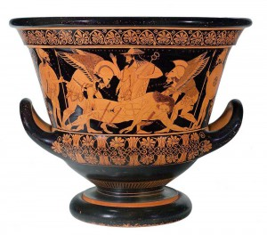**Stations Worksheet**

**Station 3/6**

What item does Zahi Hawass say he wants the British Museum to give to Egypt?

According to Neda Ulaby, what makes the legality of how these objects were taken difficult to pin down?

**Station 2/6**

Lauren Henry says that an object was “repatriated” to Italy. What country does she say it was originally from?

Russia (formerly the Soviet Union) took artifacts from Germany as restitution for damage done by Germany in World War II, but the items they took were not all from Germany in the first place. Who do you think should get the artifacts?

**Station 1/6**

Where is the vase originally from?

Who bought the vase?

To whom was the vase returned?

When the teacher says to begin, turn over the document on your table. On your own, read the document, and then work with your partners to answer the questions.

When the teacher calls time, move clockwise to the next artifact. You will have 5 minutes per station!

**Station 4/6**

What languages are on the Rosetta Stone?

What did the Rosetta Stone allow researchers to translate for the first time?

How did the British get the Rosetta Stone?

**Station 5/6**

Where are the Maqdala treasures from?

How did the British get them?

The Victoria and Albert Museum (in Britain) offered to return the treasures to Ethiopia “on loan”. Do you think a loan is fair? Why?

**Station 6/6**

Where did the birds come from?

What countries did they go through before being returned?

The last remaining bird is in a museum in Cape Town, South Africa, which is dedicated to British imperialist Cecil Rhodes. Do you think it should be returned? Why?