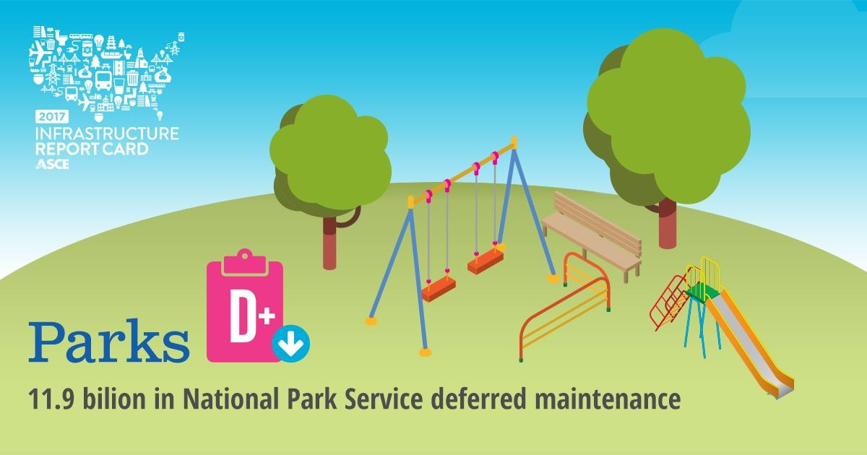

OVERVIEW
A vast network of infrastructure goes into supporting more than seven billion outdoor recreational outings. Americans enjoy park and recreation facilities maintained by entities at all levels of government. At the federal level, the National Park Service, U.S. Forest Service, and U.S. Army Corps of Engineers are the main providers of park facilities. States and localities provide the bulk of park and recreational facilities that seven in 10 Americans use on a regular basis. National forests and grasslands capture and filter drinking water for 180 million people. America’s parks and public lands also support industries such as lodging, restaurants and bars, grocery and convenience stores, and gas stations.

CONDITION & CAPACITY
A vast network of infrastructure goes into supporting more than seven billion outdoor recreational outings. Roads, bridges, trails, campsites, boat ramps, and other facilities help facilitate interaction with our public lands and access to the outdoors. The National Park Service (NPS) alone manages more than
75,000 constructed assets. The U.S. Army Corps of Engineers (USACE) ranks among the top federal
providers of outdoor recreation, hosting approximately 370 million visitors annually at 403 lake and river projects in 43 states. NPS welcomed 307.2 million visitors in 2015 and national forests and grasslands hosted 161 million visits in 2012. Our national wildlife refuges accommodated nearly 47 million visitors
in 2014. All of these parks require roads, trails, parking areas, and other facilities to make them accessible. Maintenance and investment keep the infrastructure safe and capable of meeting the demand of a growing population.

America’s parks and public lands also support numerous industries within our economy – lodging, restaurants and bars, grocery and convenience stores, gas stations, and other retailers. In 2015 NPS visitors spent $16.9 billion in communities within 60 miles of a park. Their spending supported 295,000 jobs that produced a payroll of $11.1 billion. U.S. Forest Service lands support more than 205,000 jobs

associated with recreation and wildlife visitor use. Their visitors contribute $11 billion to the economies of mostly rural, gateway communities each year.

Capital spending by local and regional public park agencies in the U.S. generated nearly $59.7 billion in economic activity and supported 340,000 jobs in 2013. The more than 6,600 state park sites constitute less than a quarter of national acreage, but see two and a half times as many visitors on an annual basis—nearly 759 million visits in 2015. The average local park and recreation agency provides 9.5 acres of park land for every 1,000 residents. 29% of American households reported using their local park frequently in 2015 and 47% reported frequenting occasionally.

These lands, historical parks and cultural sites, monuments, battlefields, and recreational areas play other critical roles in American life. National forests and grasslands capture and filter drinking water for
180 million people in over 68,000 communities. It’s estimated that the value of water flowing from U.S. Forest Service lands is $7.2 billion annually. Major U.S. cities like Los Angeles, Portland, Denver, and Atlanta receive a significant portion of their water supply from national forests.

INVESTMENT AND FUNDING
The 2016 centennial of the National Park Service helped shine a light on the infrastructure needs and
crowded facilities in our national parks. In 2015 NPS reached a record-high of $11.9 billion in deferred maintenance, which NPS defines as “maintenance that was not performed at the required intervals to ensure an acceptable facility condition to support the expected life cycle of an asset.” $5.97 billion of the deferred maintenance is for paved roads and structures including bridges, tunnels, and paved parking areas. The remaining $5.95 billion in deferred maintenance includes unpaved parking areas, unpaved roadways, utility systems, dams, constructed waterways, marinas, aviation systems, railroads, ships, monuments, fortifications, towers, interpretive media, and amphitheaters.

NPS classifies $2.38 billion of these other facilities as highest priority non-transportation facilities. This is a total increase of $434.2 million in total deferred maintenance over the year before and an increase of over a billion dollars in deferred maintenance in paved roads and structures since 2013.

At other federally owned and operated parks, the situation is similar. The USACE manages 12 million acres of lands and waters that are available for a wide variety of recreational activities. Visitation has steadily increased in recent years, and this upward trend is likely to continue; 90% of USACE lakes and rivers with recreation areas are located within 50 miles of a metropolitan area. Visitors to USACE facilities spend $13 billion annually and support 187,000 jobs. The majority of USACE recreation facilities are over 50 years old and require upkeep to meet visitor health and safety standards. The USACE continually evaluates recreation area operations to maintain or improve cost efficiency in operations.

At the Forest Service, budgets are being squeezed by the need to focus more financial resources on wildfire suppression. At the close of FY2015, the Forest Service reported a $5.1 billion maintenance backlog, including deferred maintenance for roads, trails, buildings, water systems, and fences, among other categories. Since then, deferred maintenance totals have likely grown, because for the first time in the agency’s history, more than half of its budget is being consumed by spending related to wildfires.

Investment in outdoor recreation facilities will continue to be impacted as more and more development encroaches into areas at risk from wildfire.

It's not just national parks that face significant budget shortfalls; Since the 1990s, general fund support for stake parks has steadily declined. States have undertaken various strategies to fill the gap, including increasing user feels for park entrance, camping and lodging, and recreational activities, as well as privatizing certain park operations. However, these financing strategies are insufficient to address the significant backlog of critical infrastructure projects. Conservative estimations indicate deferred maintenance in state parks totals more than $95.3 billion.

There has been some progress in addressing the chronic underfunding of our park and recreation infrastructure over the past few years. Congressional appropriations to NPS increased 7.5% over the last
10 years, after adjusting for inflation. For state parks, total operational capital expenditures grew 25.3%, or $159 million, in 2016. These gains were often a result of increased general fund allocations or dedicated bonds, both made possible by a recovering economy.

The federal transportation bill, Moving Ahead for Progress in the 21st Century Act (MAP 21) established the Federal Lands Transportation Program (FLTP) to supplement the deferred maintenance budget typically provided through discretionary appropriations. It provided $240 million to NPS and $30 million to be allocated competitively to the Forest Service, Corps, and Bureau of Land Management. FLTP was reauthorized under the most recent federal transportation bill, the Fixing America’s Surface Transportation (FAST) Act, in December of 2015. The NPS receives an annual sum each year through the FAST Act and is expected to receive a total of $1.4 billion between FY16-FY2020. The U.S. Forest Service will also receive an annual sum for a total investment of $85 million. The Corps will compete with the Bureau of Land Management, Bureau of Reclamation, and other independent federal agencies with natural resource and land management responsibilities for an additional $120 million available through FLTP.

In December of 2016, Congress passed the National Park Service Centennial Act (H.R. 4680). This legislation establishes the National Park Centennial Challenge Fund (NPCCF) that requires a one-to-one match of federal and private funds, directs the National Parks Foundation to create A Second Century endowment, and focuses NPCCF investment on an identified list of signature projects and programs eligible for funding, while prioritizing deferred maintenance, physical improvements to visitor services facilities, and trail maintenance.

There are also lessons to be learned from our state parks. Utah and South Carolina are adding new recreational infrastructure to spur increased revenue. Michigan and Idaho have increased revenues by offering year-round passes at their Department of Motor Vehicles. By increasing their access to potential customers, Michigan has seen a 30% increase in year-round pass revenue despite decreasing the cost of the pass from $24 to $10 for a license plate access sticker.

SOLUTIONS TO RAISE THE GRADES
• Charge appropriate user fees at the local, state, and federal levels and allowing those agencies to use all collected user fees to support maintenance, operations and enhancements to their park systems.

• Encourage communities who benefit economically from parks and public lands investment to also invest in their maintenance.
• Reauthorize and fully fund the Land and Water Conservation Fund to support acquisition of land and easements on land at the federal, state, and local levels.
• Increase appropriations for the National Park Service, the U.S. Army Corps of Engineers, the U.S.
Forest Service, and other federal providers of recreational facilities to address maintenance backlogs.
• Leverage partnerships between the National Park Service and other recreation facilities operators and private groups to better utilize facilities and compensate for usage.
• Enact legislation to permit the U.S. Army Corps of Engineers to retain all collected recreation fees for
use at its facilities.
• Renegotiate franchise fees with concessionaires of park and recreation facilities to increase return to support operation and maintenance of facilities.
• Conservation and recreation advocates should collaborate and cooperate to benefit public interest in both conservation and recreation.

SOURCES
American Recreation Coalition, “Outdoor Recreation Outlook 2017,” 2016,
http://www.funoutdoors.com/files/Outdoor%20Recreation%20Outlook%202017.pdf

Congressional Research Service, “Deferred Maintenance of Federal Land Management Agencies: Fy2005-2014 Estimates,” April 21, 2015, http://naturalresources.house.gov/uploadedfiles/deferredmaintenance.pdf.

Congressional Research Service, “National Park Service: Fy2017 Appropriations and Recent Trends,”
August 2, 2016, https://fas.org/sgp/crs/misc/R42757.pdf.

National Association of State Park Directors, “Statistical Report of State Park Operations: 2014-2015,” June 30, 2015, https://cnr.ncsu.edu/news/wp-content/uploads/sites/10/2016/05/NASPD-AIX-2014-15- Data-Report-Final-copy.pdf.

National Park Service, “NPS Deferred Maintenance Repots”,
https://www.nps.gov/subjects/plandesignconstruct/defermain.htm

National Park Visitor Spending Effects, Economic Contributions to Local Communities, States, and the
Nation. April 2016, pg 8, 27 July 2016, https://www.nps.gov/subjects/socialscience/vse.htm.

National Recreation and Park Association, “The Economic Impact of Local Parks: An Examination of the
Economic Impacts of Operations and Capital Spending on the United State Economy”,

The Outdoor Foundation, “Outdoor Recreation Participation Topline Report 2016”, 2016, pg 1, 20 July
2016, http://www.outdoorfoundation.org/pdf/ResearchParticipation2016Topline.pdf.

Paying for State Parks, “Evaluating Alternative Approaches for the 21st Century,” January 2013.

The Pew Charitable Trusts, Research & Analysis, Stateline, “State Parks Find New Ways to Save, Make Money”, 14 April 2016, http://www.pewtrusts.org/en/research-and- analysis/blogs/stateline/2016/04/14/state-parks-find-new-ways-to-save-make-money.

Resources for the Future, “Parks and Recreation in the United States,” June 2009.
http://www.rff.org/files/sharepoint/WorkImages/Download/RFF-BCK-ORRG_State%20Parks.pdf

US Corps of Engineers, 21 July 2016. http://asacw.hqda.pentagon.mil/Recreation.aspx.

U.S. Department of Agriculture, U.S. Forest Service, “A Forest if the Edge Report, Paths More Traveled: Predicting Future Recreation Pressures on America’s National Forests and Grasslands”, June 2015, pg 3,
21. July 2016,
http://www.fs.fed.us/sites/default/files/legacy_files/media/types/publication/field_pdf/paths-more- traveled-final-9-28-15.pdf.

U.S. Department of Agriculture, U.S. Forest Service, “Fiscal Year 2017 Budget Overview”, February 2016,
pg 6, http://www.fs.fed.us/sites/default/files/fy-2017-fs-budget-overview.pdf.

U.S. Department of Agriculture, U.S. Forest Service, “Water Facts”, 21. July 2016,
http://www.fs.fed.us/managing-land/national-forests-grasslands/water-facts

U.S. Department of the Interior, National Park Service, National Resources Stewardship and Science, “2015 National Park Visitor Spending Effects, Economic Contributions to Local Communities, States, and the Nation. April 2016, pg 8, 27 July 2016, file:///C:/Users/bray/Downloads/NPS%20VSE%202015_%20FINAL.pdf.

U.S. Department of the Interior, National Park Service, National Park Service Overview, 21 July 2016, https://www.nps.gov/aboutus/upload/NPS-Overview-04-12-16.pdf.

U.S. Department of the Interior, U.S. Fish & Wildlife, “2017 Budget Justification and Performance Information Fiscal Year 2017”, pg EX-1, 23 September 2016, https://www.fws.gov/budget/2016/FY2017_FWS_Greenbook.pdf.

U.S. DOT, The Federal Highway Administration, “The Federal Lands Highway Program Factsheet”, pg 1,
25 July 2016, https://flh.fhwa.dot.gov/programs/fltp/documents/fltp-fact-sheet.pdf

U.S. Forest Service, Budget & Performance, What the Budget Supports, 27 July 2016, http://www.fs.fed.us/about-agency/budget-performance.

