The US-Iran Standoff Gallery Walk

Directions: To start, chose an image that is hung around the room that interests them. Examine the picture; looking at the setting, the people or objects, and any other important details. Answer the questions related to the image. After answering the questions, move on to an image with the fewest number of students.

Document A: Anti-America graffiti in Tehran, Retrieved from http://origins.osu.edu/sites/origins.osu.edu/files/450px-Anti-US_Tehran.jpg
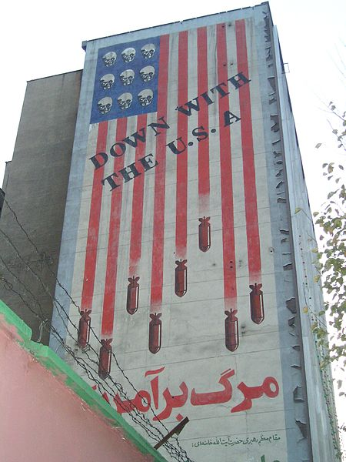

Document B: Coup d’état, Retrieved from
http://origins.osu.edu/sites/origins.osu.edu/files/Operationajax.jpg

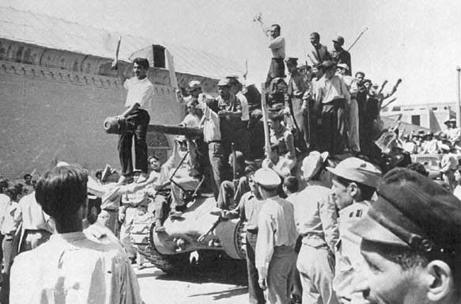

Document C: Iran U.S. cooperation, Retrieved from
http://origins.osu.edu/sites/origins.osu.edu/files/800px-The_Shah_with_Atherton%2C_Sullivan%2C_Vance%2C_Carter_and_Brzezinski%2C_1977.jpg

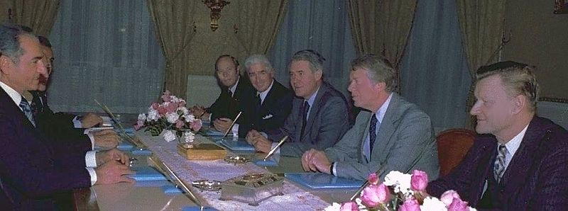

Document D: Protests in Iran, Retrieved from http://origins.osu.edu/sites/origins.osu.edu/files/800px-%D8%A7%D8%B9%D8%AA%D8%B1%D8%A7%D8%B6_%D9%85%D8%B1%D8%AF%D9%85_%D8%A7%D9%86%D9%82%D9%84%D8%A7%D8%A8%DB%8C.JPG
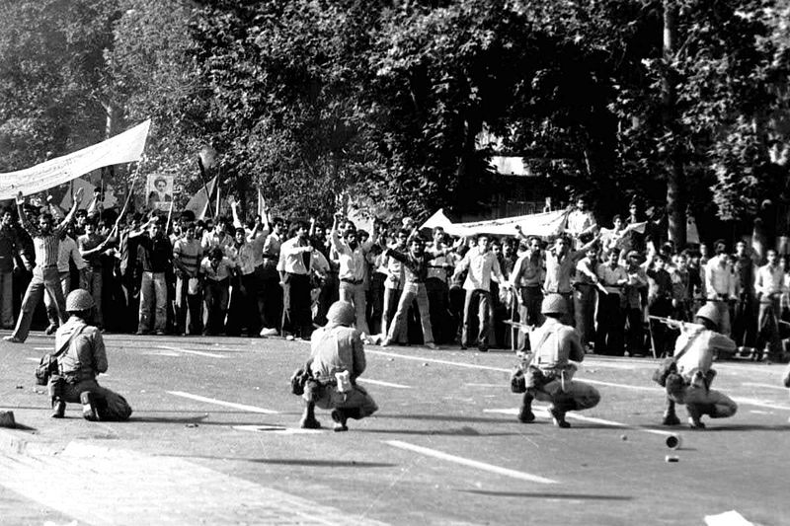

Document E: Nuclear Power advertisement, Retrieved from http://origins.osu.edu/sites/origins.osu.edu/files/Shah_of_Iran_building_two_nuclear_plants.jpg

