Jigsaw Worksheet

In your expert group read and review your assigned monument/memorial.

Monument/Memorial name:

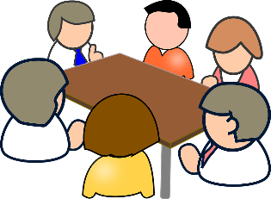
In your Jigsaw group, make notes about the monuments/memorials that others share in your group. Write down at least 1 (one) important note about each person’s monument/memorial.

Make an original argument or observation about monuments and memorials, based on the discussion you have with your Jigsaw group. This goes beyond just what you have written down for your questions. What did you talk about?

In my jigsaw group, we talked about…

Based on what I learned in this activity about monuments and memorials, I think that…
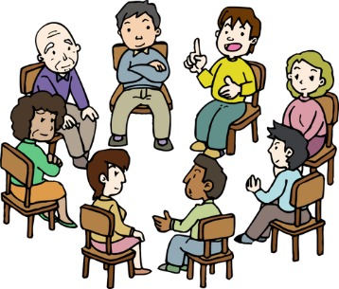

Exit Ticket: What is one new insight or perspective that you have gained from today’s activity?
One new insight/perspective that I gained today is…

