Sources The Black Fists Protest

Document A: Harry Blutstein, Quora, https://www.quora.com/What-was-the-international-reaction-to-the-Black-Power-salute-in-the-1968-Olympics

“The Los Angeles Times accused Smith and Carlos of a ‘Nazi-like salute.’ The Chicago Tribune called the act ‘an embarrassment visited upon the country,’ an ‘act contemptuous of the United States,’ and ‘an insult to their countrymen.’”

“Brent Musburger disparaged the protest, saying: ‘Smith and Carlos looked like a couple of black skinned storm troopers, holding aloft their black gloved hands during the playing of the National Anthem. It's destined to go down as the most unsubtle demonstration in the history of protest.... and it insured maximum embarrassment for the country that picked up their room and board bill in Mexico.‘”

“Pete Axthelm, writing in the New York magazine, wrote that ‘[i]f Americans chose to be ashamed of the defiant fist that Carlos raised in Mexico City, they may want to be equally ashamed and concerned about the system that molded and prepared him for that moment.’”

“The argument that politics should not intrude on the Olympic Games was refuted by Tommie Smith on his return to the US in front of 1,500 students at San Jose State. ‘They expelled us from the village and the team, but did they take away our medals from the total count? No. They wanted those medals in the count because of the power and prestige they bring. Now the United States is ahead of Russia.’ So while racial politics was a no-go zone for the Olympics, weaponizing the Olympic Games for political advantage in the Olympic Games was fine with the USOC.”

Document B: “The black fist of our time:’ The story behind a viral Colin Kaepernick cartoon” Dakin Andone, CNN, https://www.cnn.com/2017/09/04/us/colin-kaepernick-khalid-albaih-cartoon-trnd/index.html

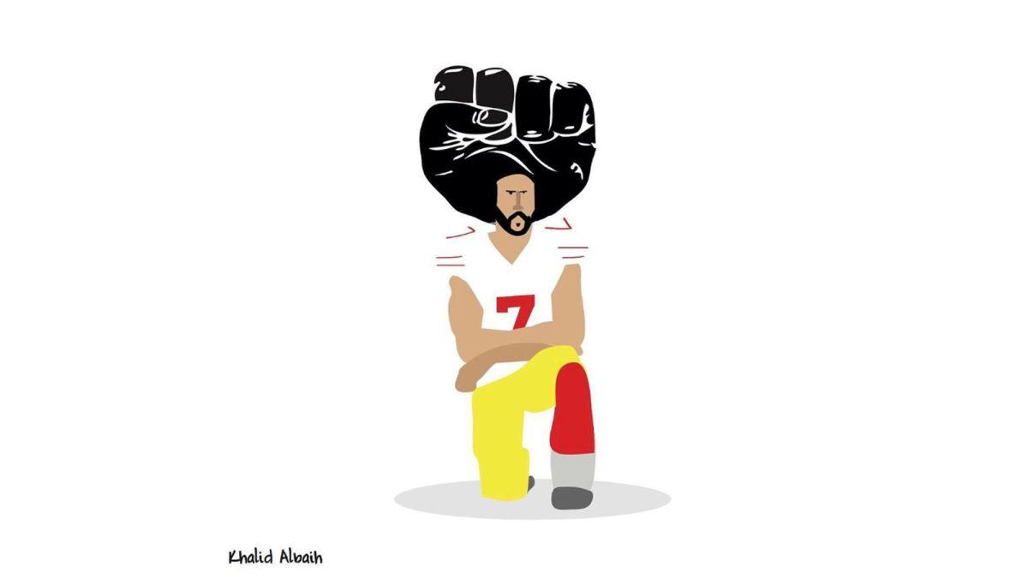

Document C: “Kaepernick’s Knee and Olympic Fists Are Linked by History,” The New York Times, https://www.nytimes.com/2018/09/06/sports/kaepernick-nike-kneeling.html

See below
