Historical Circumstances of Policy Brutality in the U.S. – Stations Activity *

Document A: “If We Must Die”
Claude McKay's Early Poetry (1911-1922): If We Must Die. Claude McKay's Early Poetry (1911-1922): A Digital Collection. (n.d.). Retrieved February 27, 2022, from https://scalar.lehigh.edu/mckay/if-we-must-die

If we must die, let it not be like hogs
Hunted and penned in an inglorious spot,
While round us bark the mad and hungry dogs,
Making their mock at our accursed lot.
If we must die, O let us nobly die,
So that our precious blood may not be shed
In vain; then even the monsters we defy
Shall be constrained to honor us though dead!
O kinsmen! we must meet the common foe !
Though far outnumbered let us show us brave,
And for their thousand blows deal one death-blow!
What though before us lies the open grave?
Like men we’ll face the murderous, cowardly pack,
Pressed to the wall, dying, but fighting back!

Document B: 1964 A protest outside the UN Headquarters in New York City, during a period of rioting
Johnson, D. (n.d.). The Gilligan Case: Police Brutality &amp; Civil Rights in Harlem. PBH. Retrieved February 27, 2022, from https://www.picturingblackhistory.org/the-gilligan-case

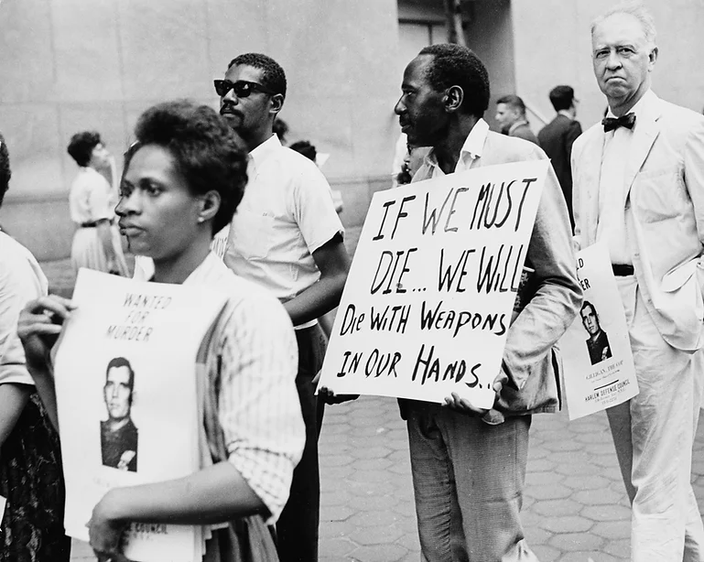

Document C: 1964 Jury's Exoneration of Gilligan Scored by Negro Leaders
The New York Times. (1964, September 2). Jury's exoneration of Gilligan scored by Negro leaders. The New York Times. Retrieved February 27, 2022, from https://www.nytimes.com/1964/09/02/archives/jurys-exoneration-of-gilligan-scored-by-negro-leaders.html

Negro leaders were highly critical yesterday of the grand jury's report that there was no basis for action against Police Lieut. Thomas R. Gilligan in the fatal shooting of a Negro boy.

Their remarks were tempered in many cases by a fear that strong statements might tend to provoke new outbreaks in Harlem, like the ones that followed the shooting.

James Farmer, national director of the Congress of Racial Equality, said that. CORE would issue its own report within 48 hours.

“CORE is astonished-that the grand jury, with the Compliance of the District Attorney's office, has seen fit to exonerate a 200-pound police lieutenant in the slaying of a 122-pound Negro youngster,” Mr. Farmer said.

He said that the District Attorney's own report “gives more than sufficient ground for a court hearing of the entire incident.”

Roy Wilkins, executive secretary of the National Association for the Advancement of Colored People, said the grand jury had failed to take into account “the morality of the act.”

New York Negroes, Mr. Wilkins said, “remain convinced that an experienced police officer should be able to arrest a 15-year-old boy without killing him.” It does not, he said, “enhance the standing of the law enforcement process or of the Police Department in the Negro community, which is constantly called upon to respect law and order while being given many plain indications that the law as enforced has scant regard for their rights.”

Mr. Wilkins added: “They can explain and explain until they're blue in the face, but they'll never explain why it's necessary for a police officer to shoot a 15-year-old kid.”

“It just doesn't go down," he said.

The Rev. Richard Hildebrand, pastor of the Bethel African Methodist Church, 60 West 132d Street, the head of the local N.A.A.C.P. chapter, called the grand jury action “about what we could expect.”
“These grand juries have a long record of exoneration of police officers accused of brutality against Negroes,” he said.

In Harlem the news of the grand jury action had not reached most citizens by late afternoon. But in one barber shop, a Negro man, told of the report, shrugged his shoulders and said: “What else did you expect?”

Document D: A policeman wields a billy club against youths African American during night of riots in Harlem, New York. (1964). photograph, Harlem, New York, from https://www.gettyimages.com/detail/news-photo/policeman-wields-a-billy-club-against-youths-african-news-photo/880085960

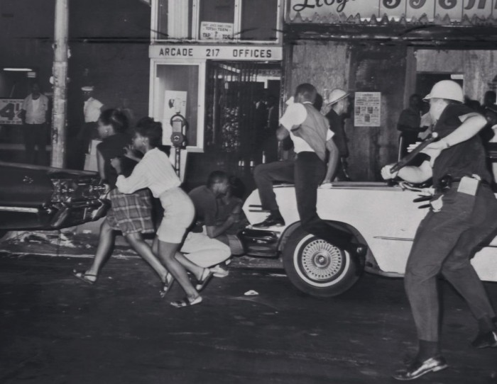
Document E: 2021 Newspaper Article
The New York Times. (2021, May 21). 'We Still Aren't Safe': 6 Young Americans on George Floyd's Death. The New York Times. Retrieved February 27, 2022, from https://www.nytimes.com/2021/05/21/opinion/young-americans-race-blm.html

The nationwide protests that followed George Floyd’s death last May hinted at a possible turning point in the way many Americans confront issues of racial injustice. How much has really changed, though?

Times Opinion asked young readers about how the protests affected their approach to social justice, politics and life in general and what changes they’ve seen, if any, in their communities. Many who responded said the video of Mr. Floyd’s murder awoke them to the reality of racial inequity in the United States and set them on a path of self-education and activism. But for some, those actions seemed fleeting.

“Even though millions of people committed to racial justice last summer, my neighborhood still struggles with the same issues it did before the protests, the same issues it faced decades ago when my grandparents were my age,” wrote Caleb Dunson, an 18-year-old reader in Chicago.

Below, Mr. Dunson and five others tell us how the experience influenced their thinking over the past year. Their comments have been edited for length and clarity.

‘My anger has gotten deeper, more nuanced and more directed’:
As a young Indigenous woman, George Floyd’s death and the conversations that followed were brutal reminders of the pervasive nature of anti-Black sentiment in places like my home state, Montana.

Sometimes it feels like a game of catch-up, people of color standing at the finish line of humanity and basic rights while white people take their time debating how best to word their diversity mission statements, how to best deal with a murderous cop.

‘The trauma loop never stops, but I can’:
I was 17 when Trayvon Martin was killed and I stayed up to watch that verdict. I thought for sure that George Zimmerman would be found guilty — how could he not? I was so naïve. It was at that moment that I realized America is not safe for Black people like myself. Now, at 27, Derek Chauvin’s murder of George Floyd solidifies what I already knew: Black people are under threat every time they come into contact with an agent of white supremacy, which is often the police.

‘Our deaths only matter if they can provoke an emotional response from white Americans’:
George Floyd’s death has made me resent the power that white people have to define justice in our society. Black Americans have been getting murdered by the police and vigilantes for as long as this country has existed, and yet it feels like our deaths only matter if they can provoke an emotional response from white Americans. This time around, it took a nine-minute video of a Black man’s brutal killing to elicit that response.

Document F: Yucel, K. (2020). Protesters hold signs outside the Minneapolis 1st Police precinct during a demonstration against police brutality and racism. photograph, Minneapolis, Minnesota, from https://www.gettyimages.com/detail/news-photo/protesters-hold-signs-outside-the-minneapolis-1st-police-news-photo/1228190289

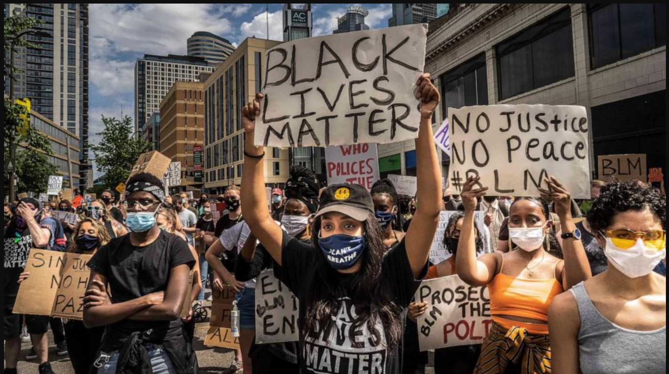

Document G: Art by Brionya J. Matthews
Art & Protest: Creatives respond to racism &amp; police brutality. V Magazine. (2020, June 5). Retrieved February 27, 2022, from https://vmagazine.com/article/art-protest-creatives-respond-to-racism-police-brutality/

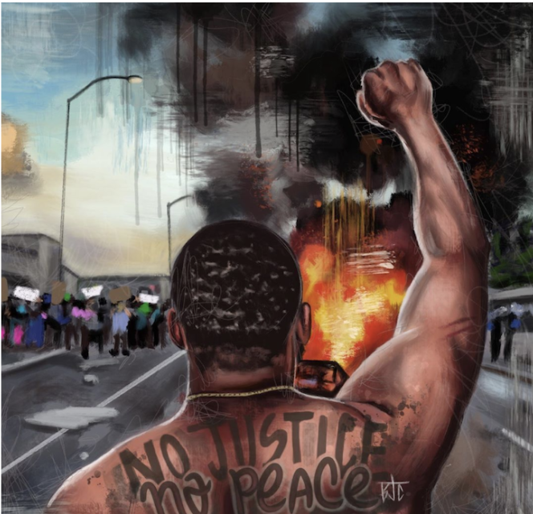

Document H: Art by Andrew Dat Tran
Estiler, K. (2020, June 12). How artists are responding to U.S. protests over police brutality and racism. HYPEBEAST. Retrieved February 27, 2022, from https://hypebeast.com/2020/6/blacklivesmatter-protest-artworks-george-floyd-breonna-taylor-ahmaud-arbery

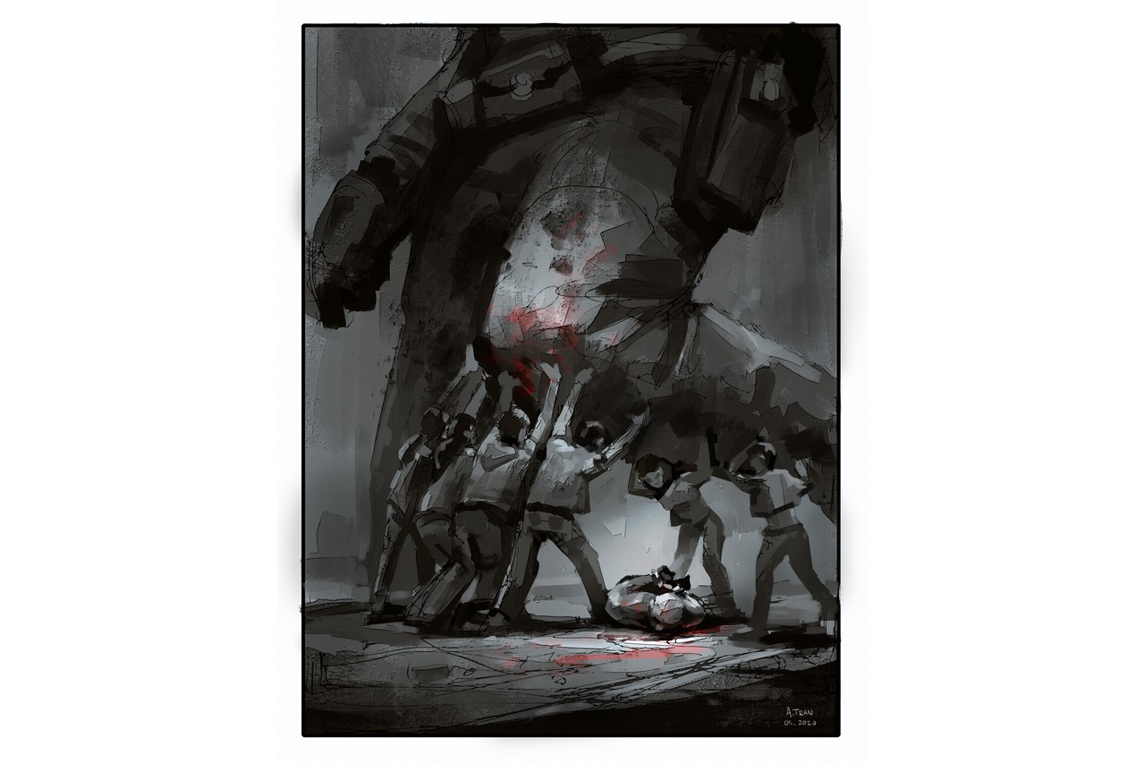

Document I: John Lewis
Pt. 1 - Frausto, R. (2020). John Lewis Portrait. FineArtAmerica. Retrieved February 27, 2022, from https://fineartamerica.com/featured/john-lewis-portrait-rick-frausto.html.
Pt. 2 - Schuessler, J. (2015, February 15). Spider Martin's Photographs of the Selma March Get a Broader View. The New York Times. Retrieved February 27, 2022, from https://www.nytimes.com/2015/02/16/arts/design/spider-martins-photographs-of-the-selma-march-get-a-broader-view.html

