Document A: African Americans and the New Deal
Most New Deal programs discriminated against Blacks. The National Recovery Administration, for example, not only offered whites the first crack at jobs, but authorized separate and lower pay scales for Blacks. The Federal Housing Authority (FHA) refused to guarantee mortgages for Blacks who tried to buy in white neighborhoods, and the Civilian Conservation Corps maintained segregated work camps. Furthermore, the Social Security Act excluded those job categories Blacks traditionally filled.

Even more galling to Black leaders, the president failed to support an anti-lynching bill and a bill to abolish the poll tax. Roosevelt feared that conservative southern Democrats, who had seniority in Congress and controlled many
committee chairmanships would block his bills if he tried to fight them over civil rights issues.

Source: This excerpt is from the Digital History online textbook.

Vocabulary
mortgage: a loan to buy a house galling: irritating

Document B: A Conservative Critic of the New Deal
New Deal programs were financed by tripling federal taxes from $1.6 billion in 1933 to $5.3 billion in 1940. Excise taxes, personal income taxes, inheritance taxes, corporate income taxes, holding company taxes, and so-called “excess profits” taxes all went up.
Higher business taxes meant that employers had less money for growth and jobs. Social Security excise taxes on payrolls made it more expensive for employers to hire people, which discouraged hiring.
What about the good supposedly done by New Deal spending programs? These didn’t increase the number of jobs in the economy, because the money spent on New Deal projects came from taxpayers who consequently had less money to spend on food, coats, cars, books, and other things that would have stimulated the economy. This is a classic case of the seen versus the unseen — we can see the jobs created by New Deal spending, but we cannot see jobs destroyed by New Deal taxing.
Source: Jim Powell, senior fellow at the Cato Institute, a conservative think-tank, is author of FDR’s Folly, How Roosevelt and His New Deal Prolonged the Great Depression (Crown Forum, 2003).

Document C
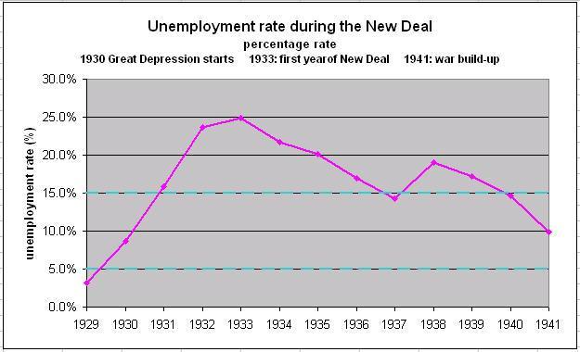  Today’s Unemployment Rate: Roughly 4% | 1. What was the unemployment rate in 1929 (before the Great Depression)?  2. What was the unemployment rate in 1933 (right before the New Deal)?  3. When the New Deal ended in 1938, what was the unemployment rate  4. Did the New Deal reduce unemployment levels to pre-Great Depression levels?
Document D  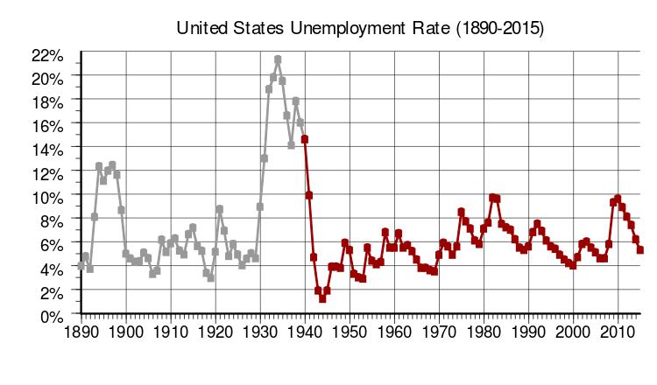 | 5. Comparing these two documents, what seems to be the bigger reason for the decline in the unemployment rate after the Great Depression:  1) the New Deal or 2) the US entering World War II in December of 1941?

Document E
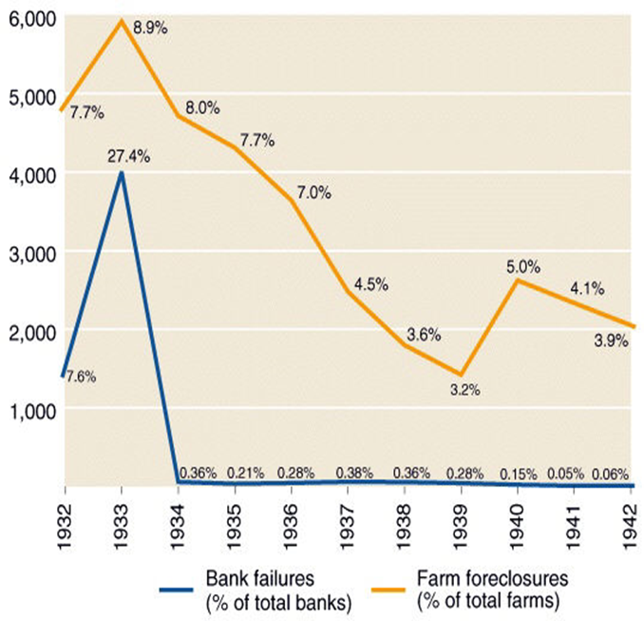 | 1. Was the New Deal (began in 1933) successful in reducing the number of bank failures?  2. Name 2 New Deal programs that reformed the U.S. banking system after the Great Depression.  -  -  3. Was the New Deal (began in 1933) successful in reducing farm foreclosures?  4. Name 1 New Deal program that helped farmers.  -

