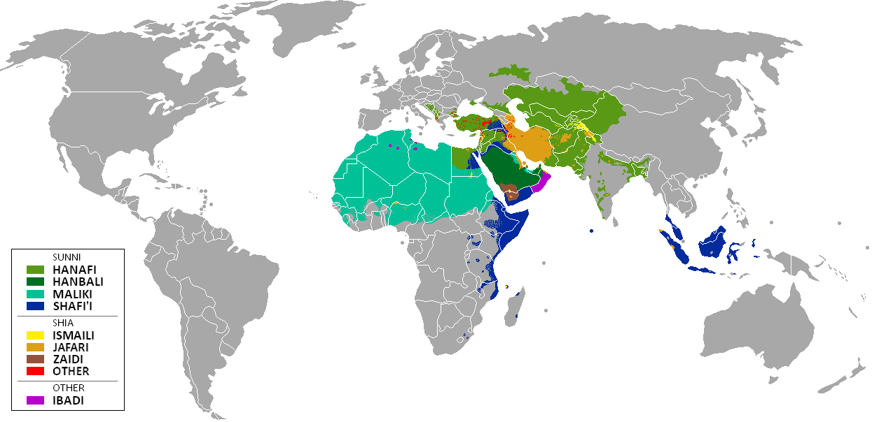
Sunni and Shia Today

This is the map you looked at during the Gallery Walk. Colored parts of the world are majority Muslim. Shades of Green and Blue cover places that are different schools of Sunni. Shades of Yellow, Brown, and Red mark different branches of Shia Islam.
- Circle on the map where most Shia live.

- What is the main difference between Sunni and Shia?

- Sunni believe that the leader should be chosen by the _______________.

- Shia believe that the leader should come from Muhammad’s _____________.

- Is this a political difference, a religious difference, or both? Why?

- How might this difference have helped Sunni Islam spread more widely than Shia Islam?

