Source Packet: Use these sources for documents for the Gallery Walk

Document A: Sahih al-Bukhari, Sahih al-Bukhari, Vol. 1, Book 2, Hadith 48

Narrated by Abu Huraira, one of the Prophet's closest Sahabah:

One day while the Prophet was sitting in the company of some people, (The angel) Gabriel came and asked, "What is faith?" Allah's Messenger replied, 'Faith is to believe in Allah, His angels, (the) meeting with Him, His Apostles, and to believe in Resurrection." Then he further asked, "What is Islam?" Allah's Messenger replied, "To worship Allah Alone and none else, to offer prayers perfectly, to pay the compulsory charity (Zakat) and to observe fasts during the month of Ramadan." Then he further asked, "What is Ihsan (perfection)?" Allah's Messenger replied, "To worship Allah as if you see Him, and if you cannot achieve this state of devotion then you must consider that He is looking at you." Then he further asked, "When will the Hour be established?" Allah's Messenger replied, "The answerer has no better knowledge than the questioner. But I will inform you about its portents.

When a slave (lady) gives birth to her master.
When the shepherds of black camels start boasting and competing with others in the construction of higher buildings. And the Hour is one of five things which nobody knows except Allah.
The Prophet then recited: "Verily, with Allah (Alone) is the knowledge of the Hour--." (31. 34) Then that man (Gabriel) left and the Prophet asked his companions to call him back, but they could not see him. Then the Prophet said, "That was Gabriel who came to teach the people their religion." Abu 'Abdullah said: He (the Prophet) considered all that as a part of faith.

Document B: Furu’ al-Din (Ancillaries of the Faith), Furu' al-Din. (n.d.). Retrieved February 10, 2020, from http://en.wikishia.net/view/Furu'_al-Din

Document C: Map of Shia and Sunni Countries, Peaceworld111. (2015, January 11).
Madhab Map3.png. Retrieved February 10, 2020, from https://commons.wikimedia.org/wiki/File:Madhhab_Map3.png
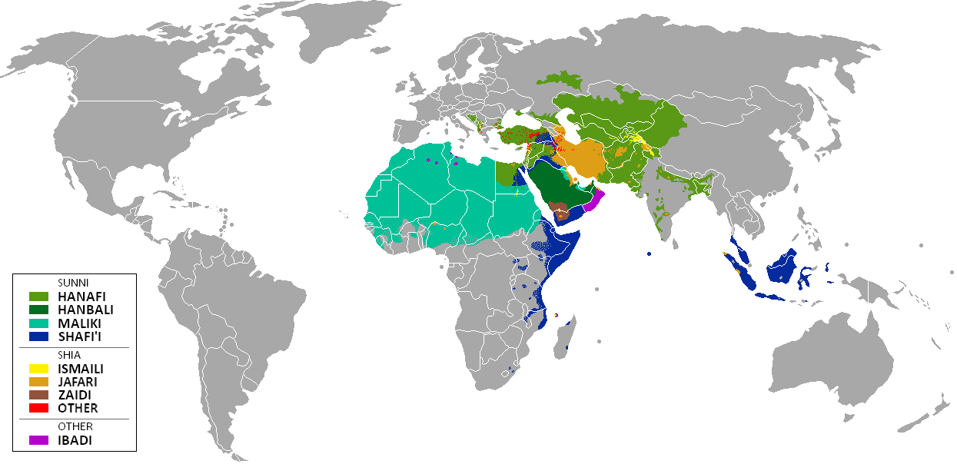

Document D: “Mawla” Wiktionary Entry, مولى. (n.d.). Retrieved from https://en.wiktionary.org/wiki/مولى#Arabic

Document E: The Hadith of the Wilayah, Ghadir Khum Part 1. (2013, November 12). Retrieved from https://www.al-islam.org/shiite-encyclopedia/ghadir-khum-part-1

The Messenger of Allah declared: "It seems the time approached when I shall be called away (by Allah) and I shall answer that call. I am leaving for you two precious things and if you adhere both of them, you will never go astray after me. They are the Book of Allah and my progeny, that is my Ahlul-Bayt. The two shall never separate from each other until they come to me by the Pool (of Paradise)."
Then the Messenger of Allah continued: "Do I not have more right over the believers than what they have over themselves?” People cried and answered: "Yes, O’ Messenger of God.” Then Prophet (S) held up the hand of ‘Ali and said: "Whoever I am his leader (Mawla), ‘Ali is his leader (Mawla). O’ God, love those who love him, and be hostile to those who are hostile to him."

Document F: Battle of Karbala, By Abbas Al-Musavi. - File:Brooklyn Museum - Battle of Karbala - Abbas Al-Musavi - overall.jpg- Online Collection of Brooklyn Museum, Public Domain, https://commons.wikimedia.org/w/index.php?curid=79802133

