Westward Expansion & Imperialism Sources Analysis: Sources

Document A: 1835 Land Advertisement, (n.d.) retrieved from: ://en.wikipedia.org/wiki/History_of_South_Australia

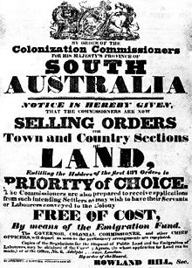

Document B: Dawes Act Advertisement, (n.d.) Retrieved from: https://www.thoughtco.com/dawes-act-4690679

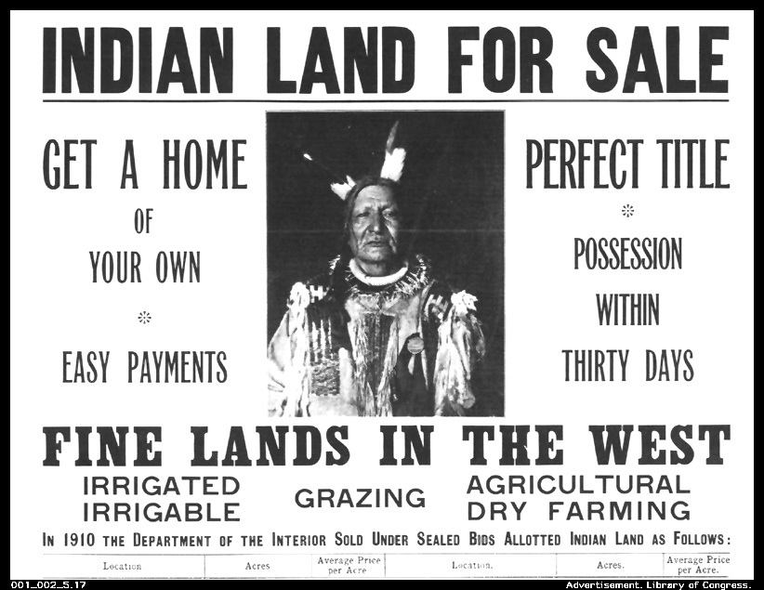

Document C: Canadian land advertisement, (Neylan) Retrieved from: http://origins.osu.edu/article/canada-s-dark-side-indigenous-peoples-and-canada-s-150th-celebration/page/0/0

