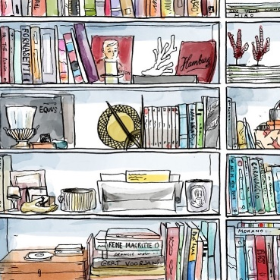
Timee it Was- Stations Worksheet Differentiated
Directions: Go from station to station and at each station look at the document provided for that station. Spend about 5-10 minutes at each station to analyze the document and answer the questions which correspond to each document

Station 1/4 Activity/Questions
- Examine Document C and analyze how each group is standing in the picture, who seems to be in power here?
Power is being held by…

- How old do these protesters look?
These protesters look to be about…

- How can you compare this to other stations you’ve looked at?
Both this station and source D and E show…

Station 2/4 Activity/Questions
- Examine Document D, and analyze the picture. What is the attitude of each group in the picture?
The protestors seem________________ while the police seem…___________________

- What do you think is being symbolized by the protesters putting flowers in the soldiers’ guns?
It is symbolizing…

- How can we draw comparisons between this picture and other stations?
This picture is showing similar themes as…

Station 3/4 Activity/Questions
- Examine Document E, who has the power in this picture?
Power is being held by…

- How does this picture show violence against protesters?
The picture shows this violence by…

- How does this document compare to the other stations?
This document shows similar themes as…

Station 4/4 Activity/Questions
- Examine Document F, what was the conclusion of this report?
The conclusion of the report was that…

- What is the commission’s view on violence in the society?
The commission viewed violence in a society was…

- Who created the ghetto?
The ghetto was created by…

- What parallels can you draw between this report and the other stations?
This report has similar themes as…

