Stations Worksheet Influenza Pandemics Now, Then, and Again
Move around the room and use the sources at each station to answer the questions below. In Station 1 you will find sources about the 1918 Spanish Flu. In Station 2 you will find sources about the 1980s AIDS epidemic. And in Station 3 you will find sources about the 2020 COVID-19 Pandemic. Analyze the sources to complete this worksheet.
Station 2: 1980s AIDS Epidemic Activity/Questions
- What differences do we see between the way Reagan’s administration dealt with the AIDS epidemic and the way Princess Diana dealt with it?

- What do you think the goal of each side in these sources was?

Station 1: 1918 Spanish Flu Activity/Questions
- What did most countries believe was the most important thing in 1918? How can we tell this from the sources?

- It could also be a prompt to write a longer answer, with blank space below:

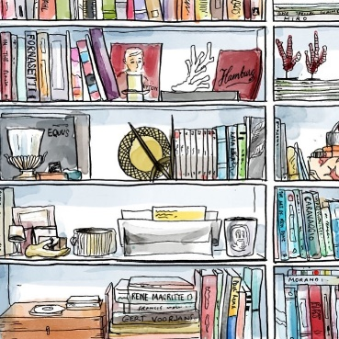
Station 3: 2020 COVID-19 Pandemic Activity/Questions
- Why do you think the Trump administration is not social distancing? How do you think this relates to what their goal is?

- Why do you think the task force from Singapore appears more concerned than the US?

