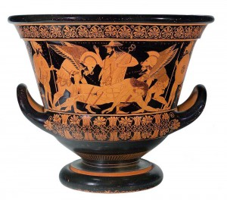**Stations Worksheet**

**Station 1/6**

Where is the vase originally from?

The vase is originally from _____________.

Who bought the vase?

The vase was purchased by the __________________ in New York City.

To whom was the vase returned?

The vase was sent to _____________.

When the teacher says to begin, turn over the document on your table. On your own, read the document, and then work with your partners to answer the questions.

When the teacher calls time, move clockwise to the next artifact. You will have 5 minutes per station!

**Station 2/6**

Lauren Henry says that an object was “repatriated” to Italy. What country does she say it was originally from?

She says that it was originally from __________.

Russia (formerly the Soviet Union) took artifacts from Germany as restitution for damage done by Germany in World War II, but the items they took were not all from Germany in the first place. Who do you think should get the artifacts?

I think that the artifacts should go to _________________________.

**Station 4/6**

What languages are on the Rosetta Stone?

______________, ______________ (the common language), and

_________________.

What did the Rosetta Stone allow researchers to translate for the first time?

____________________________

How did the British get the Rosetta Stone? The British took it from __________________.

**Station 3/6**

What item does Zahi Hawass say he wants the British Museum to give to Egypt?

He wants the ____________ ____________.

According to Neda Ulaby, what makes the legality of how these objects were taken difficult to pin down?

The objects were taken ______________________________.

**Station 6/6**

Where did the birds come from?

The birds are from an ancient city in ____________________.

What countries did they go through before being returned?

The birds went from Germany to _____________, back to

_____________, and then to __________________.

The last remaining bird is in a museum in Cape Town, South Africa, which is dedicated to British imperialist Cecil Rhodes. Do you think it should be returned? Why?

I think the birds should/shouldn’t (circle one) be returned because….

________________________________________________________________

________________________________________________________________.

**Station 5/6**

Where are the Maqdala treasures from?

The Maqdala treasures are from ______________ (formerly called Abyssinia).

How did the British get them?

The British took the treasures during a ____________.

The Victoria and Albert Museum (in Britain) offered to return the treasures to Ethiopia “on loan”. Do you think a loan is fair? Why?

I think that a loan is/is not (circle one) fair because…(write your reason below)

________________________________________________________.