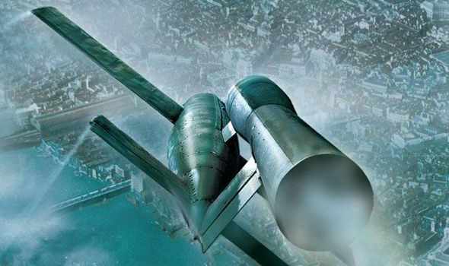
Military Drones Stations Worksheet
Directions:
For each station use the image to answer the first 2 questions. Then use the articles to answer the last 2 questions of each station. After completing all stations complete the historical analysis individually.
Station 1/Source 1

- Is this poster for or against the usage of military drones? Support your answer with evidence from the source.

- By using the poster, make an inference on why people argue against using military drones?

Station 1/Source 2

- List 2 positives and 2 negatives to using drones for military use.

- How has the usage drones for military use changed from earlier military drones such as the V1 in World War II?

Station 2/ Source 1

- In the propaganda poster, what is being depicted? What emotions does this elicit?

- By using the propaganda poster, what is the target of the V1s? Explain your answer.

Station 2/ Source 2

- How did political figures view the V1?

- Would you consider the V1 to be a military tool or more of a terror weapon? Justify your answer.

Station 3/Source 1

- Source 1 is the Kettering Bug, the first military drone. Describe the appearance of it. Explain why that is significant.

- Make an inference how people/soldiers/ or politicians will react to the Kettering Bug.

Station 3/Source 2

- Read the article and note specific examples of how people reacted to the Kettering Bug.

- Why were people afraid of early drones? What did they have the potential to do?

Historical Analysis:
By using information from today’s lecture and sources from the stations, create an argument either for or against the usage of military drones by using evidence as well as rationale.

