Sources Template Modify as Necessary

Document A(1-4): Flynn, K. (1970, February 1). Black women, medical racism, and covid-19. Origins. Retrieved April 3, 2022, from https://origins.osu.edu/index.php/connecting-history/black-women-medical-racism-and-covid-19
Sandra Lindsay, a Black, Jamaican intensive care nurse at Long Island Jewish Medical Center in New York became the first person in New York City, and in most news reports, the United States, to be inoculated with the COVID-19 vaccine on December 14, 2020. Lindsay’s vaccine shot was administered by a Black physician, Dr. Michelle Chester.
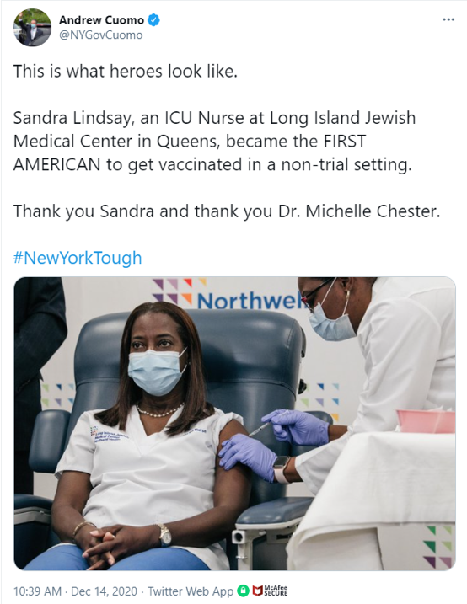
A tweet from New York Governor Andrew Cuomo heralding Sandra Lindsay for receiving a COVID-19 vaccine, and Dr. Michelle Chester for administering it, on December 14, 2020.
Given the virtual absence of Black medical personnel in the U.S. healthcare system, especially nurses, the mass circulation of this image and the optics of the two Black female health care workers appeared orchestrated. Governor Andrew Cuomo and the medical community praised Lindsay. She was a healthcare hero.
Lindsay was also a reminder of the ways in which ideas of race and the practice of medicine have a troubled history, with serious medical outcomes for the Black community.
The effects of racism on health are apparent in the roll-out of the COVID-19 vaccine. The racial disparities in access to the vaccine are stark, while there also exists a distrust of vaccinations among the Black community.
It is easy to pathologize Black peoples’ fears regarding COVID-19 vaccination as cultural, as many analysts are doing today. Given the history of medical atrocities perpetuated against Black people, however, it is more than likely that it is the people and medical establishment behind the vaccine, as opposed to the vaccine itself, that Black people are afraid of.
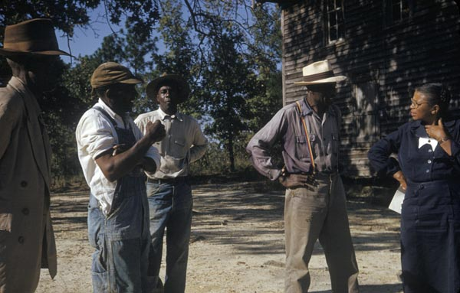
Nurse Eunice Rivers talks with test subjects of the Tuskegee Syphilis Study, c. 1953.
For some members of the Black community, Lindsay conjured up recollections of Eunice Rivers, the public health nurse who acted as the intermediary between the Black men who participated in the Tuskegee Study (1932-1972) and the U.S. Public Health Service. The purpose of this infamous experiment was to study “untreated syphilis in the male Negro.”
A Black Twitter user asked, “Wasn’t it a nurse, a sister at that… that help[ed] gather [patients] for the Tuskegee Experiment”? Another intoned, “Eunice strikes again. But this time, many of us are aware what’s going on.”
The twitter users are correct. Rivers’ involvement in the Tuskegee experiment was extensive and, without her, it would not have been successful. She found subjects for the study and went as far as to drive them to Tuskegee for examinations. She assisted with assessments and some medical procedures and completed follow-up paperwork. When the men died, Rivers encouraged their families to allow Tuskegee Hospital to perform autopsies.
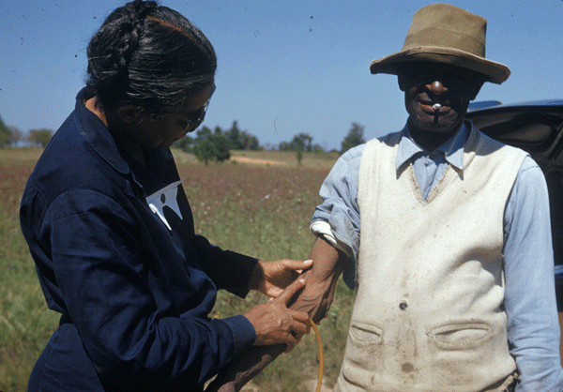
Eunice Rivers takes a blood sample from a test subject of the Tuskegee Syphilis Study, c. 1953.
Rivers was not the only Black person involved (Dr. Robert Russo Morton, Tuskegee’s Institute’s principal and Dr. Eugene Dibble, medical director, for example) and other health care professionals “signed off” on the “experiment.” Still, she is often the face, and has borne the brunt, of the attention in relation to the experiment. Evoking Rivers’ complicated role in the Tuskegee experience in response to Lindsay is understandable.
Historically, across the African diaspora, Black women were instrumental in the provision of health care. Black health care workers, whether formally or informally trained, were trusted by members of Black communities.
Nurse Rivers was no exception. She developed amicable relationships with the men and their families, captured in the Emmy award winning television movie “Miss Evers’ Boys”. Sadly, the Tuskegee experiment is one of several examples that has led to Black people’s distrust of the medical establishment.
To understand this distrust, one must focus on the historical mistreatment of Black people. One cannot argue that it is some sort of shared cultural trait and ignore the racist structures that have continually dehumanized Black people.
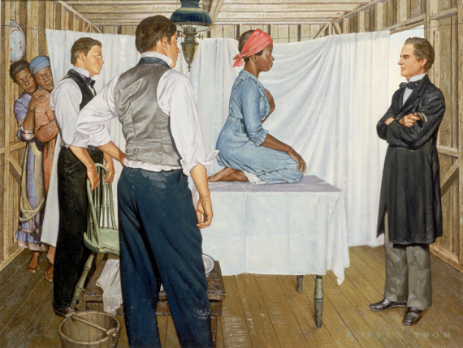
J. Marion Sims stands at the head of an examination table where the ensalved woman, Lucy, sits. Anarcha and Betsy look on the scene from behind the white partition. This 1952 illustration by Robert Thom of Sims' gynecological experiments involving enslaved women is part of a larger collection entitled Great Moments in Medicine. From the collection of Michigan Medicine, University of Michigan, UMHS.30.
For example, Anarcha, Besty, and Lucy are the names of enslaved women whom Marion Sims, the father of gynecology, experimented on. He performed surgeries without anesthesia because of a widely held belief that Blacks had a higher tolerance for pain.
Then there is Henrietta Lacks, whose cancer cells (known as HeLa cells) were taken without her consent and studied in laboratories, and the forced sterilization of Black women and teenagers in North Carolina at roughly the same time as the Tuskegee experiment. These are a few examples of the liberties that the medical establishment has taken with Black bodies.
But we should not believe that health inequities are a now a thing of the past. Research has shown that graduating medical students hold views similar to Sims regarding Black people and pain.
And it isn’t primarily poor people who are affected by racism, as many people assume. Race, gender, and class intersect on the persistent health inequities experienced by middle-class Black women and their encounters with physicians.
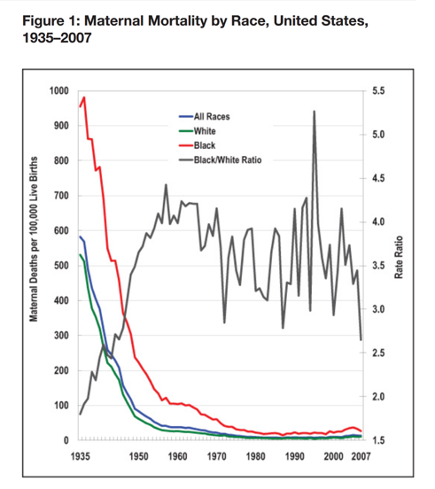
A graph showing maternal mortality by race in the United States from 1935 to 2007.
Black women, according to the Centers for Disease Control and Prevention, “are two to three times more likely to die from pregnancy-related causes than white women.” Compared to white women with a high school education, Black women with college degrees have higher infant mortality rates.
The very rich and famous are not exempted either. Tennis player, Serena Williams, has written about her horrifying birthing experience. Williams’ history of blood clots and other health issues resulted in her spending six weeks in the hospital following the birth of her daughter. Her traumatic experience became a high-profile testament to a medical system that is designed to fail Black women. Fortunately, Williams had the resources to avoid becoming another statistic.
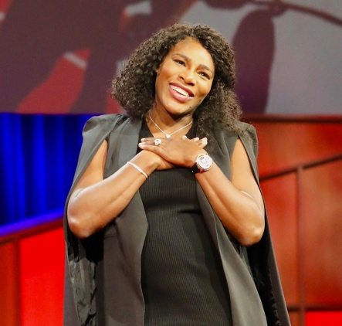
Serena Williams in April 2017 shortly after announcing her pregnancy that would end with traumatic health issues.
The unequal experience that Black people have experienced during the COVID pandemic was given a face late in 2020 when a video made by Dr. Susan Moore went viral.
A physician and a COVID-19 patient, Moore, posted a Facebook video where she described the racist mistreatment she experienced at the hands of medical personnel at an Indiana Hospital. Moore knew well that the system has little regard for Black lives. “This is how Black people get killed when you send them home and they don’t know how to fight for themselves,” she stated.
Moore was fighting for herself, but her complaints of pain were dismissed by the physician. According to Moore, he made her feel as if she “was a drug addict,” adding, “if I was white, I wouldn’t have to go through that.” Within a few days after being discharged from the hospital, Moore died from COVID complications. Her death is a stark and painful reminder of the disposability of Black lives and serves as additional evidence of medical racism.
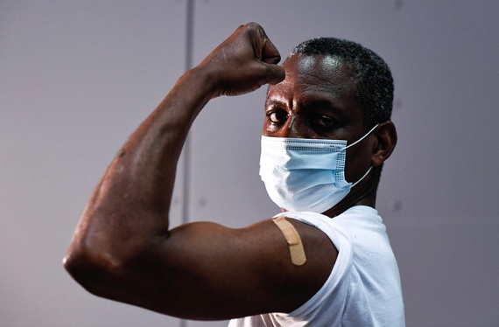
MTA of New York employee Severin Smith poses for a photograph after receiving the COVID-19 vaccine in January, 2021.
The mistreatment and exploitation experienced by African Americans in the name of scientific research helps account for their refusal to be inoculated for COVID-19, but we should also not disregard how history is being made in the present.
We need more than cursory acknowledgment to histories of abuse and neglect. As Black people continue to die disproportionately from the coronavirus, Sandra Lindsay and other Black medical personnel cannot be the panacea.
The burden of undoing decades of racism and inequality, which has been and continues to be embedded in the American medical system, must be a shared one.

Document B (1-4): How discrimination can harm Black Women's Health. News. (2018, October 31). Retrieved April 3, 2022, from https://www.hsph.harvard.edu/news/hsph-in-the-news/discrimination-black-womens-health/
Black women face risks to their health from discrimination—both from health professionals who don’t take their concerns seriously and from biological wear and tear caused by chronic stress. An October 2018 Oprah.com article on the topic cites research from two researchers and an alumna from Harvard T.H. Chan School of Public Health.
Research by Nancy Krieger, professor of social epidemiology, has found that early-life exposure to Jim Crow laws—which legalized racial discrimination in Southern U.S. states from the late 1870s through the mid-1960s—can lead to negative health effects decades later. For example, among U.S. women currently diagnosed with breast cancer, being born in a Jim Crow state heightened black women’s risk of being diagnosed with estrogen-receptor negative breast tumors, which are more aggressive and less responsive to traditional chemotherapy.
Krieger told Oprah.com, “My research shows [Jim Crow laws are] still being reckoned with in the bodies of people who lived through that time.” Potential reasons include lack of access to health care, exposure to environmental hazards, and economic deprivation.
The School’s David R. Williams, Florence Sprague Norman and Laura Smart Norman Professor of Public Health, pointed to neighborhood racial segregation as a key driver of health inequities. According to the article, predominantly black neighborhoods have higher levels of air pollution and fewer supermarkets than other neighborhoods, and lack access to medical specialists.
The article also cites research by Arline Geronimus, SD ’85, professor of health behavior and health education at the University of Michigan School of Public Health, who pioneered the theory of “weathering”—the idea that high levels of chronic stress can lead to negative health outcomes and premature aging.

Document C1: Haskins, J. (2019, February 25). Celebrating 10 African-American Medical Pioneers. AAMC. Retrieved April 3, 2022, from https://www.aamc.org/news-insights/celebrating-10-african-american-medical-pioneers
These trailblazers broke barriers and shattered stereotypes — and went on to conduct research, discover treatments, and provide leadership that improved the health of millions.
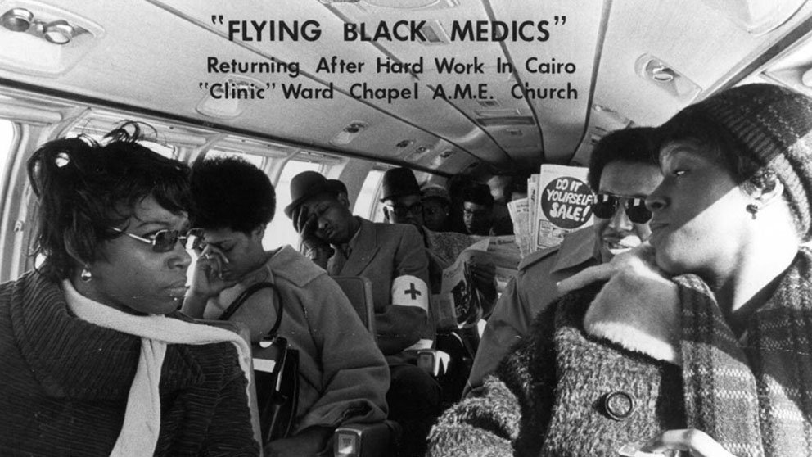
The Flying Black Medics, created by Leonidas Harris Berry, MD, return from providing medical care and education to Cairo, Illinois, residents in 1970.National Institutes of Health
They fought slavery, prejudice, and injustice — and changed the face of medicine in America. They invented modern blood-banking, served in the highest ranks of the U.S. government, and much more.
Marilyn Hughes Gaston, MD (b. 1939)
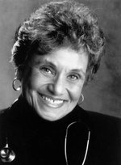National Library of Medicine, National Institutes of Health
In a pivotal experience while working as an intern at Philadelphia General Hospital in 1964, Marilyn Hughes Gaston, MD, admitted a baby with a swollen, infected hand. The baby suffered from sickle cell disease, which hadn’t occurred to Gaston until her supervisor suggested the possibility. Gaston quickly committed herself to learning more about it, and eventually became a leading researcher on the disease, which affects millions of people around the world. She became deputy branch chief of the Sickle Cell Disease Branch at the National Institutes of Health, and her groundbreaking 1986 study led to a national sickle cell disease screening program for newborns. Her research showed both the benefits of screening for sickle cell disease at birth and the effectiveness of penicillin to prevent infection from sepsis, which can be fatal in children with the disease.
In 1990, Gaston became the first black female physician to be appointed director of the Health Resources and Services Administration’s Bureau of Primary Health Care. She was also the second black woman to serve as assistant surgeon general as well as achieve the rank of rear admiral in the U.S. Public Health Service. Gaston has been honored with every award that the Public Health Service bestows.

Document C2: Haskins, J. (2019, February 25). Celebrating 10 African-American Medical Pioneers. AAMC. Retrieved April 3, 2022, from https://www.aamc.org/news-insights/celebrating-10-african-american-medical-pioneers
These trailblazers broke barriers and shattered stereotypes — and went on to conduct research, discover treatments, and provide leadership that improved the health of millions.
The Flying Black Medics, created by Leonidas Harris Berry, MD, return from providing medical care and education to Cairo, Illinois, residents in 1970.National Institutes of Health
They fought slavery, prejudice, and injustice — and changed the face of medicine in America. They invented modern blood-banking, served in the highest ranks of the U.S. government, and much more.
Patricia Era Bath, MD (b. 1942)
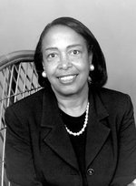National Library of Medicine, National Institutes of Health
Interning in New York City in the 1960s sparked a revelation for Patricia Era Bath, MD. Bath, the first African-American to complete an ophthalmology residency, noticed that rates of blindness and visual impairment were much higher at the Harlem Hospital’s eye clinic, which served many black patients, than at the eye clinic at Columbia University, which mostly served whites. That observation spurred her to conduct a study that found twice the rate of blindness among African-Americans compared with whites. Throughout the rest of her career, Bath explored inequities in vision care. She created the discipline of community ophthalmology, which approaches vision care from the perspectives of community medicine and public health.
Bath blazed trails in other ways as well, co-founding the American Institute for the Prevention of Blindness in 1976, which supports programs that protect, preserve, and restore eyesight. Bath was also the first woman appointed chair of ophthalmology at a U.S. medical school, at the University of California, Los Angeles David Geffen School of Medicine in 1983. And she was the first black female physician to receive a medical patent in 1988 for the Laserphaco Probe, a device used in cataract surgery.

Document C3: Haskins, J. (2019, February 25). Celebrating 10 African-American Medical Pioneers. AAMC. Retrieved April 3, 2022, from https://www.aamc.org/news-insights/celebrating-10-african-american-medical-pioneers
These trailblazers broke barriers and shattered stereotypes — and went on to conduct research, discover treatments, and provide leadership that improved the health of millions.
The Flying Black Medics, created by Leonidas Harris Berry, MD, return from providing medical care and education to Cairo, Illinois, residents in 1970.National Institutes of Health
They fought slavery, prejudice, and injustice — and changed the face of medicine in America. They invented modern blood-banking, served in the highest ranks of the U.S. medical field
Alexa Irene Canady, MD (b. 1950)
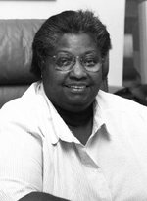
National Library of Medicine, National Institutes of Health
Alexa Irene Canady, MD, nearly dropped out of college due to a crisis of self-confidence but ultimately went on to achieve dramatic success in medicine. In 1981, she became the first black neurosurgeon in the United States, and just a few years later, she rose to the ranks of chief of neurosurgery at Children’s Hospital of Michigan.
Canady worked for decades as a successful pediatric neurosurgeon and was ready to retire in Florida in 2001. But she donned her surgical scrubs once again to practice part time at Sacred Heart Hospital in Pensacola, where there was a dearth of pediatric neurosurgery services. Canady has been lauded for her patient-centered approach to care, which she said was a boon to her career. “I was worried that because I was a black woman, any practice opportunities would be limited.” But, she noted, “by being patient-centered, the practice growth was exponential.”

Document C4: Haskins, J. (2019, February 25). Celebrating 10 African-American Medical Pioneers. AAMC. Retrieved April 3, 2022, from https://www.aamc.org/news-insights/celebrating-10-african-american-medical-pioneers
These trailblazers broke barriers and shattered stereotypes — and went on to conduct research, discover treatments, and provide leadership that improved the health of millions.
The Flying Black Medics, created by Leonidas Harris Berry, MD, return from providing medical care and education to Cairo, Illinois, residents in 1970.National Institutes of Health
They fought slavery, prejudice, and injustice — and changed the face of medicine in America. They invented modern blood-banking, served in the highest ranks of the U.S. government, and much more. In honor of Black History Month, read the inspiring stories of 10 pioneering black physicians.
Regina Marcia Benjamin, MD, MBA (b. 1956)
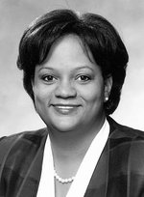
National Library of Medicine, National Institutes of Health
Regina Marcia Benjamin, MD, MBA, may be best known for her tenure as the 18th U.S. Surgeon General, during which she served as first chair of the National Prevention Council. The group of 17 federal agencies was responsible for developing the National Prevention Strategy, which outlined plans to improve health and well-being in the United States.
But it’s not just her work at the highest levels of public health that earned her praise. Long before she was appointed “the nation’s doctor” in 2009, Benjamin worked extensively with rural communities in the South. She is the founder and CEO of BayouClinic in Bayou La Batre, Louisiana, which provides clinical care, social services, and health education to residents of the small Gulf Coast town. Benjamin helped rebuild the clinic several more times, including after damage inflicted by Hurricane Katrina in 2005 and a fire in 2006. Of the clinic, she said she hopes that she is “making a difference in my community by providing a clinic where patients can come and receive health care with dignity.

Document D( 1-4): Crosby, K. (2021, February 17). Recognizing medical contributions by Africans and Black Americans. Medical News. Retrieved April 3, 2022, from https://www.medpagetoday.com/publichealthpolicy/generalprofessionalissues/91243
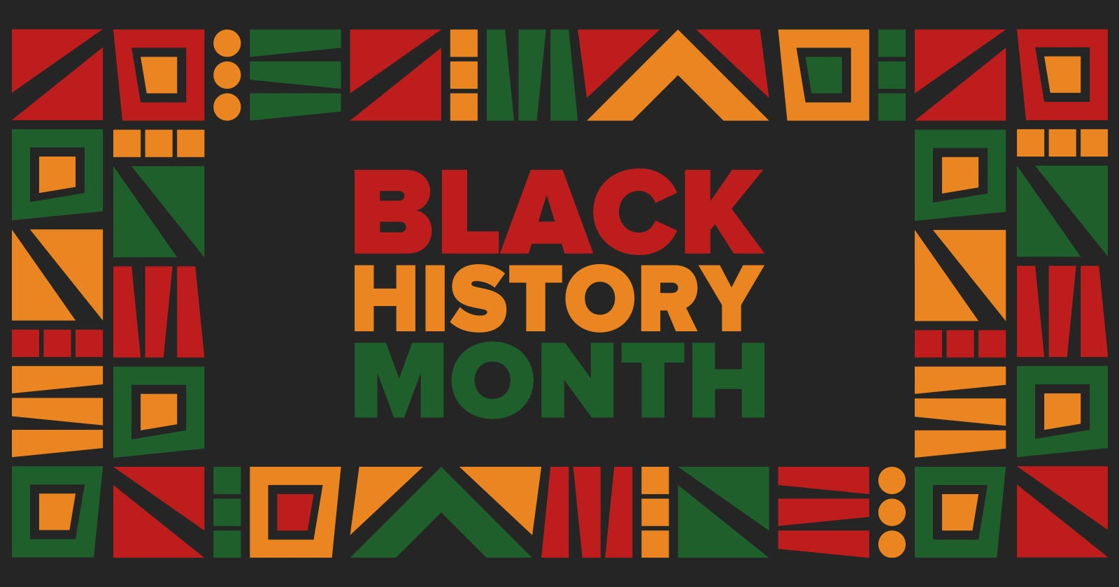
The contributions made by African and Black American medical professionals to health and wellness are many. While determining just how many lives these trailblazers saved is impossible, we know that without their imagination, knowledge, and desire to help others many lives would have been lost. Since it is Black History Month, now is the perfect time to recognize and celebrate some of the numerous contributions the Black community has afforded the medical industry and the world overall.
1964 – Jane Wright, MD
Wright is an accomplished surgeon and revolutionary cancer researcher. Her work elevates chemotherapy from a last-ditch effort for the treatment of cancer to a feasible therapy option.
While working with a team at New York University School of Medicine, Wright develops a way to deliver heavy doses of anticancer medications to tumors located within the spleen, kidneys, and other hard-to-reach places. In 1967, she serves as the head and associate dean of the Cancer Chemotherapy Department at New York Medical College in New York City.
1986 – Marilyn Hughes Gaston, MD
In 1964, as Gaston works as an intern at Philadelphia General Hospital, an infant with an infected, swollen hand is admitted. Once Gaston learns that the infant has sickle cell disease, she commits herself to learning more about it, eventually becoming a top researcher for this disease.
Gaston becomes the deputy branch chief of the National Institutes of Health's Sickle Cell Disease Branch. Her research shows the effectiveness of the antibiotic penicillin to prevent sepsis infection (which can be fatal for children with sickle cell disease) and the benefits of screening newborns for the disease.
Due to her extensive career, Gaston receives every Public Health Service award available.
1988 – Patricia Era Bath, MD
In 1988, Bath is the first Black female physician to receive a patent for a medical device.
As an ophthalmologist, Bath noticed that there were differences in the number of Black patients and white patients experiencing visual impairments and blindness. She decides to conduct a study to determine the prevalence of visual impairment and blindness based on race and finds that the prevalence of blindness is two times higher in African Americans than in Caucasian Americans.
Bath's technique and device, the Laserphaco Probe, are used during cataract surgery.
Bath states that eyesight is a basic human right, and in 1976 founds the American Institute for the Prevention of Blindness.

Document E (1-4): Valenti, L. (2020, June 24). 6 organizations that support Black Women's health-and why the work they're doing is so essential. Vogue. Retrieved April 3, 2022, from https://www.vogue.com/article/black-womens-health-support-organizations
BY LAUREN VALENTI
June 24, 2020
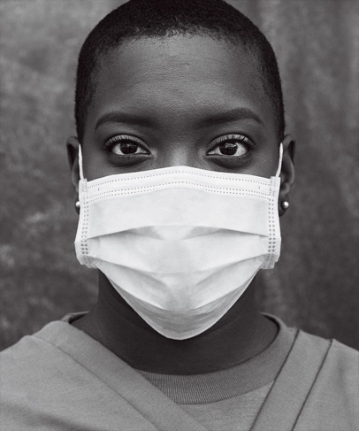
Photographed by Ethan James Green, Vogue, June/July 2020
Amid the global pandemic and recent acts of racial injustice, the fractured U.S. health system is facing a reckoning for the many ways in which it has historically and is currently failing Black women. While strides are being made in terms of growing awareness and more focused efforts to address issues such as the maternal health crisis and its disproportionate impact on Black women, the fact is that the system needs a complete overhaul if equity in treatments and outcomes is going to be achieved.
“It’s like that pictorial of an iceberg: There’s this little peak at the top, but below it’s catastrophic,” Dr. Jessica Shepherd, an ob-gyn in Dallas who has been speaking out on how racism plagues medicine and hospital care, told Vogue. “It’s the perfect analogy of how racism affects health. You’re just seeing the tip, but there are all these ways it impacts quality of life and health outcomes for African Americans.”
As the call for change reaches a fever pitch, here are six organizations committed to advocating for Black women’s health, as well as providing individualized support, education, and financial assistance.
Black Mamas Matter Alliance
Historically, Black women have had the highest maternal mortality rates. According to the CDC, they are three to four times more likely to experience a pregnancy-related death than white women. The Black Mamas Matter Alliance represents the voices of Black mothers to change policy, drive research, and reframe the conversation for better Black maternal health and justice.
Sisters Network (A National African American Breast Cancer Survivorship Organization)
The Sisters Network’s overall goal is to reduce the mortality rate of breast cancer among Black women (breast cancer death rates are 40% higher among Black women than white women) through increasing national attention, providing information and resources, and aiding research efforts.
Black Women for Wellness
California-based Black Women for Wellness is an organization dedicated to improving the health and well-being of Black women and girls through multifaceted education, civic engagement, and policy work. Programming includes workshops on sex education, voting guidance, environmental justice, and healthy cooking.
Black Women’s Health Imperative
For 35 years, the Black Women’s Health Imperative has been at the forefront of the fight against health disparities for Black women, from convening the first National Conference on Black Women’s Health Issues in 1983 to recent initiatives such as its Positive Period! Campaign and All of Us research program.
Mamatoto Village
Mamatoto Village is dedicated to helping forge career pathways for Black women in public health and human services, as well as providing access to better perinatal support for women and families. In April, the nonprofit released A Black Mama’s Guide to Living and Thriving, an empowering resource for enhancing mental health, self-love, personal pleasure, nourishment, and financial health during pregnancy and beyond.
The Loveland Foundation
According to the National Alliance on Mental Illness, Black Americans are 10% more likely to experience serious psychological distress, and are more likely to experience socioeconomic disparities that may contribute to worse mental health outcomes. Founded by activist and academic Rachel Cargle, the Loveland Foundation provides financial assistance to Black women and girls so that they can seek therapy for healing and overall wellness.

