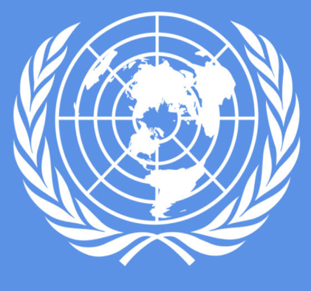
Stations Worksheet Template
Station 1/The Nuremberg Trials Activity/Questions
Read the article and watch the video on the Nuremberg Trials.

- What were the Nuremberg Trials?

The Nuremburg trails were…

- What crimes did the Nazis commit during WWII?

During WWII, the Nazis committed various crimes. These crimes included…

- How did the Nuremberg Trails influence international law?
The Nuremberg Trails influenced international law by…
You will be exploring different cases of international crimes!

At each station you will find a case study…read the text or watch the video at each station.

Work with your group to discuss and answer the questions for each station.
You will have 15-20 minutes at each station!

Station 2/Rwanda Activity/Questions
Read the article on genocide in Rwanda
- What is meant by “international penal tribunal” and how did it come about?

“International penal tribunal” means…

- What happened in Rwanda?

- How did the situation in Rwanda develop international responsibility for genocide?

The situation in Rwanda developed increased international responsibility for genocide by…

EXIT TICKET
Station 3/Myanmar and Bangladesh Activity/Questions
Read the article and watch the video on Myanmar

- What happened along the Myanmar-Bangladesh border?

On the Myanmar-Bangladesh boarder…

- Why are these crimes against humanity?

These were crimes against humanity because….

- What was one response from the court, from the video, that stuck out to you? Why?
One response that stuck out to me was…
What kinds of injustices are prosecuted in an international court? How?

