Jigsaw Worksheet

In your expert group read your assigned monument/memorial. As a group, answer the questions below.
Monument/Memorial name:

In your Jigsaw group, make notes about the monuments/memorials that others share in your group. Write down at least 1 (one) important note about each person’s monument/memorial.

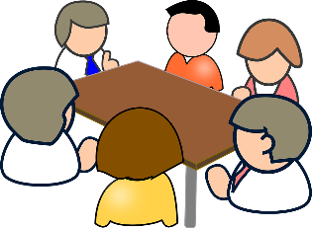

Make an original argument or observation about monuments and memorials, based on the discussion you have with your Jigsaw group. This goes beyond just what you have written down for your questions. What did you talk about?

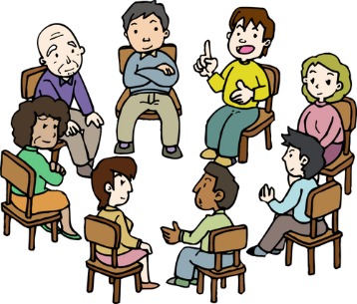

Exit Ticket:
- To whom are we responsible as a society when we create monuments and memorials to the past? How should we decide which events or individuals are important to remember?
- How might your response differ when considering the social responsibility to others and then the educational responsibility to tell the truth about the past?

