Source Packet

Directions:
Each of these boxes contains a primary or secondary source related to the role of Cuba in the American Civil Rights Movement. As you read through each document, answer the questions in the corresponding box on your Stations Worksheet.

Document 1: Rosemari Mealy. (1993). Fidel and Malcolm X. (59-61)

“We have always been in solidarity with the struggle of Black people, of minorities, and of the poor in the United States. We have always been in solidarity with them, and they have been in solidarity with us.

We must fight to defeat the campaigns, the schemes, and the lies, all that is aimed at separating us. I think that in these times we need that friendship more than ever, and we need your solidarity more than ever. And we fully appreciate it, because we understand that one has to be very courageous to [support] ... Cuba in the United States....

Cuba has an important role to play, a very big responsibility, because there were people who thought that the revolution here would collapse just like socialism [in Europe] .... But of course, this country will resist. We are waging three great battles: the political battle, where we maintain the unity of the people, the support of the people, the determination of our people; the economic battle, which is even more difficult here than elsewhere given the conditions we face; and the battle for defense.

We have to work in these three directions. But we are not doing this for ourselves. We are doing it for all the just causes of the world, at a time of skepticism. Optimism and the hope of the peoples will again be born, because the negative forces will not prevail. (59-61)”

Document 2: (1975) “Intelligence-Report on CIA Assassination Plots”. Gerald R. Ford Library

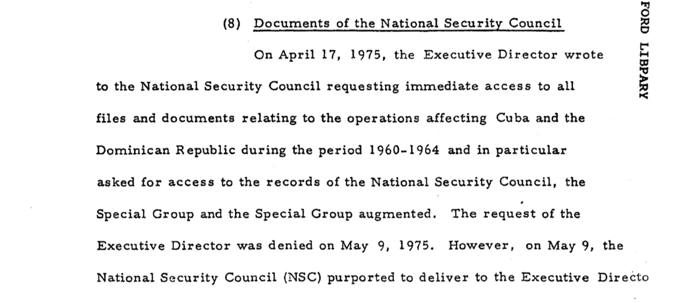

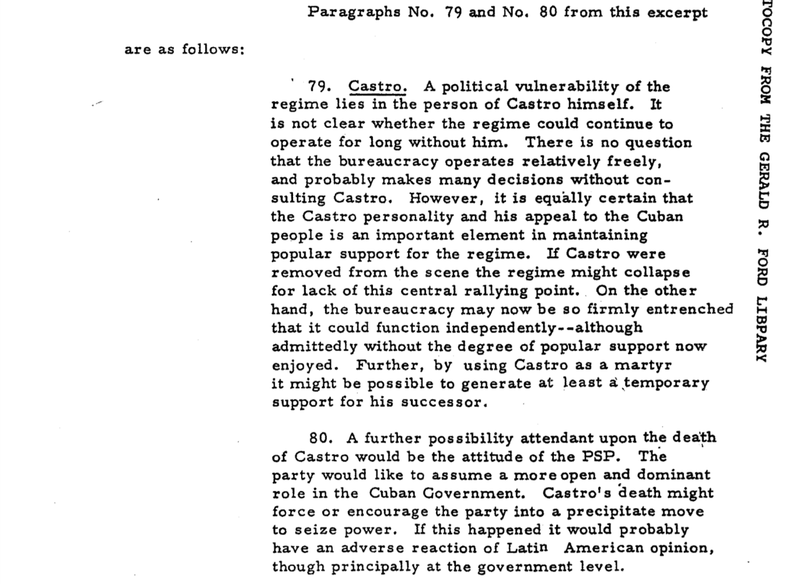

Document 3:
Benson. (2012).Owning the Revolution: Race, Revolution, and Politics from Havana to Miami, 1959–1963, (6)

Cold War and Civil Rights struggles allowed Cuban leaders to compare their progress against racial discrimination to U.S. failures to improve conditions for African Americans. Revolutionary leaders publicly invited African-American tourists to the island, where they could experience “first class treatment—as a first class citizen.” In a related gesture of solidarity during a visit to the United Nations, Cuban leaders stayed in a black hotel in Harlem. The frequent appearance of images and editorials condemning lynching in the U.S. South also encouraged Cubans of color to appreciate that the revolution disavowed such behavior, even though lynching had not been a common component of anti-black violence in Cuba. These gestures to the inconsistencies of North American democracy gave revolutionary leaders a moral weapon against the U.S. and a focal point for solidifying Afro-Cuban support. Calling attention to racial violence in the United States distanced the new government from the exile community in Miami, who, despite living in the midst of the Civil Rights movement in Florida, rarely mentioned any support for African American equality. Editorials in the exile newspaper Patria, for instance, labeled Castro’s stay at the African American hotel in 1960 the “Harlem Show,” claiming that the revolutionary leader’s decision was “obviously an act to discredit and humiliate the United States in its own territory.

Document 4: Christopher Shell. (2021). African Americans, Anti-Racism, and Cuba

While the United States did not take kindly to the creation of a communist state in its backyard, African American opinions about communist Cuba were rather different. African Americans were already engaged in their own fight against American racism and were particularly interested in a nation whose national leaders were vocal about undoing systemic racism.

Conversely, Castro had kicked out major U.S. hotels and casinos from Cuba and was searching for another way to fill the tourist void. At their meeting, Castro and Louis discussed plans for middle-class African Americans to travel to Cuba and experience first-hand the “anti-racist” society that Castro was shaping.

Unfortunately, the 1962 embargo enacted by President John F. Kennedy snuffed out any plans of establishing an African American travel network with Cuba. However, that did not sever the transnational relationship between African Americans and communist Cuba.

The Black Panther Party (BPP) was founded in 1966, in East Oakland, California. A self-help organization committed to Black self-determination, the BPP looked to communist China and communist Cuba as models for bringing revolutionary change in the United States. The Cuban government also paid attention to the BPP.

In 1984, civil rights activist Jesse Jackson was a presidential candidate for the Democratic Party. To bolster his knowledge of international affairs, Jackson made the trip to Havana to meet with Fidel Castro, 24 years after Joe Louis had visited Cuba.

The meeting between Jackson and Fidel culminated in Jackson securing the freedom of 26 Cuban political prisoners and 22 American citizens, which Washington thought was a near impossible task. Jackson’s success led him to denounce U.S. policy towards Cuba when he told reporters “A no-talk policy does not work. We must talk with the Cubans.”

The put Jackson at odds with many Americans and certainly with the Reagan Administration, which pursued an aggressive anti-communist agenda in Latin America broadly and against Cuba in particular.

Jackson secured the freedom of people that the Castro administration had labelled as “terrorists” and “enemies of the state.” Ironically, in the same year, Cuba offered political asylum to Black Panther member, Assata Shakur, whom the United States had deemed “an enemy of the state.”

Since the 1959 Cuban Revolution, the United States has had a fraught relationship with Cuba. As these images remind us, however, African Americans have sometimes viewed Cuba differently. It has been a more complicated relationship as Cuba represented a nation fighting to dismantle a legacy of systemic racism, never mind that it was a communist country.

