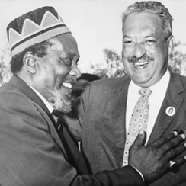
Name: International Ripples of the Civil Rights Movement

- Analyze each photograph on your own
- Write down what you think is happening in each photo
- When your teacher reads the description, write down what really happened in each photo
Document B: Malcolm X Photo Analysis
- What do you think is happening in this photo?

- What is really happening in this photo? (African Summit Conference, 1964)

Document A: Thurgood Marshall Photo Analysis
- What do you think is happening in this photo?

- What is really happening in this photo? (Lancaster House Conference, 1960)

Document C: Stokely Carmichael Photo Analysis
- What do you think is happening in this photo?

- What is really happening in this photo? (International Day of Solidarity, 1967)

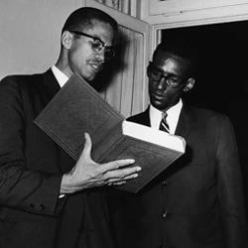
International Ripples of the Civil Rights Movement
- Read your assigned document
- Discuss with your group and answer the question
- Build a two-slide presentation that includes:
  - A brief summary of the document
  - Your answer to the text-based question
  - An image related to the text

Document F: Malcolm X Text-Based Question
- What does Malcolm X mean when he said, “African problems are our problems and our problems are African problems”?

Hint: Think about why African Americans might identify more with continental Africans than other groups of Americans.
Document E: Decolonization Text-Based Question
- In what ways could pan-African unity strengthen resistance to colonialism and neocolonialism?

Hint: Look up the term “Year of Africa” and consider how there is strength in numbers.
Document D: Thurgood Marshall Text-Based Question
- How was nominating a civil rights attorney to SCOTUS in 1967 “the right thing to do” and “the right time to do it”?

Hint: Think about President Johnson’s role in the Civil Rights Movement.
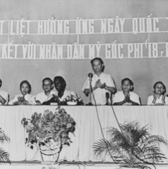
International Ripples of the Civil Rights Movement
- Read your assigned document
- Discuss with your group and answer the question
- Build a two-slide presentation that includes:
  - A brief summary of the document
  - Your answer to the text-based question
  - An image related to the text
Document H: Stokely Carmichael Text-Based Question
- Why did the message of “Black power” resonate with those advocating for pan-Africanism?

Hint: The newly independent countries of Africa were trying to set their own course after years of European colonization and domination.
Document G: African Unity Text-Based Question
- What benefits and challenges arose when the newly independent African nations began working together in an official capacity?

Hint: Consider what goals newly independent countries may or may not have in common.

Document I: Afro-Sino Relations Text-Based Question
- Why did China emerge as a key partner to the newly independent African nations in the fight against neocolonialism?

Hint: How would the goals of China and other emerging countries differ from the United States and Soviet Union during the Cold War?
International Ripples of the Civil Rights Movement
Exit Ticket: Synthesis Questions
- Based on everything you learned today, why do you think leaders of the Civil Rights Movement had such a profound impact on people outside the United States?

- How can Civil Rights activists today work to broaden their reach beyond the United States? How can we use modern tools or technology to build these connections? How can you be a part of the movement?

