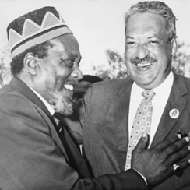
Name: International Ripples of the Civil Rights Movement

- Analyze each photograph on your own
- Write down what you think is happening in each photo
- When your teacher reads the description, write down what really happened in each photo
Document B: Malcolm X Photo Analysis
- What do you think is happening in this photo?

- What is really happening in this photo? (Include location/date)

Document A: Thurgood Marshall Photo Analysis
- What do you think is happening in this photo?

- What is really happening in this photo? (Include location/date)

Document C: Stokely Carmichael Photo Analysis
- What do you think is happening in this photo?

- What is really happening in this photo? (Include location/date)

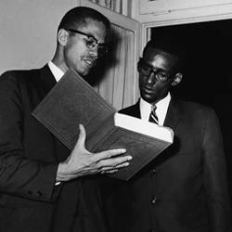
International Ripples of the Civil Rights Movement
- Read your assigned document
- Discuss with your group and answer the question
- Build a two-slide presentation that includes:
  - A brief summary of the document
  - Your answer to the text-based question
  - An image related to the text

Document E: Decolonization Text-Based Question
- In what ways could pan-African unity strengthen resistance to colonialism and neocolonialism?

Document D: Thurgood Marshall Text-Based Question
- How was nominating a civil rights attorney to SCOTUS in 1967 “the right thing to do” and “the right time to do it”?

Document F: Malcolm X Text-Based Question
- What does Malcolm X mean when he said, “African problems are our problems and our problems are African problems”?

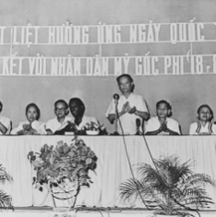
International Ripples of the Civil Rights Movement
- Read your assigned document
- Discuss with your group and answer the question
- Build a two-slide presentation that includes:
  - A brief summary of the document
  - Your answer to the text-based question
  - An image related to the text
Document H: Stokely Carmichael Text-Based Question
- Why did the message of “Black power” resonate with those advocating for pan-Africanism?

Document G: African Unity Text-Based Question
- What benefits and challenges arose when the newly independent African nations began working together in an official capacity?

Document I: Afro-Sino Relations Text-Based Question
- Why did China emerge as a key partner to the newly independent African nations in the fight against neocolonialism?

International Ripples of the Civil Rights Movement

After hearing your classmates share their presentations, answer the following synthesis questions as your exit ticket.
Exit Ticket: Synthesis Questions
- Based on everything you learned today, why do you think leaders of the Civil Rights Movement had such a profound impact on people outside the United States?

- How can Civil Rights activists today work to broaden their reach beyond the United States? How can we use modern tools or technology to build these connections? How can you be a part of the movement?

