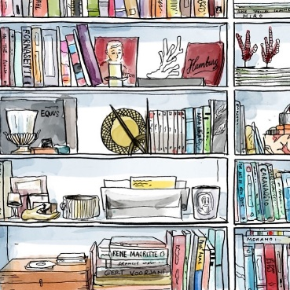**Stations Worksheet Influenza Pandemics Now, Then, and Again**

**Move around the room** and use the sources at each station to answer the questions below. In **Station 1** you will find sources about the **1918 Spanish Flu**. In **Station 2** you will find sources about the **1980s AIDS epidemic**. And in **Station 3** you will find sources about the **2020 COVID-19 Pandemic**. Analyze the sources to complete this worksheet.

**Station 1: 1918 Spanish Flu Activity/Questions**

1. What did most countries believe was the **most important** thing in **1918**? How can we tell this from the sources?
2. How can we see this **goal** by analyzing the **photograph**?

*Hint: What do you know about that was also going on in the world in 1918?*

**Station 2: 1980s AIDS Epidemic Activity/Questions**

1. What **differences** do we see between the way **Reagan’s administration** dealt with the AIDS epidemic and the way **Princess Diana** dealt with it?
2. **What do you think the** **goal** of each side in these sources was?

*Hint: Do you think the President would want to help the LGBTQ+ community in the 1980s?*

**Station 3: 2020 COVID-19 Pandemic Activity/Questions**

1. Why do you think the **Trump administration is not social distancing**? How do you think this relates to what their **goal** is?
2. Why do you think the task force from **Singapore appears more concerned** than the US?

*Hint: Would it be hard to tell people it’s safe to go back to normal if you don’t act normal?*