Voices from the Vietnam War
Directions: Read the sources below and use the questions to analyze the impact of the Vietnam War on those involved.

DOCUMENT A:
“In rural Quang Ninh, Vu and his family heard snippets of news—how many airplanes were shot down that day, who was winning, what the “cruel American wolves” were doing in various areas of the country. There was little explanation of why the violence was happening. “People didn’t talk about the meaning of the war,” he said. “We were really confused why the Americans tried to invade our homeland. We hadn’t done anything to them.”

I asked Vu if the Vietnamese had understood that the United States perceived communism as a threat.

“People didn’t even know what communism was,” Vu told me. “They just knew what was going on with their lives.”” - https://www.theatlantic.com/international/archive/2015/04/the-vietnam-war-as-seen-by-the-north-vietnamese/390627/

- How does Vu and his family view the USA and the conflict?

- Why do you think it means when Vu says “People didn’t talk about the meaning of the war”?

DOCUMENT B:
Tran Thi Thon served in the North Vietnamese army from 1965 to 1975, delivering supplies from the North to the South.
"The day I remember most vividly was the day we found a downed American pilot.," she said.

"I saw that he had lost his shoe, so I took my shoe off and strapped it on his foot.

"Then, I took my handkerchief out and wiped the blood off his face.

"I felt very sympathetic because he was just another human and he didn't want to be in this war just like I didn't.

"The pilot then told my crew to hide, as a rescue helicopter was on its way and they would shoot us.

"But the helicopter never came and the pilot was captured by our soldiers."

While making her deliveries, she saw a yellow liquid covering the jungle. It felt cool to the touch, so she and her teammates picked leaves and rubbed the substance on their skin to refresh themselves. It was Agent Orange. Now, the skin on her arms, legs, and stomach is covered in scars. She underwent several operations to repair the damage. But the worst consequence of the exposure were the birth defects of her son, who died of lung cancer at the age of 35, and her daughter, who is physically and mentally disabled. (Photograph by Lonnie Schlein) - https://www.bbc.com/news/in-pictures-33408096

- What was Thon’s contribution and experience with the war?

- How did Agent Orange impact Thon?

DOCUMENT C:

“We do this [escalating U.S. military involvement in Vietnam] in order to slow down aggression. We do this to increase the confidence of the brave people of South Vietnam who have bravely born this brutal battle for so many years with so many casualties. And we do this to convince the leaders of North Vietnam—and all who seek to share their conquest—of a simple fact: We will not be defeated. We will not grow tired. We will not withdraw either openly or under the cloak of a meaningless agreement.”—President Lyndon Johnson, speaking to the nation on April 7, 1965 explaining his decision to send U.S. combat troops to Vietnam.” - cfr.org/blog/vietnam-war-forty-quotes

- What was Lyndon Johnson’s message to the leaders of North Vietnam?

- What was the USA approach to the conflict?

DOCUMENT D:

“We seem bent upon saving the Vietnamese from Ho Chi Minh, even if we have to kill them and demolish their country to do it. I do not intend to remain silent in the face of what I regard as a policy of madness which, sooner or later, will envelop my son and American youth by the millions for years to come.” —Senator George McGovern (D-SD) speaking on the Senate floor on April 25, 1967.” - cfr.org/blog/vietnam-war-forty-quotes

- What is Senator George McGovern’s stance on the USA’s involvement in the Vietnam war?

- Whose side do you think that he supports.

DOCUMENT E:

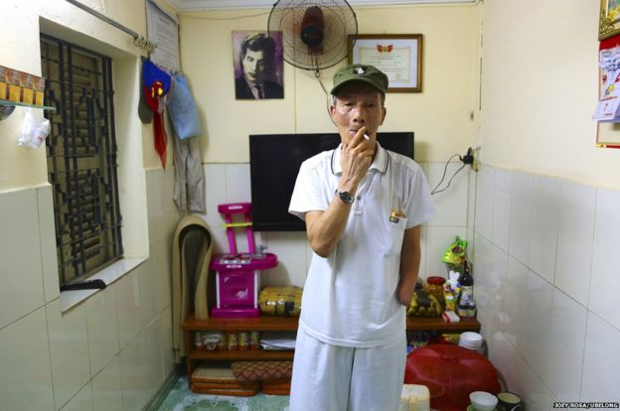

“Tran Van Thinh joined up aged 19 and ended his service with a high rank and multiple medals of honour. In the battle of Quang Tri in 1968 he was hit by a bomb that blew off part of his left arm and shattered his right leg. Married for 30 years with one son and two grandchildren, he lost two brothers in the war.

"I was very young. All I knew at that time was that I had to fight the Americans to reunify my country," he said. “My most disturbing memory was killing two American soldiers." (Photograph by Joey Rosa)” - https://www.bbc.com/news/in-pictures-33408096

- Why did Thinh fight in the war?

- How did the Vietnam war impact Thinh?

