SUMMARY
The U.S. has 614,387 bridges, almost four in 10 of which are 50 years or older. 56,007 — 9.1% — of the nation’s bridges were structurally deficient in 2016, and on average there were 188 million trips across a structurally deficient bridge each day. While the number of bridges that are in such poor condition as to be considered structurally deficient is decreasing, the average age of America’s bridges keeps going up and many of the nation’s bridges are approaching the end of their design life. The most recent estimate puts the nation’s backlog of bridge rehabilitation needs at $123 billion.

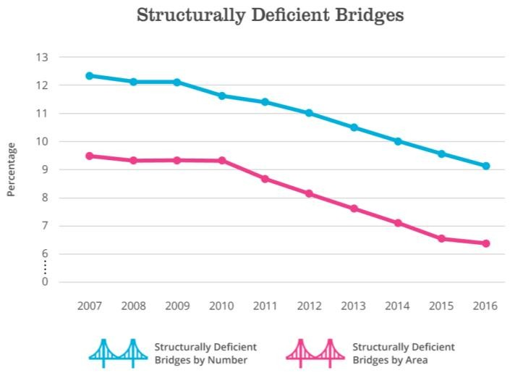CONDITION & CAPACITY Over the past decade, there has been increased awareness of the significance of bridges to our nation’s economy and the safety of the traveling public. At all levels of government, a concerted effort has been made to reduce the number of structurally deficient bridges in the U.S.—bridges that require significant maintenance, rehabilitation, or replacement. Structurally deficient bridges are not unsafe, but could become so and need to be closed without substantial improvements.

As of 2016, one in 11 (9.1%) of bridges were designated structurally deficient, which

represents an improvement from a decade ago when 12.3% of bridges were structurally deficient. As bridges greatly vary in size, the percentage of deck area that belongs to structurally deficient bridges is another useful indicator. 6.3% of total bridge area belonged to structurally deficient bridges in 2016, an improvement from 9.5% in 2007. Encouragingly, higher traffic volume bridges are less likely to be structurally deficient. Yet, on average, there were 188 million trips across a structurally deficient bridge each day in 2016. Some states are doing better than others at maintaining, repairing, or replacing their bridges. The percentage of bridges that are structurally deficient ranged from 1.6% in Nevada to 24.9% in Rhode Island in 2016.

Of the 614,387 bridges in the National Bridge Inventory, almost four in 10 (39%) are over 50 years or older, and an additional 15% are between the ages of 40 and 49. The average bridge in the U.S. is 43 years old. Most of the country’s bridges were designed for a lifespan of
50 years, so an increasing number of bridges will soon need major rehabilitation or retirement.

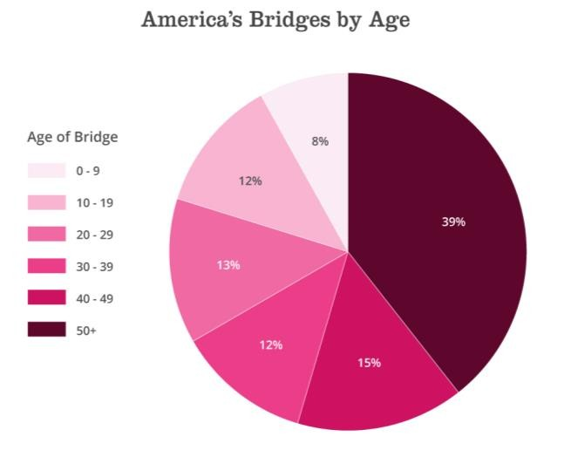As part of a bridge’s regular inspection, it may be determined that the bridge can only carry traffic up to a certain weight or speed, requiring posting of a load restriction. One in 10 (10.1%) bridges had such restrictions in 2016. Posted bridges can
dramatically increase driving time for larger vehicles such as school buses, ambulances, and delivery trucks. Bridges that do not serve current traffic demand or meet current standards, whether due to too few lanes or too narrow lanes or shoulders, are considered functionally obsolete. More than one in eight (13.6%) bridges in the U.S. were functionally obsolete in 2016 (if a bridge is both functionally obsolete and structurally deficient, it is only counted as structurally deficient). These bridges frequently act as choke points and can increase congestion.

FUNDING & FUTURE NEED
In recent years, investment at all levels of government has prioritized fixing bridges. The federal government estimates that $17.5 billion was spent on bridge capital projects in 2012, with $6 billion
from the federal government and $11.5 billion from state and local sources. This is a substantial increase from the $11.5 billion that was spent on bridges in 2006. Investments in bridges were bolstered in 2009 and 2010 with the influx of additional funding from the American Recovery and Reinvestment Act and peaked in 2010 with $18 billion spent. Despite the recent increases in spending, investments in the country’s bridges are insufficient. The most recent federal estimate puts the backlog of rehabilitation projects for the nation's bridges at $123 billion. See the Roads chapter for more information on public spending on highways, including bridges.

The past decade has also been marked with uncertainty for the federal surface transportation program, making it a challenge for state transportation agencies to make long-term plans. In December 2015, Congress passed the Fixing America’s Surface Transportation (FAST) Act, a five-year surface

transportation bill, which should secure federal funding through 2020, however implementation of the increased funding levels included in the FAST Act has been delayed due to Congress’ inability to pass a new spending bill.

Federal investment in bridges has historically been paid for from the Highway Trust Fund, however, the fund has been teetering on the brink of insolvency for nine years due to the limitations of its primary funding source, the federal motor fuels tax. The state of the Highway Trust Fund is explored in greater depth in the Roads chapter.

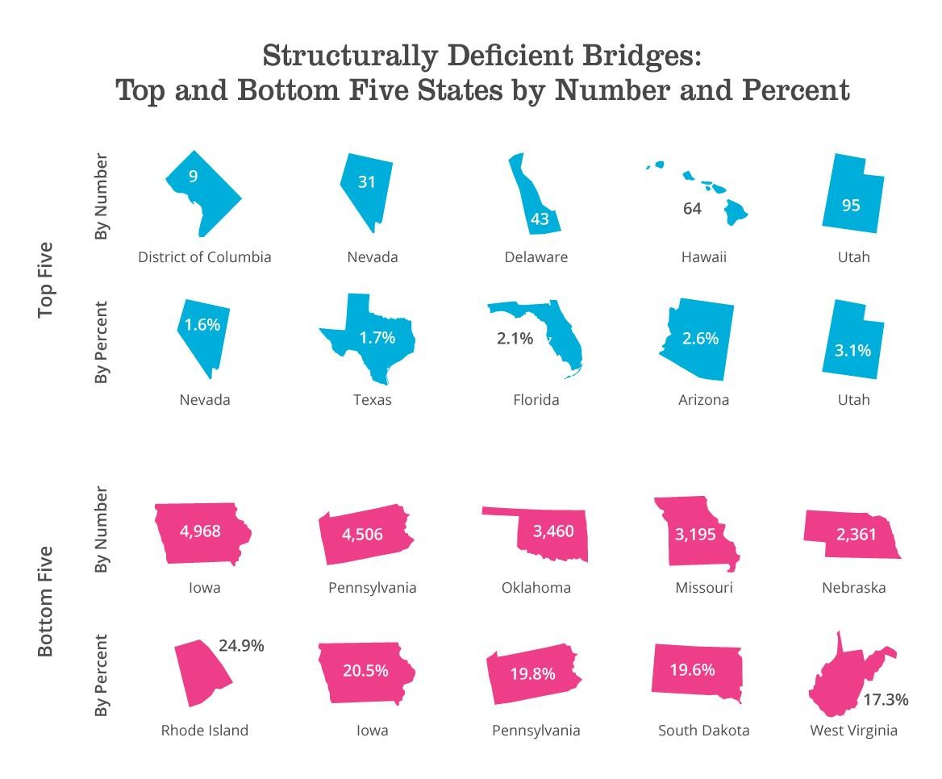
INNOVATION
New technologies and materials are helping engineers build bridges better and faster while also improving maintenance for longer bridge life. Sensors are being embedded into both new and existing bridges to provide continuous feedback on structural conditions. These data help engineers identify and address problems earlier and improve public safety. New materials such as ultra-high performance concrete, high performance steel, and composites are being used to add durability, higher strengths, resilience, and longer life to bridges. Prefabricated bridge elements—structural components that are built off-site—are being used to reduce the amount of time traffic needs to be disrupted while a bridge is repaired or constructed.

RECOMMENDATIONS TO RAISE THE GRADE
1. Increase funding from all levels of government to continue reducing the number of structurally deficient bridges, decrease the maintenance backlog, and address the large number of bridges that have passed or are approaching the end of their design life.
2. Bridge owners should consider the costs across a bridge’s entire lifecycle to make smart design decisions and prioritize maintenance and rehabilitation.
3. Fix the federal Highway Trust Fund by raising the federal motor fuels tax. To ensure long-term, sustainable funding for the federal surface transportation program, the current user fee of 18.4 cents per gallon on gasoline and 24.4 cents per gallon on diesel should be raised and tied to inflation to restore its purchasing power, fill the funding deficit, and ensure reliable funding for the future.
4. States should ensure their funding mechanisms (motor fuels taxes or other) are sufficient to fund needed investment in bridges.
5. States and the federal government should consider long-term funding solutions for transportation infrastructure and potential alternatives to the motor fuel taxes, including further study and piloting of mileage-based user fees.

DEFINITIONS
Structurally deficient – Bridges that require significant maintenance, rehabilitation, or replacement. These bridges must be inspected at least every year since critical load-carrying elements were founds to be in poor condition due to deterioration or damage.

Functionally obsolete – Bridges that do not meet current engineering standards, such as narrow lanes
or low load-carrying capacity. A bridge that is both structurally deficient and functionally obsolete is only counted as structurally deficient.

SOURCES
ASCE analysis of U.S. Department of Transportation, Federal Highway Administration. National Bridge
Inventory ASCII files.
U.S. Department of Transportation, Federal Highway Administration. 20 15 Status o f the Natio n’s
Highways, Bridges and Transit: Conditions and Performance. January 2017.

U.S. Government Accountability Office. Report to Congressional Committees: Highway Bridges—Linking
Funding to Conditions May Help Demonstrate Impact of Federal Investment. September 2016.

