The “Wars” on Crime and Drugs Sources.

Document A: Origins Article
- Think, Pair, Share Warm Up
- Station 5

“From Harlem to Ferguson: LBJ’s War on Crime and America’s Prison Crisis”
http://origins.osu.edu/article/harlem-ferguson-lbjs-war-crime-and-americas-prison-crisis

Flamm, M. W. (2015, April). From Harlem to Ferguson: LBJ's War on Crime and America's
Prison Crisis. Origins: Current Events in Historical Perspective, 8(7).

Document B: Children of Incarcerated Parents
Station 1: Statistics #1

Image pulled from:
[The Atlantic]. (2015, October 2). Mass Incarceration, Visualized. [Video File]. Retrieved from
https://www.youtube.com/watch?v=u51_pzax4M0

Document C: Imprisonment of black men, high school dropouts, under 35
Station 1: Statistics #1

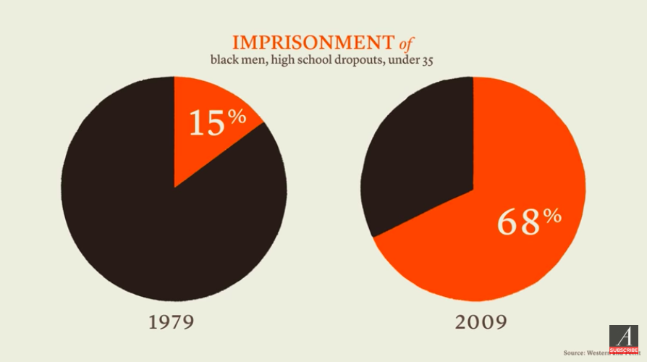

Image pulled from:
[The Atlantic]. (2015, October 2). Mass Incarceration, Visualized. [Video File]. Retrieved from
https://www.youtube.com/watch?v=u51_pzax4M0

Document D: Risk of Parental Imprisonment
Station 1: Statistics #1

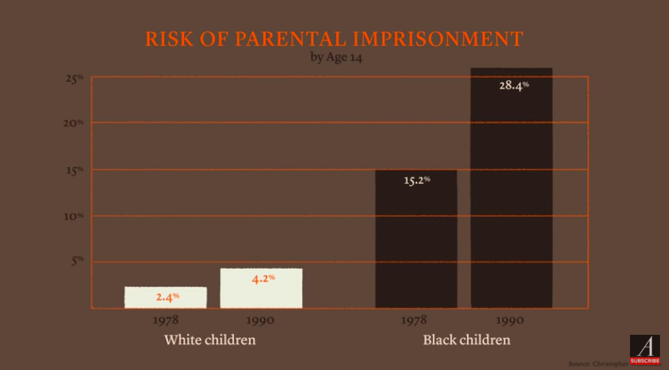

Image pulled from:
[The Atlantic]. (2015, October 2). Mass Incarceration, Visualized. [Video File]. Retrieved from
https://www.youtube.com/watch?v=u51_pzax4M0

Document E: The New Jim Crow
Station 2: The New Jim Crow

“In the era of colorblindness, it is no longer socially permissible to use race, explicitly, as a justification for discrimination, exclusion, and social contempt. So we don't. Rather than rely on race, we use our criminal justice system to label people of color "criminals" and then engage in all the practices we supposedly left behind. Today it is perfectly legal to discriminate against criminals in nearly all the ways it was once legal to discriminate against African Americans. Once you're labeled a felon, the old forms of discrimination-employment discrimination, housing discrimination, denial of the right to vote, and exclusion from jury service-are suddenly legal. As a criminal, you have scarcely more rights, and arguably less respect, than a black man living in Alabama at the height of Jim Crow.”

“The overwhelming majority of the increase in imprisonment has been poor people of color, with the most astonishing rates of incarceration found among black men.”

“So what accounts for this vast new system of control? Crime rates? That is the common answer. But no, crime rates have remarkably little to do with skyrocketing incarceration rates. Crime rates have fluctuated over the past thirty years, and are currently at historical lows, but incarceration rates have consistently soared.”

“The War on Drugs and the "get tough" movement explain the explosion in incarceration in the United States and the emergence of a vast, new racial undercaste. In fact, drug convictions alone accounted for about two-thirds of the increase in the federal system, and more than half of the increase in the state prison population between 1985 and 2000. Drug convictions have increased more than 1000% since the drug war began, an increase that bears no relationship to patterns of drug use or sales.”

“People of all races use and sell drugs at remarkably similar rates, but the enemy in this war has been racially defined. The drug war has been waged almost exclusively in poor communities of color, despite the fact that studies consistently indicate that people of all races use and sell drugs at remarkably similar rates.”

“In fact, the research suggests that where significant differences by race can be found, white youth are more likely to commit drug crimes than youth of color.”

“To get a sense of how large a contribution the drug war has made to mass incarceration, consider this: there are more people in prison today just for drug offenses than were incarcerated in 1980 for all reasons. The reality is that the overwhelming majority of people who are swept into this system are non-violent offenders.”

Alexander, Michelle. The New Jim Crow. Ohio State Journal of Criminal Law, vol. 9, no. 1
(2011), 7-26.

Document F: Grammys 2016: Watch Kendrick Lamar’s stunning performance
Station 3: Kendrick Lamar Performance

Play the video from the following link. Watch at least (0:00-1:35).

https://www.theverge.com/2016/2/15/11004624/grammys-2016-watch-kendrick-lamar-perform-alright-the-blacker-the-berry

Singleton, M. (2016, February 16). Watch Kendrick Lamar's stunning performance from the
2016 Grammys. Retrieved March 6, 2020, from https://www.theverge.com/2016/2/15/11004624/grammys-2016-watch-kendrick
lamar-perform-alright-the-blacker-the-berry

Document G: Kendrick Lamar’s Performance TranscriptStation 3: Kendrick Lamar’s Performance

I'm the biggest hypocrite of 2015
I'm the biggest hypocrite of 2015
Once I finish this, if you listenin’ sure you will agree
Been feeling this way since I was 16, came to my senses
You never liked us anyway, bump your friendship, I meant it
I'm African-American, I'm African
I'm black as the moon, heritage of a small village
Pardon my residence
Came from the bottom of mankind
My hair is nappy, you know that it’s big, my nose is round and wide
You hate me don't you?
You hate my people, your plan is to terminate my culture
You know you’re evil I want you to recognize that I'm a proud monkey
You vandalize my perception but can't take style from me
And this is more than confession
I mean I might press the button just so you know my discretion
I'm guardin' my feelins, I know that you feel it
You sabotage my community, makin' a killin'
You made me a killer, emancipation of a real hitta

As we proceed to give ya what you need
Trap our bodies but can’t lock our minds
Everybody just stop.
Document H: Incarceration Rate Timeline
Station 4: Statistics #2
Graph pulled from:
Flamm, M. W. (2015, April). From Harlem to Ferguson: LBJ's War on Crime and America's
Prison Crisis. Origins: Current Events in Historical Perspective, 8(7).

Document I: Global Incarceration Rates
Station 4: Statistics #2

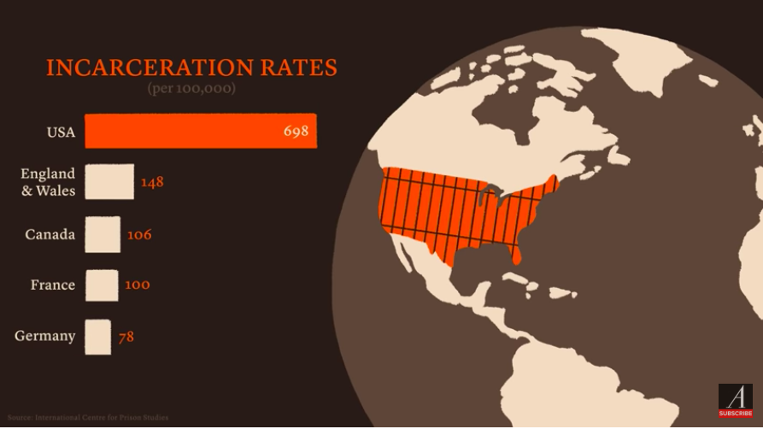
Image pulled from:
[The Atlantic]. (2015, October 2). Mass Incarceration, Visualized. [Video File]. Retrieved from
https://www.youtube.com/watch?v=u51_pzax4M0
Document J: Racial and ethnic disparities in correctional facilities
Station 4: Statistics #2

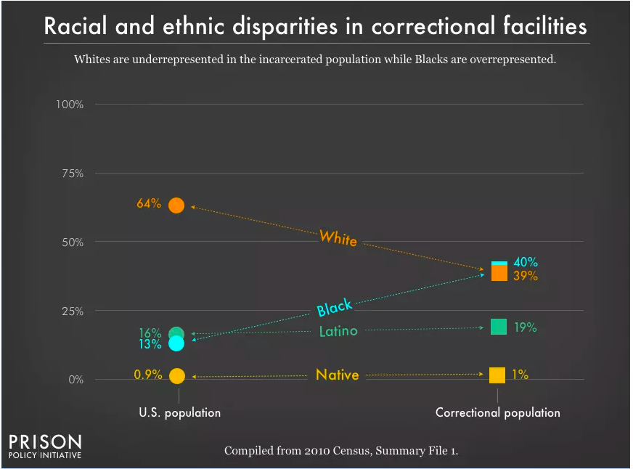

Image pulled from:
Sawyer, W., & Wagner, P. (2019, March 19). Mass Incarceration: The Whole Pie 2019. Retrieved
March 6, 2020, from https://www.prisonpolicy.org/reports/pie2019.html

Document K: The future of race in America: Michelle Alexander at TEDxColumbus
Station 6: Michelle Alexander TED Talk

Play the video from the following link. Watch at least (0:29-2:14).
https://www.youtube.com/watch?v=SQ6H-Mz6hgw

[TEDx Talks]. (2013, October 16). The future of race in America: Michelle Alexander at
TEDxColumbus. [Video File].
Retrieved from https://www.youtube.com/watch?v=SQ6H-Mz6hgw

Supplemental Sources:

Document L: The New Jim Crow: Mass Incarceration in the Age of Colorblindness

Alexander, Michelle. The New Jim Crow : Mass Incarceration in the Age of Colorblindness. New York : [Jackson, Tenn.] :New Press ; Distributed by Perseus Distribution, 2010.

Document M: Mass Incarceration, Visualized

https://www.youtube.com/watch?v=u51_pzax4M0

[The Atlantic]. (2015, October 2). Mass Incarceration, Visualized. [Video File]. Retrieved from
https://www.youtube.com/watch?v=u51_pzax4M0

Document N: Mass Incarceration: The Whole Pie 2019

https://www.prisonpolicy.org/reports/pie2019.html

Sawyer, W., & Wagner, P. (2019, March 19). Mass Incarceration: The Whole Pie 2019. Retrieved
March 6, 2020, from https://www.prisonpolicy.org/reports/pie2019.html

