Alternative Sources: Westward Expansion & Imperialism: Two Sides of the Same Coin?

Document One: (n.a.) Retrieved from: http://nairobiwire.com/2015/05/unbelievable-colonial-advertisement-selling-karen-land-at-sh2000-per-acre.html

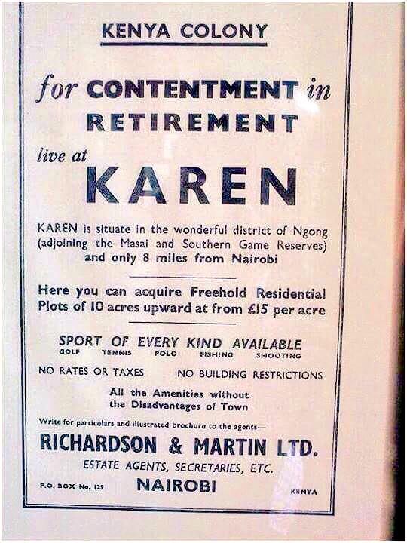

Document Two: (n.a.) Retrieved From: https://iltf.org/land-issues/issues/

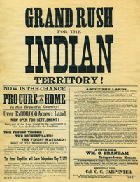

Document Three A and B:
(n.a.) Retrieved From: http://carlisleindian.dickinson.edu/teach/analyzing-and-after-photographs-exploring-student-files

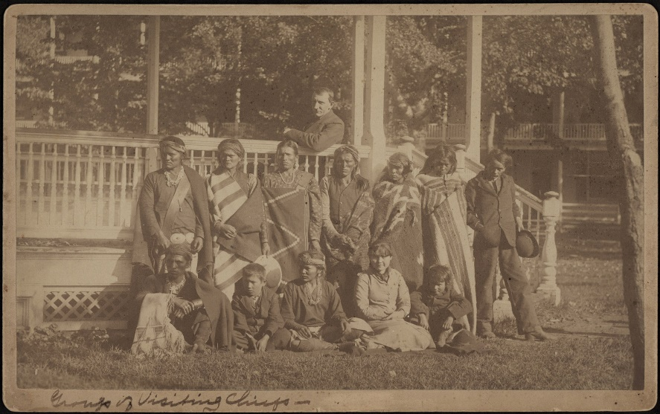

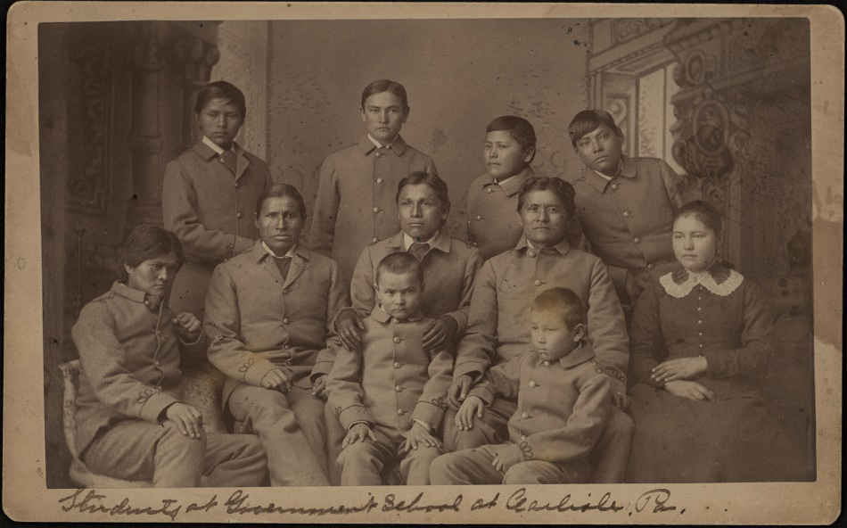

Document Four:
Retrieved from: http://carlisleindian.dickinson.edu/teach/analyzing-and-after-photographs-exploring-student-files

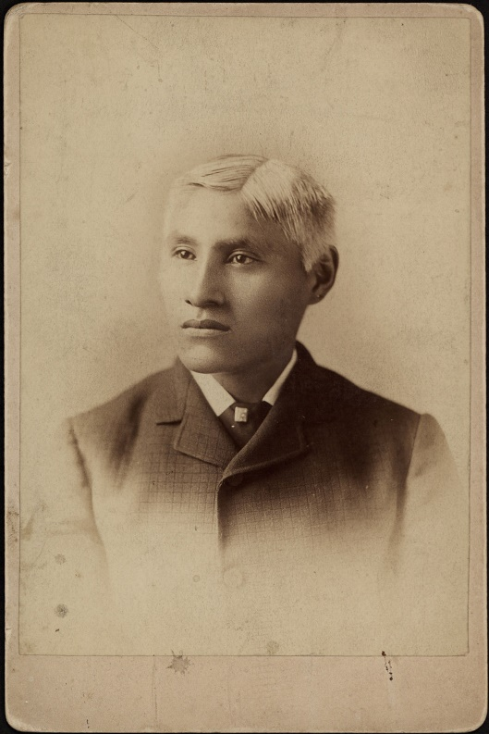

Document E:
Retrieved From https://schoolingtheworldgirls.wordpress.com/2013/07/02/the-white-mans-last-burden-education/

