Student Loan Timeline Graph

Directions: Below, you will find a list of events. Place each event on the graph on the next page. Just draw arrows to the year, and then write the number that correlates with the event. After you have completed this, answer the questions that correspond.

#1- 1944- The passage of the GI Bill
#2- 1945- End of WWII
#3- 1958- First student loan program, the National Defense Education Act, is implemented (Introduction of Perkins Loans)
#4- 1965- Higher Education Act (Introduction of Stafford Loans and Pell Grants)
#5- 1966- Peacetime GI Bill
#6- 1972- Creation of Sallie Mae
#7- 1993- Signed into law; allowed federal government to make loans directly
#8- 1996- Introduction of 529 Plans
#9- 2004- Sallie Mae privatizes

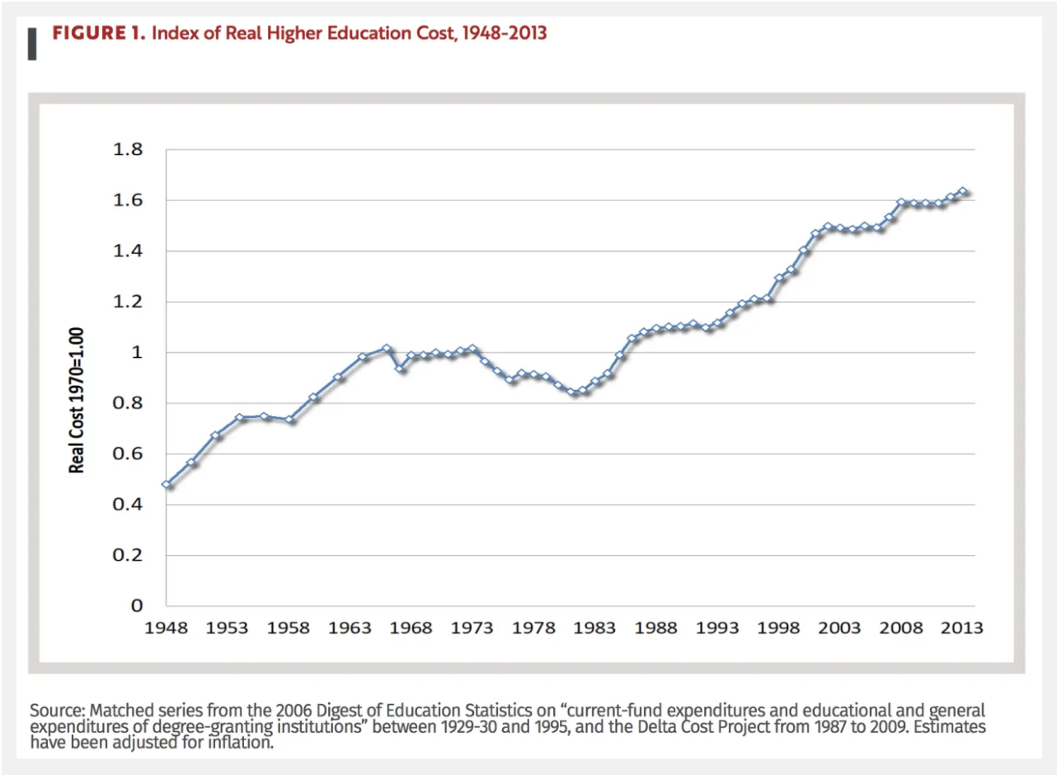
Questions

- What happened to the costs of education after WWII?

- What was the trend between 1953 and 1958? What is the trend after 1958? Why do you think that is?

- What happened to the cost of education after the introduction of Pell Grants and Stafford Loans?

- What has been the trend from 1980 to present? Why might this be the case?

