A History of Stolen Citizenship Why do some votes count less than others?

Document A: “Everything Points to a Democratic Victory”, Retrieved from: http://origins.osu.edu/article/6154/images/.

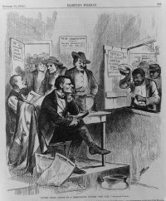

Document B: “March on Washington”, Retrieved from: http://origins.osu.edu/article/6154/images/.

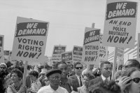

Document C: “Shall St. Louis Be the Slave Master?”, Retrieved from: http://origins.osu.edu/article/6154/images/.

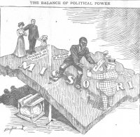

Document D: “Ex-Felon Voting”, Retrieved from: http://origins.osu.edu/article/6154/images/.

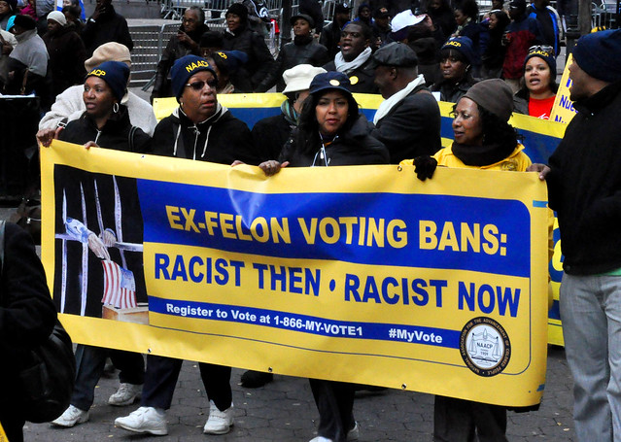

Document E: “Felony Disenfranchisement By State”, Retrieved from: http://origins.osu.edu/article/6154/images/.

