Think-Pair-Share

On your own, come up with at least one example of a piece of cultural heritage (physical, intangible, or natural) for our city.

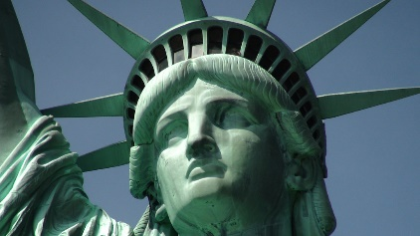

With your partner, compare ideas. Working together, can you think of any more examples? Are they physical, intangible, or natural?

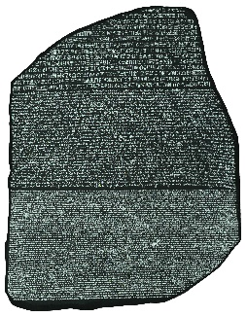

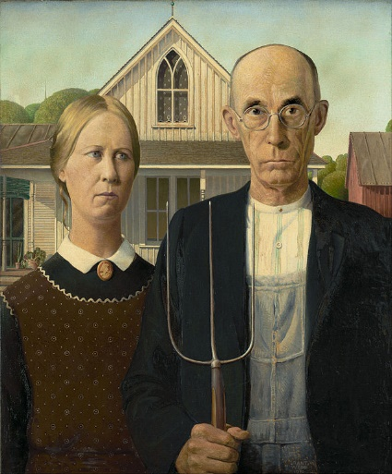
Decide which of your examples to share with the class. Write it down in this box.

