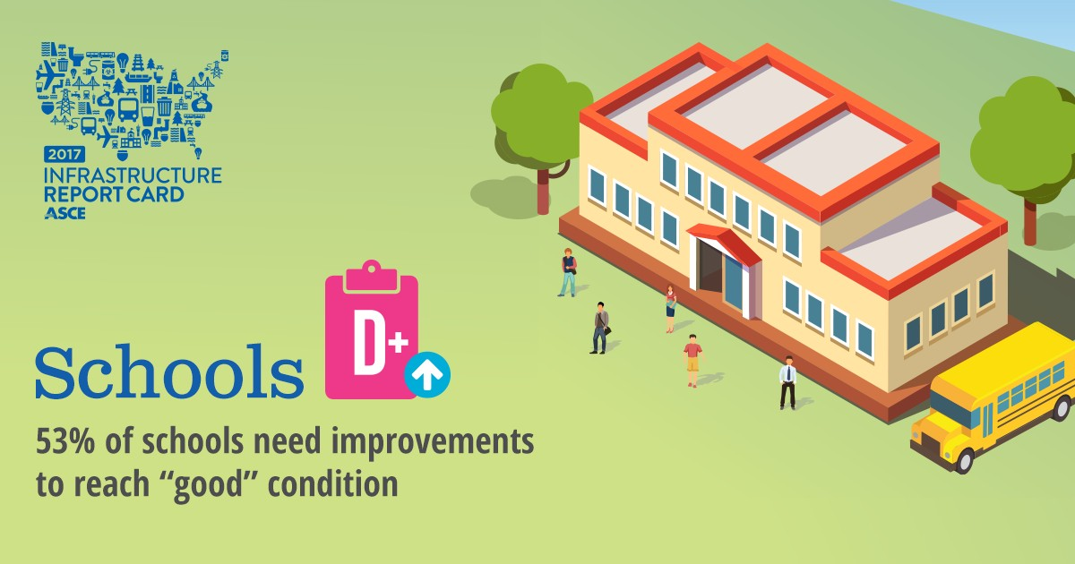

OVERVIEW
Every school day, nearly 50 million K-12 students and six million adults occupy close to 100,000 public school buildings on an estimated two million acres of land. The nation continues to underinvest in school facilities, leaving an estimated $38 billion annual gap. As a result, 24% of public school buildings were rated as being in fair or poor condition. While there have been a number of insightful reports in recent years, state and local governments are plagued by a lack of comprehensive data on public school infrastructure as they seek to fund, plan, construct, and maintain quality school facilities.

CAPACITY & CONDITION
Every school day, nearly 50 million K-12 students and 6 million adults occupy close to 100,000 public
school buildings on an estimated two million acres of land. The student population increased by nearly five million between 1994 and 2013, requiring an additional 13,000 K-12 schools. Enrollment is projected to increase by 3% between the 2013-2014 and 2025-26 academic years – rising from 50 million to 51.4 million students. State and local governments face a constant challenge to keep up with operations and maintenance and the need for new construction, in addition to accommodating improved health and safety standards, stronger accessibility requirements, and new technology.

Recent government statistics show that a significant numbers of public school facilities are not in acceptable condition. Among public schools with permanent buildings – 99% of public schools – almost a quarter (24%) were rated as being in “fair” or “poor” condition. But 31 percent of schools have temporary buildings, either in addition to or instead of permanent buildings, and the number of these schools in “fair” or “poor” condition rises to 45%. In more than 30% of public school facilities, windows, plumbing, and HVAC systems are considered in “fair” or “poor” condition. Outdoor facilities such as parking lots, bus lanes, drop-off areas, fencing, athletic fields, and sidewalks are also problematic. 36%

of school parking lots are in “fair” or “poor” condition, as well as 32% of bus lanes, 31% of athletic facilities, and 27% of playgrounds. More than half (53%) of public schools need to make investments for repairs, renovations, and modernizations to be considered to be in “good” condition.

In many cases, planning is lacking, as four in 10 public schools currently do not have a long-term educational facilities plan in place to address operations and maintenance. The main reason for repair, renovation, or modernization work on school facilities relates to improving energy efficiency as well as technology infrastructure.

FUNDING & FUTURE NEED
School funding varies widely by state. Five states pay for nearly all of their school districts’ capital costs,
12 states provide no direct support for districts for capital construction responsibilities, and in the remaining 33 states, the levels of support vary greatly. The federal government contributes little to no funding for the nation’s K-12 educational facilities.

While school districts collectively invested as much as $49 billion per year in school facilities from 2011
to 2013 for new facilities and capital construction, it is estimated that the nation should be spending $87 billion per year to renew facilities so they provide healthy, safe, and modern learning environments— leaving a $38 billion annual investment gap. In addition, districts need to spend $58 billion annually just to maintain and operate the current inventory of facilities, along with an estimated $77 billion annually to upgrade existing facilities to reduce the backlog of deferred maintenance. Another $10 billion per
year is needed for new construction to accommodate the anticipated increase in enrollments in the coming decade.

Following the 2008 recession, many states reduced overall funding per student and have not restored it, even as enrollments and needs have grown. During the 2014 school year at least 31 states provided less funding than in the 2008 school year, and in at least 15 states, these cuts exceeded 10%. Local government funding also fell in at least 18 states over the same period. While local funding did increase in 27 states, those increases rarely counteracted state-level cuts. And, while most states increased funding per student in 2015, 12 states imposed new cuts.

Facing tight budgets, school districts’ ability to fund maintenance has been constricted, contributing to the accelerating deterioration of heating, cooling, and lighting systems. Deferred maintenance and decisions to choose less expensive temporary fixes are ultimately costing school districts more money in the long-term.

PUBLIC SAFETY & RESILIENCE
In many instances school buildings also serve communities as emergency shelters during man-made or natural disasters. This secondary function has a significant role in public health, safety, and welfare, and requires facilities that are maintained to function in emergencies and resilient to quickly recover. Many schools require upgrades to effectively fulfill this important community purpose, including windows that can withstand high winds, structures designed to survive earthquakes, and rooms specifically designed
as shelters from tornados.

RECOMMENDATIONS TO RAISE THE GRADE
• Governments at every level should regularly assess the needs of their public school facilities and publish this data.
• Maximize flexibility for states to use funds for a variety of projects that should include greening and energy efficiency upgrades, asbestos abatement and removal, improvements to after-school facilities and community spaces, and modifications to comply with the Americans with Disabilities Act.
• Continue to encourage school districts to adopt regular, comprehensive major maintenance, renewal, and construction programs, and implement preventative maintenance programs to extend the life of school facilities.
• Expand federal and state tax credits and matching funds to support increased use of school construction bonds and simplify the process for local school districts to obtain facility construction financing for improvements and modernizations.
• Explore alternative financing, including lease financing, as well as ownership and use arrangements, to facilitate school construction projects.
• Develop capital planning frameworks that can be nimble and responsive to changing technologies and changing demographics, to optimize learning environments and consider the holistic needs of the community.

SOURCES
21st Century School Fund, National Council on School Facilities, The Center for Green Schools, The State
o f Our Schoo ls, Am erica’s K-12 Facilities, 2016

Center on Budget and Policy Priorities, Most States Have Cut School Funding, and Some Continue
Cutting, Jan. 2015

Council of the Great City Schools, Rev ersing the Cy cle o f D eterio ratio n in the Natio n’s P ublic Schoo l
Buildings, Oct. 2014

National Center on Education Statistics, Co nditio n o f Ame rica’s P ublic Schoo l Facilities 2 01 2 -2013, March
2014

U.S. Department of Education, National Center for Education Statistics, 21st Century School Fund

