Sources HIV Past and Present

Document A: A Century of HIV
McDow, T. (n.d.). A century of HIV. Origins. Retrieved April 2, 2022, from https://origins.osu.edu/article/century-hiv-world-aids-day-africa-actup-unaids
(Please see Article Excerpts Document)

Document B: Boy Blue by Cyndi Lauper
YouTube. (2016). YouTube. Retrieved April 2, 2022, from https://www.youtube.com/watch?v=3yV0eZ6bBSg.

Document C: HIV/AIDs Timeline
Centers for Disease Control and Prevention. (n.d.). HIV/AIDS timeline. Centers for Disease Control and Prevention. Retrieved April 2, 2022, from https://npin.cdc.gov/pages/hiv-and-aids-timeline#2015
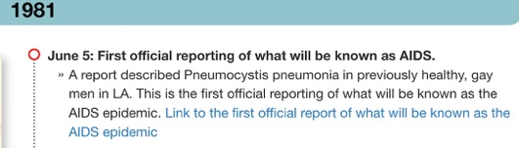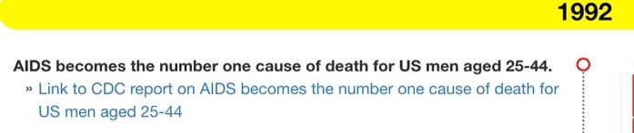
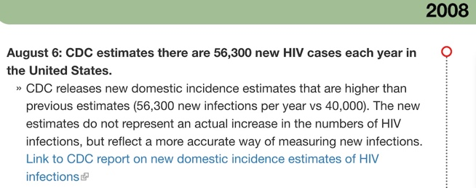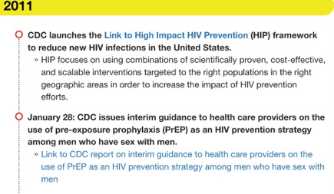
NBCUniversal News Group. (n.d.). Scientists have possibly cured HIV in a woman for the first time. NBCNews.com. Retrieved April 11, 2022, from https://www.nbcnews.com/nbc-out/out-health-and-wellness/scientists-possibly-cured-hiv-woman-first-time-rcna16196


Document D: HIV Among Gay and Bisexual Men (Two-Way Table- Present: LGBTQ+ Community/Stations)
CDC fact sheet: HIV among gay and bisexual men. (n.d.). Retrieved April 2, 2022, from https://www.cdc.gov/nchhstp/newsroom/docs/factsheets/cdc-msm-508.pdf

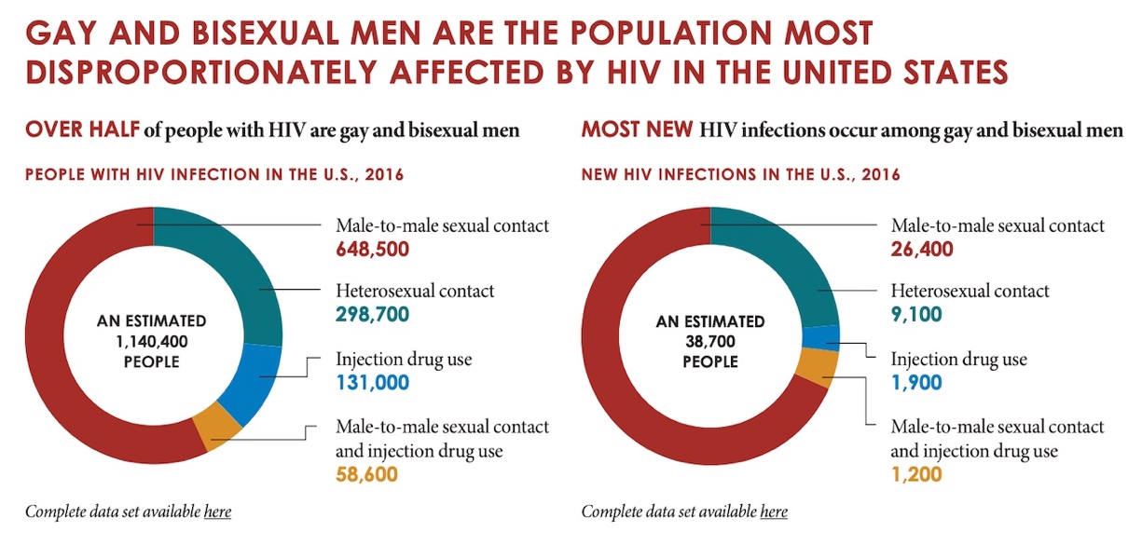

Document E: HIV in the United States and Dependent Areas (Two-Way Table- Present: Black community, Latinx community, white community/Stations)
Centers for Disease Control and Prevention. (2021, August 9). HIV in the United States and dependent areas. Centers for Disease Control and Prevention. Retrieved April 2, 2022, from https://www.cdc.gov/hiv/statistics/overview/ataglance.html#:~:text=By%20Race%2FEthnicity,-Black%2FAfrican%20American&text=In%202019%3A,and%2013%25%20of%20the%20population.&text=Hispanic%2FLatino%20people%20accounted%20for,and%2018%25%20of%20the%20population.

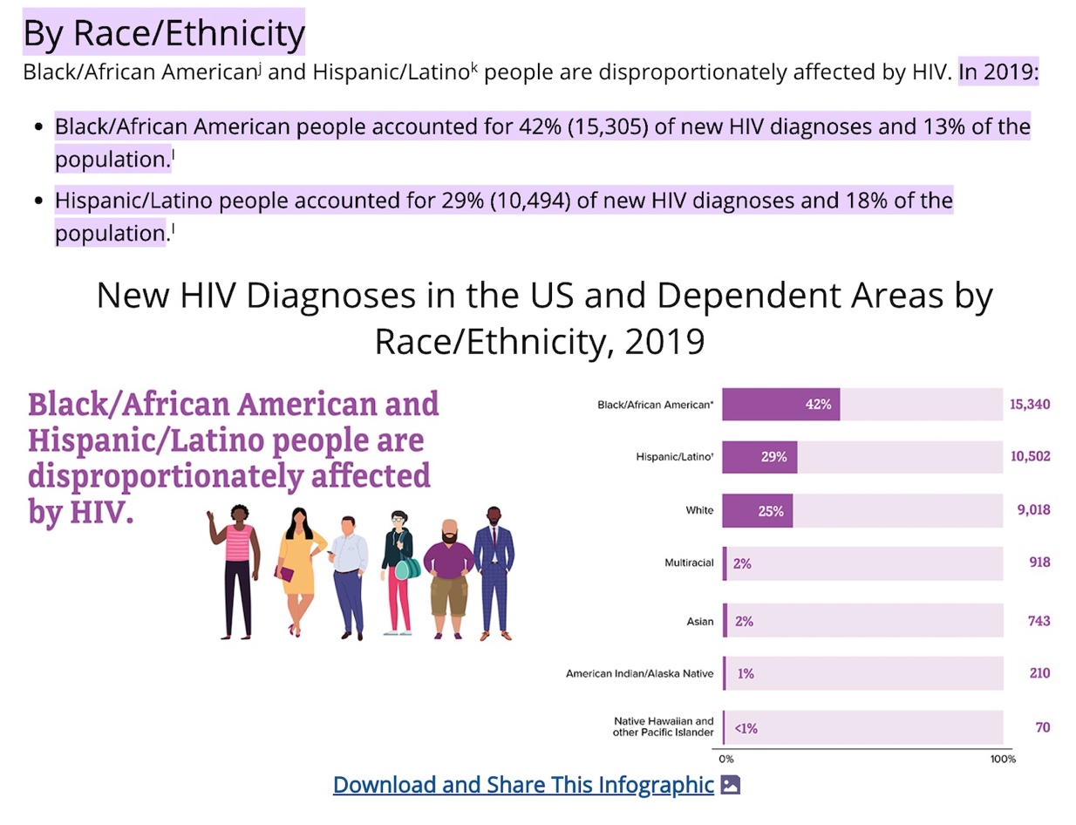

Document F: HIV and AIDs: United States, 1981-2000 (Two-Way Table- Past: Black community, Latinx community, white community/Stations)
Centers for Disease Control and Prevention. (n.d.). HIV and AIDS --- United States, 1981--2000. Centers for Disease Control and Prevention. Retrieved April 2, 2022, from https://www.cdc.gov/mmwr/preview/mmwrhtml/mm5021a2.htm#tab1
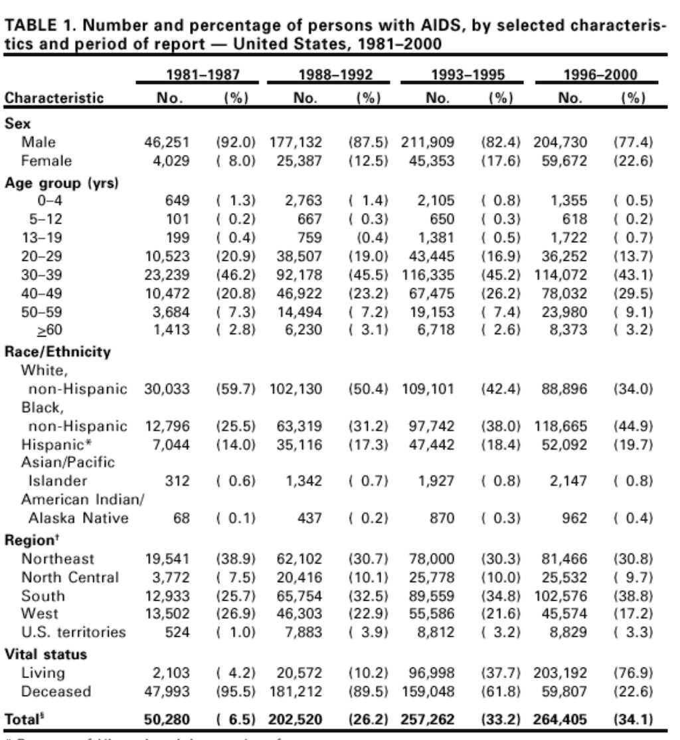

Document G: HIV and AIDs: United States, 1989-1994 (Two-Way Table- Past: LGBTQ+ community/Stations)

Centers for Disease Control and Prevention. (n.d.). Update -- trends in AIDS among men who have sex with men -- United States, 1989-1994. Centers for Disease Control and Prevention. Retrieved April 3, 2022, from https://www.cdc.gov/mmwr/preview/mmwrhtml/00037153.htm
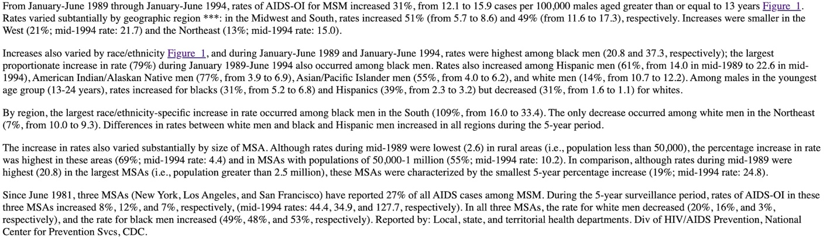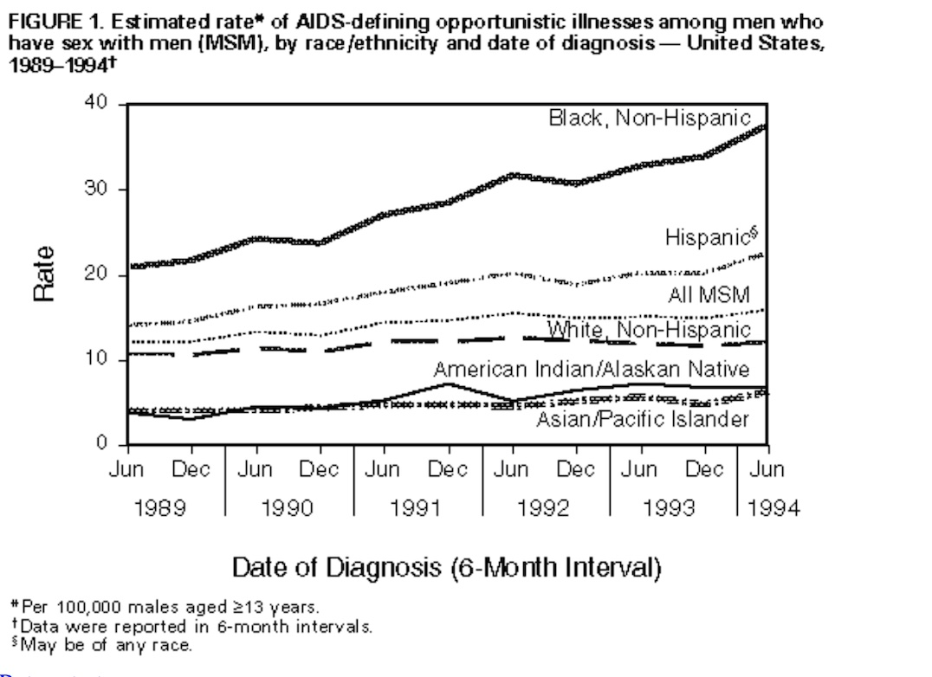

Document H: Image on PowerPoint
Knegt, P. (2012, November 30). Que(e)Ries: Why do we need to watch the second coming of the HIV/AIDS documentary? IndieWire. Retrieved April 3, 2022, from https://www.indiewire.com/2012/11/queeries-why-do-we-need-to-watch-the-second-coming-of-the-hivaids-documentary-42789/
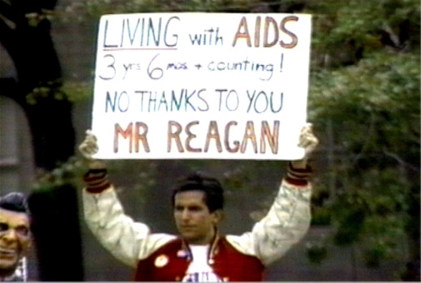

Document I: Image on PowerPoint
Weiner, J., & Weiner, J. (2018, May 4). CCTP 802 – art and media interfaced. CCTP 802 Art and Media Interfaced. Retrieved April 3, 2022, from https://blogs.commons.georgetown.edu/cctp-802-spring2018/2018/05/04/the-art-of-the-aids-crisis-cautionary-oeuvres-from-the-1980s/
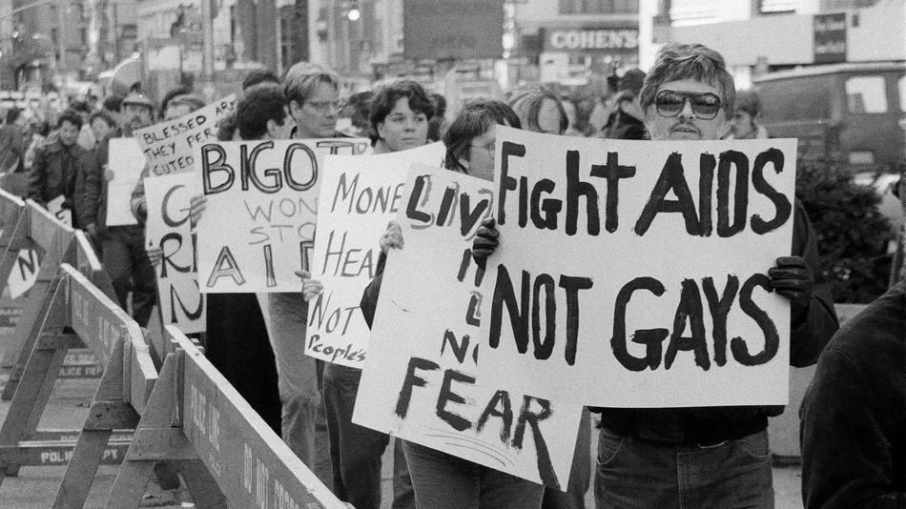

Document J: Image on PowerPoint
Swedberg, S. (2019, July 31). AIDS and AIDS activism in the 1980s United States: A Syllabus. Nursing Clio. Retrieved April 3, 2022, from https://nursingclio.org/2019/07/31/aids-and-aids-activism-in-the-1980s-united-states-a-syllabus/
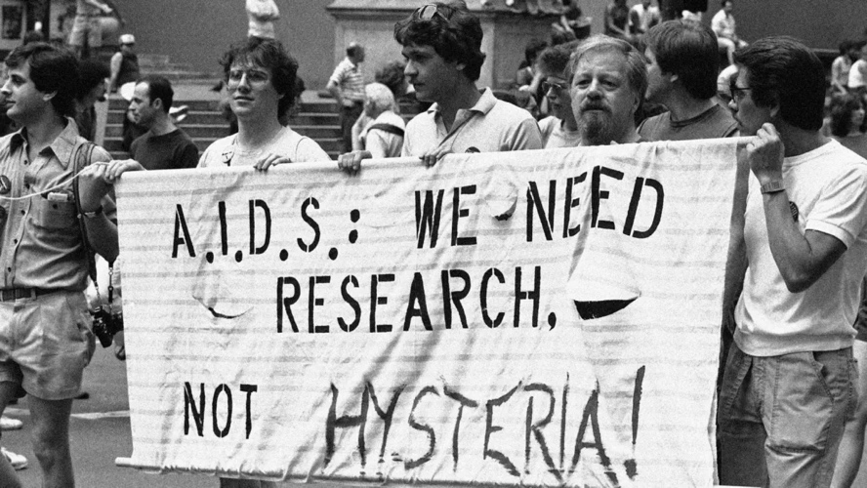

Document K: Image on PowerPoint
AIDS activists look back at the birth of a movement. (n.d.). Retrieved April 3, 2022, from https://www.ny1.com/nyc/all-boroughs/news/2021/06/15/aids-activists-look-back-at-the-birth-of-the-movement
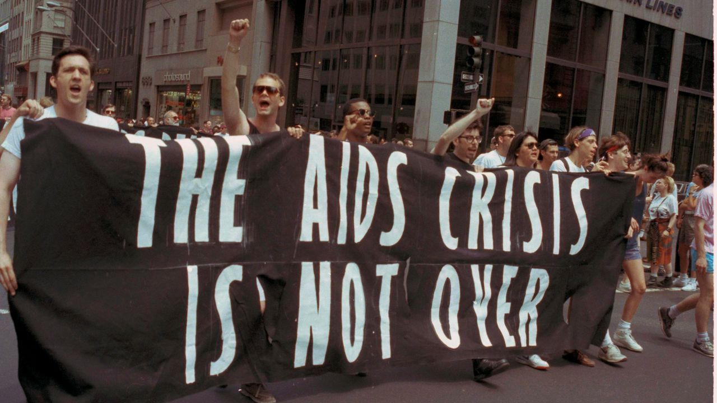

Document L: Image on PowerPoint
Straube, T. (2020, May 28). HIV activists endorse the "Reclaim Pride Coalition" Plan for a Stonewall 50 March. POZ. Retrieved April 3, 2022, from https://www.poz.com/article/hiv-activists-endorse-reclaim-pride-coalition-plan-stonewall-50-march
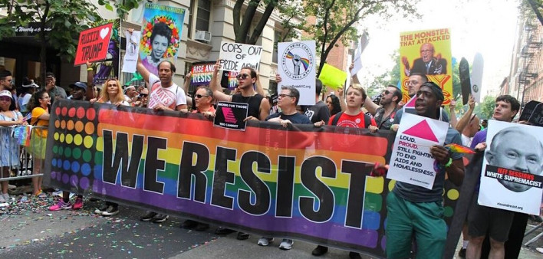

Document M: Image on PowerPoint
Royles, D. (2021, September 21). Lil Nas X: The AIDS activist Gen Z needs. AAIHS. Retrieved April 3, 2022, from https://www.aaihs.org/lil-nas-x-the-aids-activist-gen-z-needs/
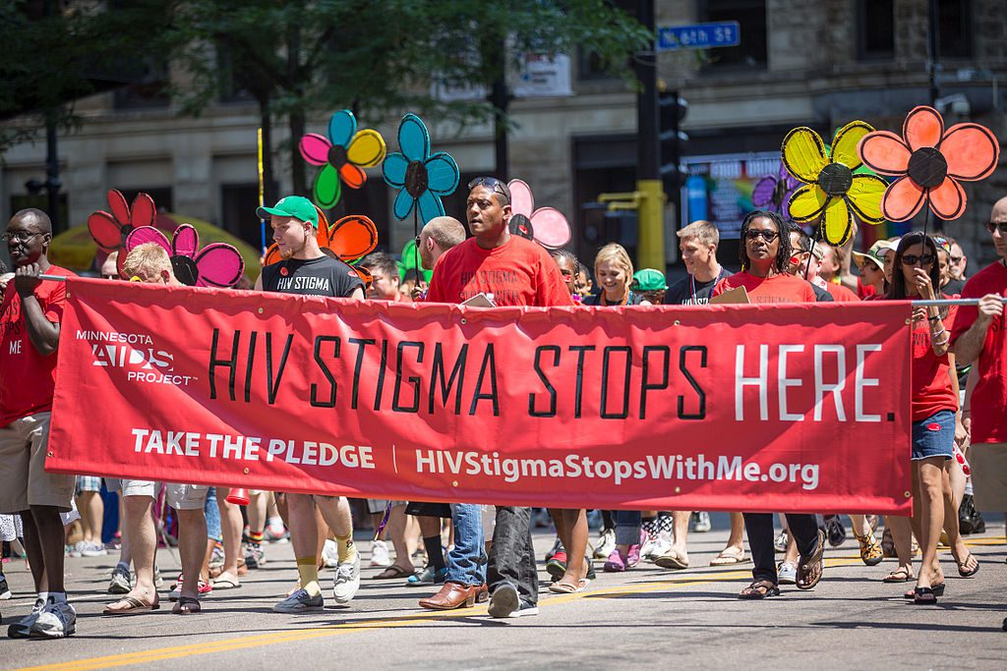

Document N: Image on PowerPoint
History.com Editors. (2021, June 14). AIDS crisis timeline. History.com. Retrieved April 3, 2022, from https://www.history.com/topics/1980s/hiv-aids-crisis-timeline
