Differentiated Sources

Document A: Origins “How We Learned to Love the Constitution”
By James M. Banner Jr.
https://origins.osu.edu/history-news/how-we-learned-love-constitution
“The election of 1800 produced a constitutional crisis, the gravest in our history except for that of 1860. The crisis occurred because of a constitutional anomaly. The original Constitution of 1787 did not require, as did a tardy amendment in 1804, that Electoral College members vote first for candidates for president and then separately for candidates for vice president. When the electoral votes were tallied in December 1800, the Democratic-Republican ticket of Thomas Jefferson and Aaron Burr had soundly defeated the Federalist ticket of John Adams (the incumbent president) and Charles Cotesworth Pinckney, 73 to 65. The trouble was that Jefferson and Burr had both received the same number of votes. Because of this, the election had to be decided by the House of Representatives.
Like either candidate last fall, Burr could have resolved the unintended deadlock by simply withdrawing his name from contention for the presidency. But, opportunistic to a fault, he did not do so. As a result, the Federalist Party, political home of Adams and Alexander Hamilton, was in a perfect position to make mischief by throwing its support to Burr so as to prevent Jefferson’s election by the House.
To resolve an electoral vote deadlock, the House, then as now, voted by states, not individual members. Election required the votes of a simple majority of states; in 1801, Jefferson needed the votes of nine of the sixteen states to be elected. But only eight states were firmly in his camp. Here was the trouble, and the Federalists made the most of it.
Unlike the crisis this past fall, which was settled by the courts, the crisis of 1801 could be settled constitutionally only by the House. And the Federalists would not let that happen. For 35 ballots, stretching over six days beginning on February 11, the House voted and voted again, each time with the same result — too few states to put Jefferson over the top. Ill members arrived on stretchers; others slept in the House chambers. Rumors spread that armed units loyal to Jefferson were gathering to ensure his election. Yet no one would budge.
Finally, after the thirty-fifth ballot, a single Federalist, James A. Bayard, Delaware’s sole representative, took a crucial step. He announced to his Federalist colleagues that on the next vote he would withhold his state’s vote from Burr. Bayard’s decision prompted enough other Federalists to withdraw their votes from Burr so that, on February 17, the Squire of Monticello attained the majority of states he needed for election. Roughly two weeks later, on March 4, he was duly inaugurated third president of the United States. Constitutional breakdown, and perhaps armed conflict, had been averted.
Despite the cost to his own party (which never recovered from its defeat) and to himself (he lost his House seat in the next election), Bayard had elevated the Constitution above considerations of party or self. He had made the Constitution the stated measure of law and politics. No one had ever done that before. Bayard’s was the first act of pure constitutionalism — putting the Constitution above considerations of person or party — in American history.
We take for granted these days appeals to the Constitution, both sincere and demagogic. Last fall, all factions appealed to constitutional rectitude, constitutional tradition, constitutional right. Those appeals, even when lacking sincerity, owed much to the act of a single man from a small state long ago. As the turbulent but peaceful resolution of the electoral confusion last fall demonstrates, the Constitution’s supremacy remains the bedrock of our political life.

Document B: Library of Congress: Creating the United States: Election of 1800
https://www.loc.gov/exhibits/creating-the-united-states/election-of-1800.html
In the election of 1800, the Federalist incumbent John Adams ran against the rising Republican Thomas Jefferson. The extremely partisan and outright nasty campaign failed to provide a clear winner because of a constitutional quirk. Presidential electors were required to vote for two people for the offices of president and vice-president. The individual receiving the highest number of votes would become president. Unfortunately Jefferson and his vice-presidential running mate Aaron Burr both received the identical number of electoral votes, and the House of Representatives voted to break the tie. When Adams’s Federalists attempted to keep Jefferson from the presidency, the stage was set for the first critical constitutional crisis of the new American federal republic.
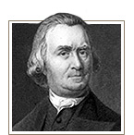
"The storm is over, and we are in port."
Thomas Jefferson to Samuel Adams, March 29, 1801

Solution to Dispute over Electing President
The manner of electing a national president sparked one of the most contentious debates at the federal Constitutional Convention. The convention rejected direct election of the president by “the people,” in favor of a system of electors equal to the number of senators and representatives and to be chosen by the states. Designed to insulate the electors from undue influence, the system required that they cast independent votes for president and vice president.

Document C: Library of Congress: Presidential Election of 1800: A Resource Guide https://www.loc.gov/rr/program/bib/elections/election1800.html#:~:text=%22Democratic%2DRepublican%20Thomas%20Jefferson%20defeated,vice%20president%20on%20their%20ballots

1800 Presidential Election Results

"Democratic-Republican Thomas Jefferson defeated Federalist John Adams by a margin of seventy-three to sixty-five electoral votes in the presidential election of 1800. When presidential electors cast their votes, however, they failed to distinguish between the office of president and vice president on their ballots. Jefferson and his running mate Aaron Burr each received seventy-three votes. With the votes tied, the election was thrown to the House of Representatives as required by Article II, Section 1 of the U.S. Constitution. There, each state voted as a unit to decide the election.

Still dominated by Federalists, the sitting Congress loathed to vote for Jefferson—their partisan nemesis. For six days starting on February 11, 1801, Jefferson and Burr essentially ran against each other in the House. Votes were tallied over thirty times, yet neither man captured the necessary majority of nine states. Eventually, Federalist James A. Bayard of Delaware, under intense pressure and fearing for the future of the Union, made known his intention to break the impasse. As Delaware’s lone representative, Bayard controlled the state’s entire vote. On the thirty-sixth ballot, Bayard and other Federalists from South Carolina, Maryland, and Vermont cast blank ballots, breaking the deadlock and giving Jefferson the support of ten states, enough to win the presidency."

Document D: National Archives: Tally of Electoral Votes for the 1800 Presidential Election https://www.archives.gov/legislative/features/1800-election/1800-election.html

Tally of Electoral Votes for the 1800 Presidential Election
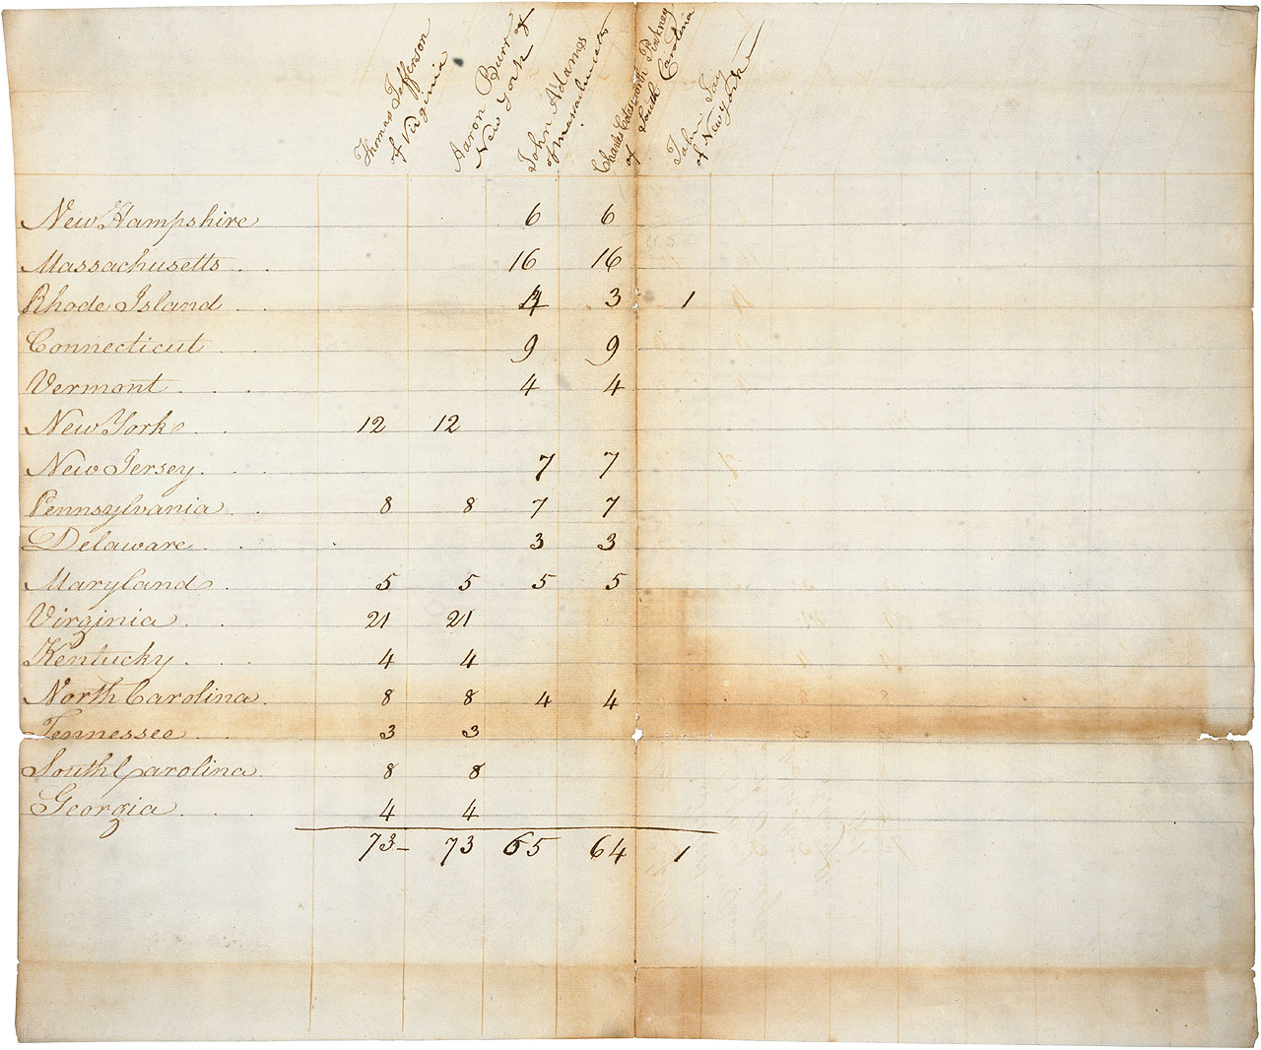
Tally of Electoral Votes for the 1800 Presidential Election, February 11, 1801.

By the election of 1800, the nation's first two parties were beginning to take shape. The Presidential race was hotly contested between the Federalist President, John Adams, and the Democratic-Republican candidate, Thomas Jefferson. Because the Constitution did not distinguish between President and Vice-President in the votes cast by each state's electors in the Electoral College, both Jefferson and his running mate Aaron Burr received 73 votes.

According to the Article II, Section 1 of the Constitution, if two candidates each received a majority of the electoral votes but are tied, the House of Representatives would determine which one would be President. Therefore, the decision rested with the lame duck, Federalist-controlled House of Representatives. Thirty-five ballots were cast over five days but neither candidate received a majority. Many Federalists saw Jefferson as their principal foe, whose election was to be avoided at all costs. But Alexander Hamilton, a well-respected Federalist party leader, hated Burr and advised Federalists in Congress that Jefferson was the safer choice. Finally, on February 17, 1801, on the thirty-sixth ballot, the House elected Thomas Jefferson to be President.

The tie vote between Jefferson and Burr in the 1801 Electoral College pointed out problems with the electoral system. The framers of the Constitution had not anticipated such a tie nor had they considered the possibility of the election of a President or Vice President from opposing factions - which had been the case in the 1796 election. In 1804, the passage of the 12th Amendment corrected these problems by providing for separate Electoral College votes for President and Vice President.

Document E: National Archive: 12th Amendment

See below.

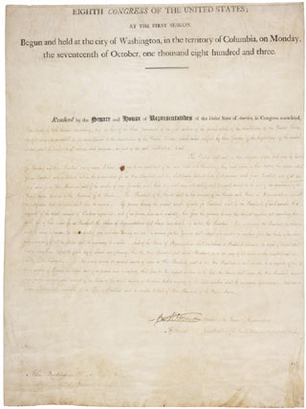

12th Amendment, December 9, 1803; Enrolled acts and resolutions of the United States Congress, 8th Congress; General Records of the U.S. Government; Record Group 11; National Archives.
Passed by Congress December 9, 1803, and ratified June 15, 1804, the 12th Amendment provided for separate Electoral College votes for President and Vice President, correcting weaknesses in the earlier electoral system which were responsible for the controversial Presidential Election of 1800.
Excerpt from the 12th amendment

“they shall name in their ballots the person voted for as President, and in distinct ballots the person voted for as Vice-President, and they shall make distinct lists of all persons voted for as President, and of all persons voted for as Vice-President, and of the number of votes for each, which lists they shall sign and certify, and transmit sealed to the seat of the government of the United States, directed to the President of the Senate”

