Sources Template Modify as Necessary

Document A: Before and After Image of the East Arm of Alaska's Glacier Bay, NASA. (2019). Images of Change - East Arm of Alaska's Glacier Bay Down to One Calving Glacier. Retrieved from https://climate.nasa.gov/images-of-change/?id=775#775-east-arm-of-alaskas-glacier-bay-down-to-one-calving-glacier

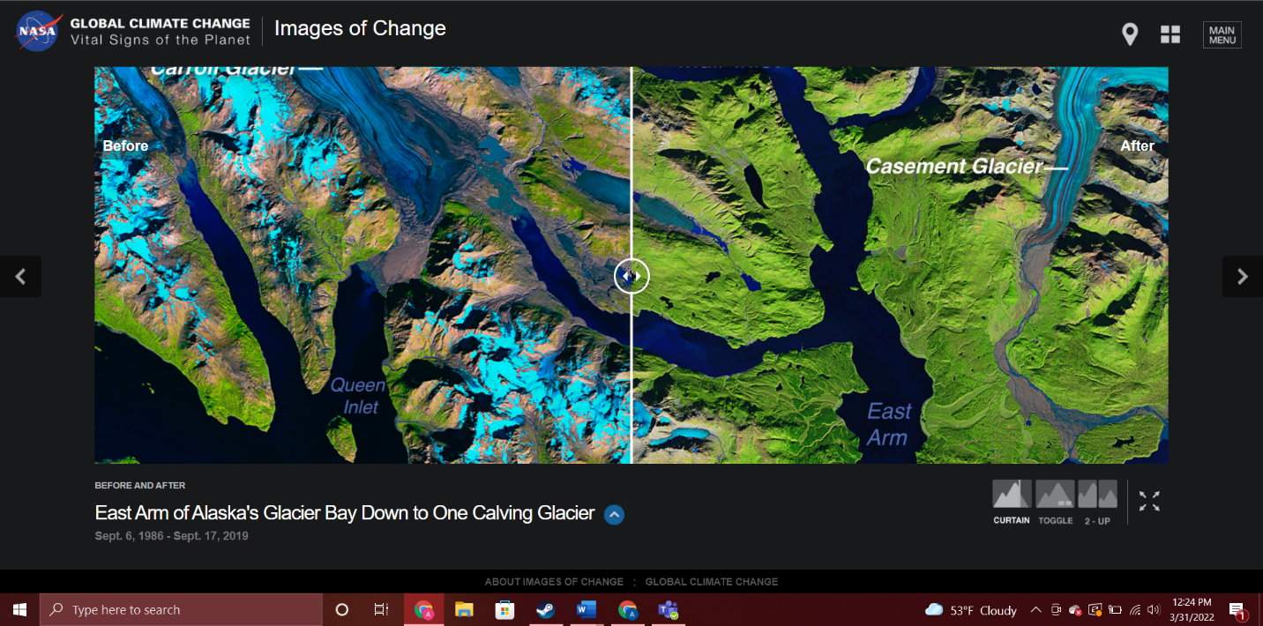

This is an interactive image on the website. You can slide the bar in the middle to show the entire image in 1989 and in 2019. This is a screenshot while the bar is placed in the middle so you can see the before and after at the same time.

Document B: Alaskan Native Elders Tell Their Climate Change Story, PBS Terra. (2021). Alaskan Native Elders Tell Their Climate Change Story | After the Ice. Retrieved from https://www.youtube.com/watch?v=OzMkyeYP7NM

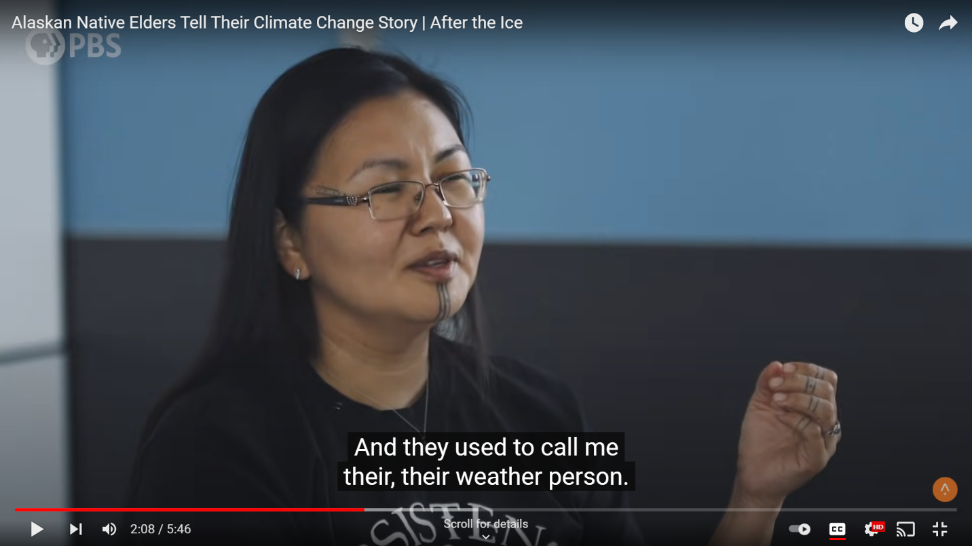
This YouTube video interviews Indigenous people from Alaska about how Climate Change has impacted their life and home.

Document C: Select paragraphs from Killing the Arctic, McCannon, John. (2020). Killing the Arctic. Origins, The Ohio State University.

Killing the Arctic

By John McCannon
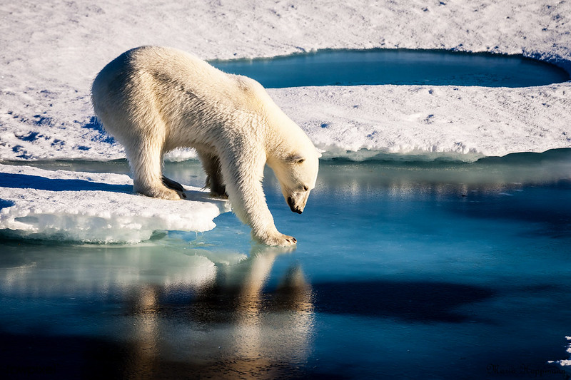
A polar bear steps off an ice slab into the Arctic waters.
We have always been killing the Arctic.
By “we” I mean non-native Westerners, who began entering the higher latitudes in substantial numbers around 1200 CE and who have left their imprint on the region ever since.
Whether settling there permanently—often to the detriment of indigenous populations—or sojourning there to hunt, fish, trap, or mine, we have carried out a ceaseless campaign of what I call “Arcticide”: the persistent and accelerating degradation of high northern environments to the point that their demise is nigh inevitable. Of this long and all-but-consummated crime, we are, all of us, guilty.
Arctic temperatures continue to soar. The oceanic ice pack dwindles, country-sized patches of permafrost lose their shape and solidity, wildfires rage, and dozens of species are menaced by extinction. The hottest Arctic temperature ever, a sweltering 100.4° F, was recorded in the Siberian settlement of Verkhoyansk in summer 2020.
The Arctic is Closer Than You Think
Not all readers may be overly alarmed to hear this. After all, the most immediate victims will be circumpolar communities, most of them tiny, all of them located far from the population centers of the south, and animal species that, however iconic, are anything but central to most people’s modern existence. How much will any given individual miss the polar bear—or the narwhal, the caribou, and the walrus?
But the polar worlds are not as distant as we might think, and, to paraphrase Leon Trotsky (at least possibly), while you may not be interested in the Arctic, the Arctic is interested in you.
When the melting of Greenland adds to rising sea levels, coastal cities from Miami to Jakarta will feel it. If the thawing of Arctic pack ice alters the temperature and salinity of the Atlantic basin, key oceanic currents such as the life-giving Gulf Stream could be diverted.
Not only will softening permafrost lose its ability to sequester greenhouse gases, it will likely permit the escape of pathogens and other dangerous substances that have been locked away for centuries.
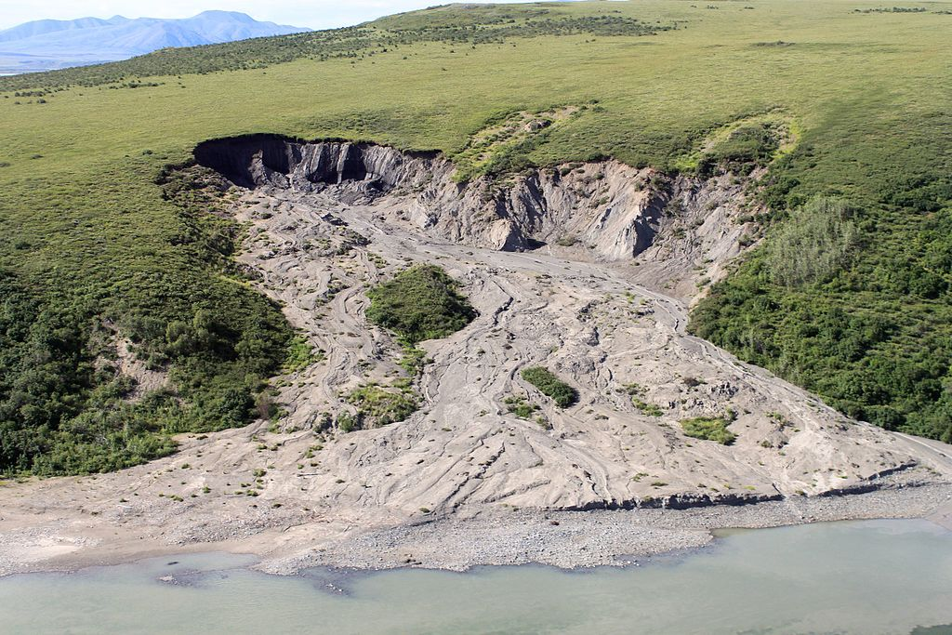
A 300m long slump caused by thawing permafrost at the Noatak National Preserve in Alaska, 2004.
Rising temperatures in the north have weakened the “Arctic fence”—the system of wind currents that normally confine the hemisphere’s coldest air to the highest latitudes—extending the so-called “polar vortex” southward and, according to many scientists, contributing to recent weather extremes in the south, including the merciless “superstorms” that have lately begun to pound seaboards in the United States and elsewhere.
All of these factors make the Arctic not some distant realm, but a global backyard. Reversing the environmental damage we have caused there would be difficult enough, even had bold action been taken years ago.
It has become all the more daunting a task, thanks to the retrograde actions of too many of today’s corporate and political leaders, among them Vladimir Putin, with his aggressive drive to maximize the settlement and economic exploitation of Russia’s Arctic territories, and Donald Trump, with his stunning withdrawal from the 2015 Paris Agreement on climate change and his reckless decision to open up the Alaska National Wildlife Refuge to oil and gas development.
It is all the more urgent now to care about what we are doing to the Arctic—not only for its sake, but also for our own. Our capacity to kill entire ecosystems has grown exponentially. But we too easily forget that the Arctic can hurt us if we continue to hurt it.

Document D: Arctic Sea Ice Extent, NASA. (2022). Arctic sea ice extent. Retrieved from https://climate.nasa.gov/vital-signs/arctic-sea-ice/
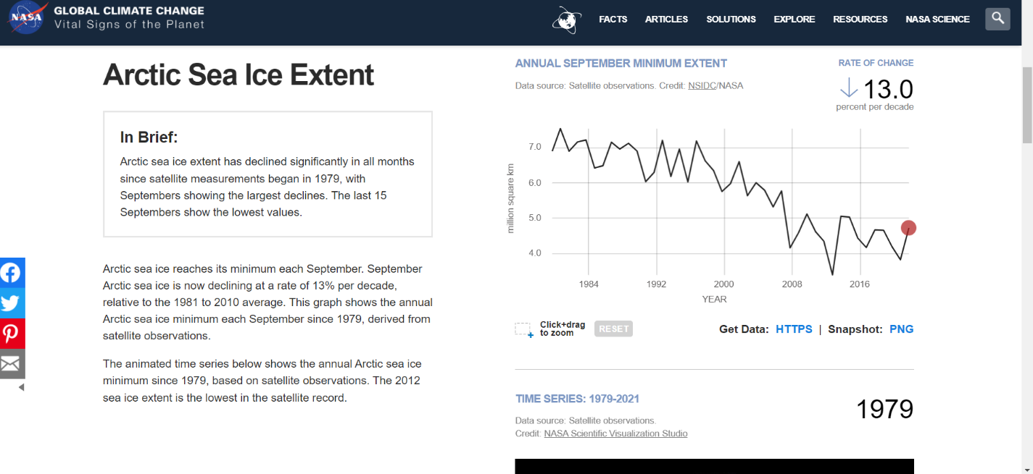

This interactive NASA website allows you to view the Arctic Sea Ice from 1979 to 2021. You can click different parts of the graph to see data from a specific year.

