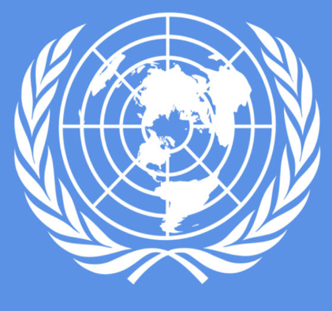
Stations Worksheet Template
Station 1/The Nuremberg Trials Activity/Questions
Read the article and watch the video on the Nuremberg Trials.

- What were the Nuremberg Trials?

- What crimes did the Nazis commit during WWII?

- How did the Nuremberg Trails influence international law?

You will be exploring different cases of international crimes!

At each station you will find a case study…read the text or watch the video at each station.

Work with your group to discuss and answer the questions for each station.
You will have 15-20 minutes at each station!

Station 2/Rwanda Activity/Questions
Read the article on genocide in Rwanda
- What is meant by “international penal tribunal” and how did it come about?

- What happened in Rwanda?

- How did the situation in Rwanda develop international responsibility for genocide?

EXIT TICKET
Station 3/Myanmar and Bangladesh Activity/Questions
Read the article and watch the video on Myanmar

- What happened along the Myanmar-Bangladesh border?

- Why are these crimes against humanity?

- What was one response from the court, from the video, that stuck out to you? Why?
One response that stuck out to me was…
What kinds of injustices are prosecutedin international courts? How?

