Stations Worksheet_____________________________________________________________
In this Stations Activity, you will be looking at sources related to Cuba’s involvement in the American Civil Rights Movement. Each box below corresponds to a station. When you arrive at that station, use the source to help you answer the questions in the box.
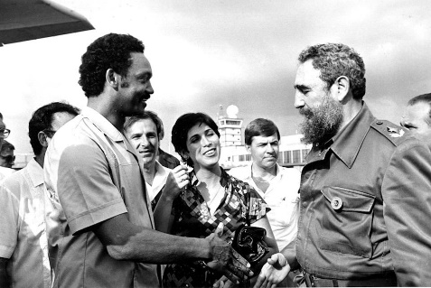

Station 1/4 Activity/Questions
Read through Castro’s speech and answer the questions below.

A: Who in the United States does Castro feel aligned with?

B: What are the three battles that Castro claims to be fighting?

C: Why does Castro say “One has to be very courageous to support Cuba in the United States”?

Station 2/4 Activity/Questions
Read the Intelligence Report on CIA Assassination Plots and answer the questions below

A: Who/What did the CIA consider to be Cuba’s most important asset?

B: What was the National Security Council considering doing in this report?

C: Why might Castro have posed such a threat to the United States?

Station 3/4 Activity/Questions
Read the secondary source about Cuban comments on racial issues in the US and answer the questions below.

A: How did Cuba plan to express solidarity with the African-American community and show them what they should expect from their country?

B: What is being suggested in the last sentence? How would Cuba benefit from bringing up racial issues in the US?

C: Do you believe that Cuba’s government was sincerely interested in racial discrimination in the United States or do you think that Cuba’s support of African Americans was motivated by other political motivations? Why?
Station 4/4 Activity/Questions
Read African Americans, Anti-Racism, and Cuba and answer the questions below.

A: How were the Black Panther Party and Cuba aligned?

B: How did Jesse Jackson work to normalize relations between Cuba and the United States?

C: Why might the US have been concerned about the growth of movements like the Black Panther Party?

