Differentiated Sources for Stations

Document A: Excerpts from Susie Baker’s memoir Reminiscences of My Life in Camp pp. 5, 9, 11

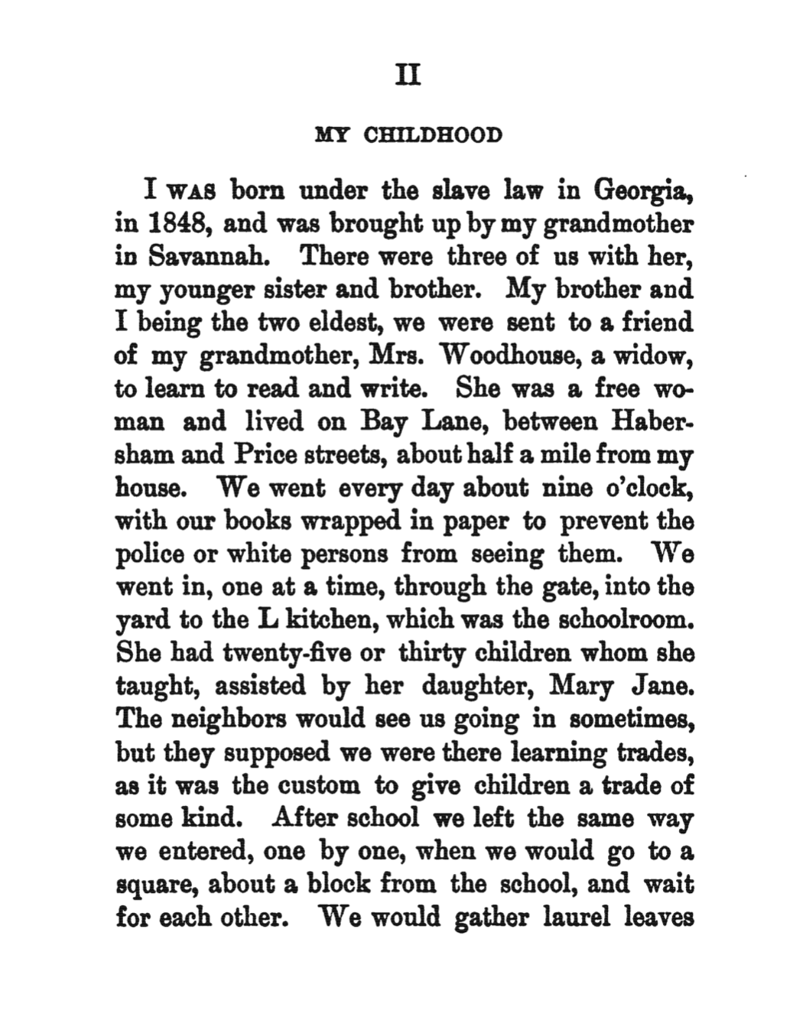
Pg. 5

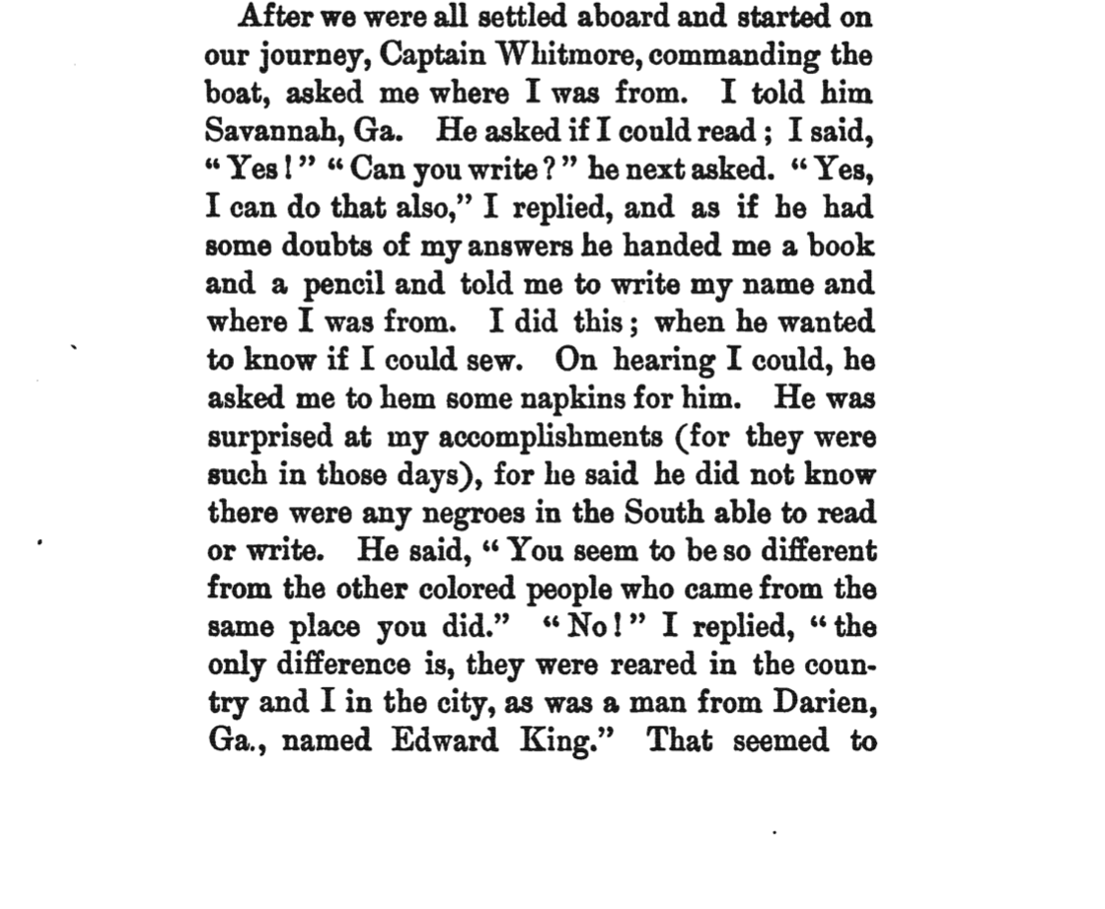

Pg. 9

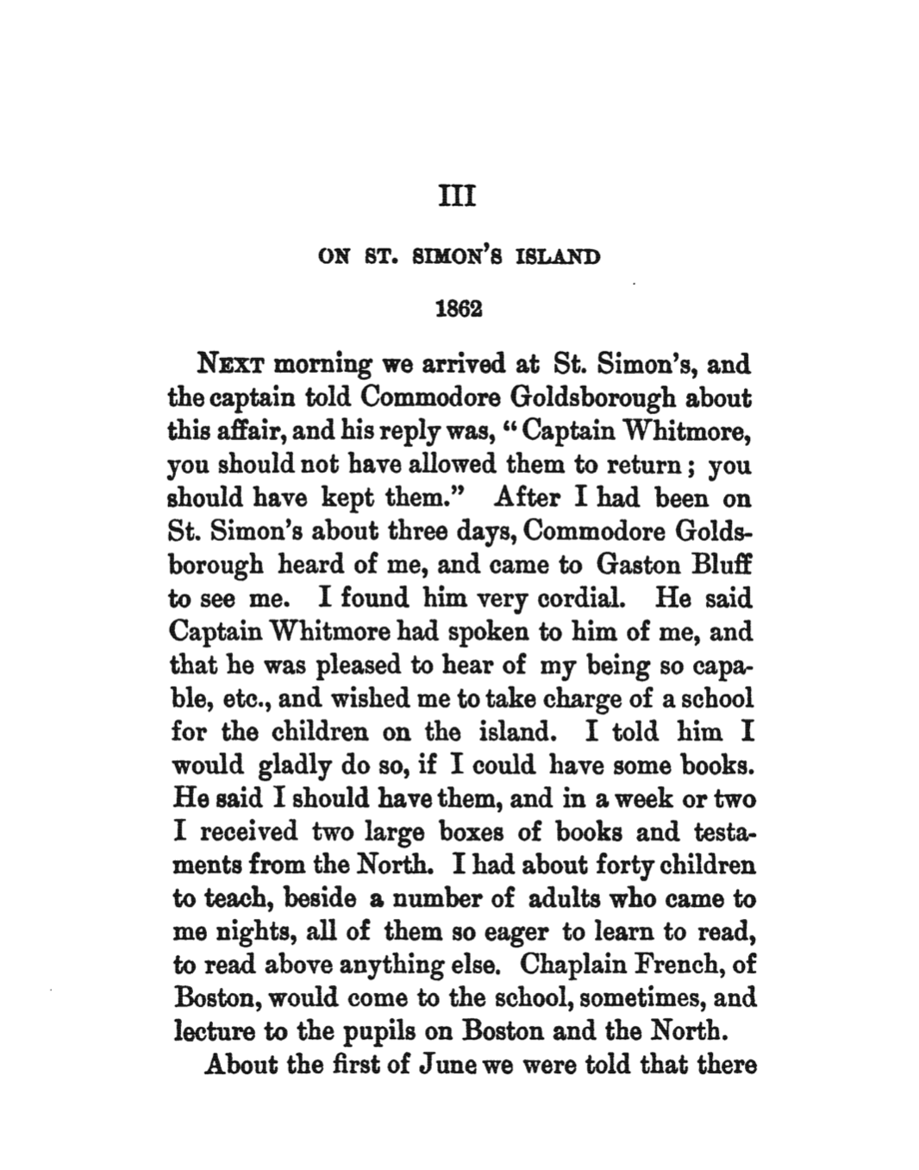
Pg. 11

Document B: Excerpts from Susie Baker’s memoir Reminiscences of My Life in Camp pp. 54-55, 61-62
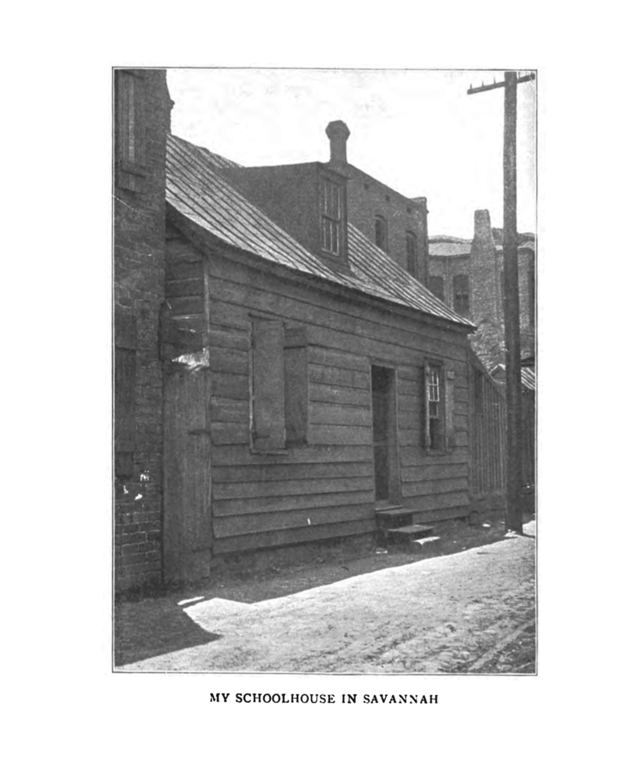
Pg. 55

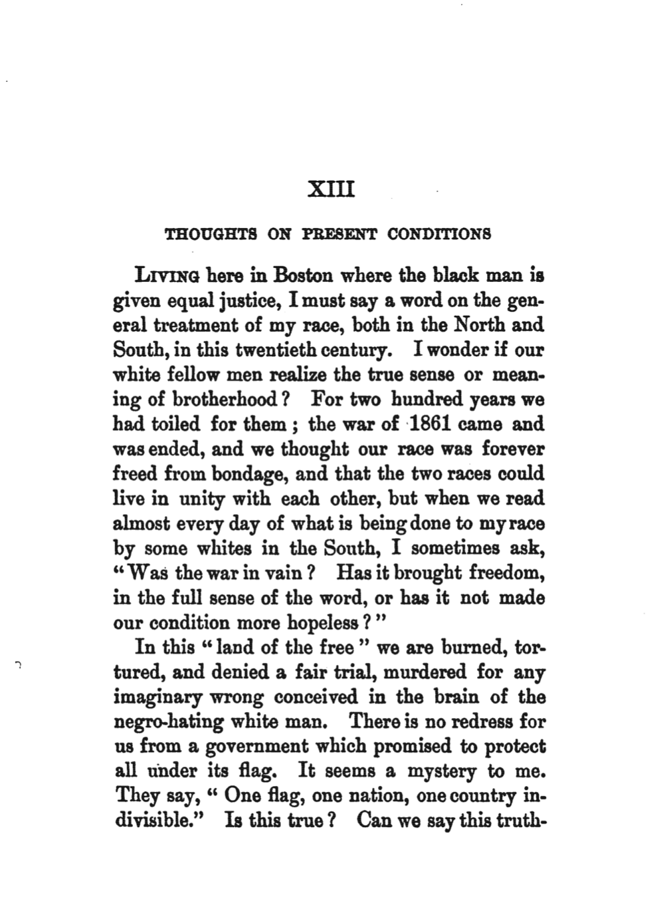
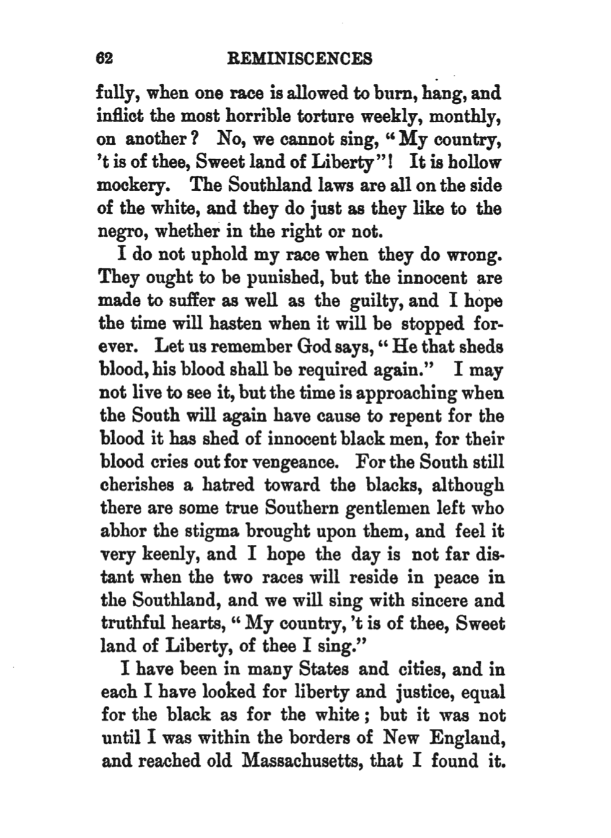
Document C: Excerpts from Learning in Secret Places by Dawn Chitty

For many, the fight for equal education in the United States started in the 1950s with the Supreme Court's decision in Brown v. Board of Education. While the families in that case were certainly courageous, efforts to redress unequal education for African Americans had started much earlier.

Enslaved persons in the 19th century struggled to educate themselves despite legal barriers and threats to their lives and wellbeing. These efforts represented a form of protest and an intentional push toward freedom.

On December 11, 1829, police in Savannah, Ga. seized 60 copies of Black abolitionist David Walker's Appeal to the Colored Citizens of the World, published three months earlier. A scathing critique of racist white institutions, the essay collection became so popular that some Southern states criminalized its mere possession. In Georgia, persons caught smuggling the literature into its ports or across its borders could be executed, and undercover police officers were deployed to ferret it out.

Perhaps Walker’s Appeal was inflammatory for promoting education as the means to overturn oppression in America. An enslaved person’s ability to read and write contradicted the idea that African Americans were intellectually inferior and revealed to them ideas of human equality that might induce slave rebellion. Walker wrote that slavery was destined to end, whether peacefully or violently.

Within a year of the Appeal’s publication, North Carolina exemplified the link between literacy and freedom by prohibiting free and enslaved Black persons from learning to read and write. Georgia passed a similar law in 1833, and other Southern states followed suit.

Document D: Excerpts from Learning in Secret Places by Dawn Chitty

Despite the roadblocks to education for African Americans, the desire to learn didn't diminish, and some found ways to circumvent the law.

Susie Baker was one of those people. She was born enslaved in 1848 in Georgia’s sea islands, the eldest of nine children. She was raised by her grandmother in Savannah, Georgia. Every day, young Susie and her brother were sent to a Mrs. Woodhouse, a widow and friend of her grandmother, who lived on Bay Lane in Savannah, Georgia.

After the war, some states established public school systems that, at first, accorded only miserly space to African American students. The Freedmen’s Bureau, established in 1865, provided some educational resources.

The Bureau did not build enough schools to meet demand. Even in the poorest rural communities, African American men and women hosted fundraisers and donated land to build schools. Susie’s schools thus offered much needed learning opportunities.

In the later years of the Reconstruction Era (1865-1877), a dual system of public schools started to form in many municipalities. A single education board offered separate public education to African Americans and white people in different school systems. These new public schools made it hard for Susie to sustain enrollment at her private schools, forcing her to close all of them by the 1870s.

Although fraught with challenges and faced with closure, Susie’s schools and her story show the struggles and lengths Black citizens traversed for equal education. Her journey left a lasting legacy on generations of activism, leading much later to the 1954 U.S. Supreme Court determination that separate education is not equal.

Document E: Excerpts from David Walker’s Appeal to the Colored Citizens of the World, 1829

My dearly beloved Brethren and Fellow Citizens.
Let no man of us budge one step, and let slave-holders come to beat us from our country. America is more our country, than it is the whites-we have enriched it with our blood and tears. The greatest riches in all America have arisen from our blood and tears: -- and will they drive us from our property and homes, which we have earned with our blood? They must look sharp or this very thing will bring swift destruction upon them. The Americans have got so fat on our blood and groans, that they have almost forgotten the God of armies. But let the go on.

What nation under heaven, will be able to do any thing with us, unless God gives us up into its hand? But Americans. I declare to you, while you keep us and our children in bondage, and treat us like brutes, to make us support you and your families, we cannot be your friends. You do not look for it do you? Treat us then like men, and we will be your friends. And there is not a doubt in my mind, but that the whole of the past will be sunk into oblivion, and we yet, under God, will become a united and happy people. The whites may say it is impossible, but remember that nothing is impossible with God.

See your Declaration Americans! ! ! Do you understand your won language? Hear your languages, proclaimed to the world, July 4th, 1776 -- "We hold these truths to be self evident -- that ALL MEN ARE CREATED EQUAL! ! that they are endowed by their Creator with certain unalienable rights; that among these are life, liberty, and the pursuit of happiness! !" Compare your own language above, extracted from your Declaration of Independence, with your cruelties and murders inflicted by your cruel and unmerciful fathers and yourselves on our fathers and on us -- men who have never given your fathers or you the least provocation! ! ! ! ! !

Document F: Excerpt from the South Carolina Act of 1740

Whereas, the having slaves taught to write, or suffering them to be employed in writing, may be attended with great inconveniences; Be it enacted, that all and every person and persons whatsoever, who shall hereafter teach or cause any slave or slaves to be taught to write, or shall use or employ any slave as a scribe, in any manner of writing whatsoever, hereafter taught to write, every such person or persons shall, for every such offense, forfeit the sum of one hundred pounds, current money.

Document G: Excerpt from the Virginia Revised Code of 1819
That all meetings or assemblages of slaves, or free negroes mixing and associating with such slaves at any meeting-house or houses, &c., in the night; or at any SCHOOL OR SCHOOLS for teaching them READING OR WRITING, either in the day or night, under whatsoever pretext, shall be deemed and considered an UNLAWFUL ASSEMBLY; and any justice of a county, wherein such assemblage shall be, either from his own knowledge or the information of others, of such unlawful assemblage., may issue his warrant, directed to any sworn officer or officers, authorizing him or them to enter the house or houses where such unlawful assemblages, may be, for the purpose of apprehending or dispersing such slaves, and to inflict corporal punishment on the offender or offenders, at the discretion of any justice of the peace, not exceeding twenty lashes.

Document H: Title VI of the Civil Rights Act of 1964

Title VI prohibits discrimination on the basis of race, color, or national origin in any program or activity that receives Federal funds or other Federal financial assistance. Programs that receive Federal funds cannot distinguish among individuals on the basis of race, color or national origin, either directly or indirectly, in the types, quantity, quality or timeliness of program services, aids or benefits that they provide or the manner in which they provide them. This prohibition applies to intentional discrimination as well as to procedures, criteria or methods of administration that appear neutral but have a discriminatory effect on individuals because of their race, color, or national origin

