Sources Black Communism

Document A: Workers of the World
Workers of the world: Black Communist protests for Labor & Safety. PBH. (n.d.). Retrieved February 25, 2022, from https://www.picturingblackhistory.org/workers-of-the-world

Document B: Strange Fruit by Billie Holiday
Billie Holiday-Strange fruit- HD - youtube. (n.d.). Retrieved February 25, 2022, from https://www.youtube.com/watch?v=Web007rzSOIz

Document C: Southern Worker (Image 1)
Southern Worker Newspaper. Southern worker. (n.d.). Retrieved February 25, 2022, from https://dlib.nyu.edu/southernworker/
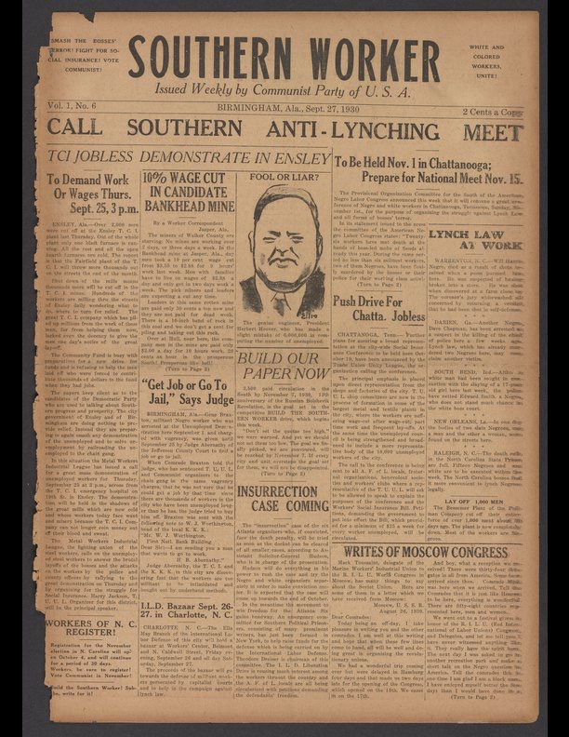

Document D: The Communist Party and Black Liberation in the 1930s (Image 2)
D'Amato, P. (n.d.). The Communist Party and Black Liberation in the 1930s. The Communist Party and Black Liberation in the 1930s | International Socialist Review. Retrieved February 25, 2022, from https://isreview.org/issue/1/communist-party-and-black-liberation-1930s/index.html
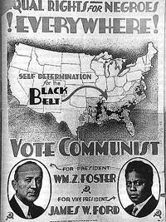

Document E: The Communist Party in 30s (Image 3)
Markowitz, N. (2019, June 3). The Communist Party in the '30s: The depression and the great upsurge. People's World. Retrieved February 25, 2022, from https://www.peoplesworld.org/article/the-communist-party-in-the-30s-the-depression-and-the-great-upsurge/
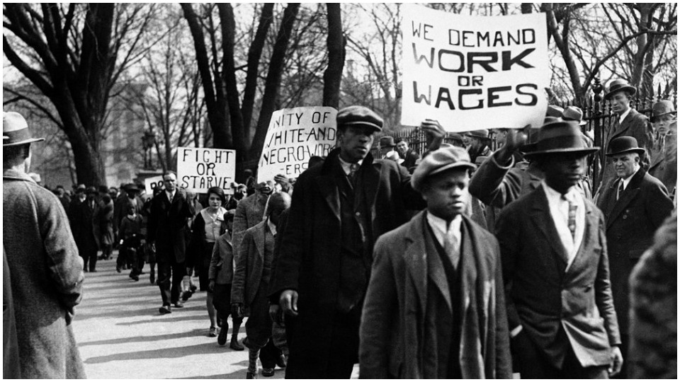

Document F: The Communist Party USA (Image 4)
Heideman, P., Heideman, P., Hudson, M., Corbyn, J., Day, M., Stipe, M., Ross, R. B., David Sirota Aditi Ramaswami, Sirota, D., Ramaswami, A., Matveev, I., Fuhrmann, U., Jong, A. de, Jones, E., Rowbotham, S., Franczak, M., Shirlow, P., Al-Dujaili, D., Akehurst, N., … Salter, E. (n.d.). How mccarthyism and the Red Scare Hurt the Black Freedom Struggle. Jacobin. Retrieved February 25, 2022, from https://www.jacobinmag.com/2020/05/mccarthyism-red-scare-civil-rights-movement

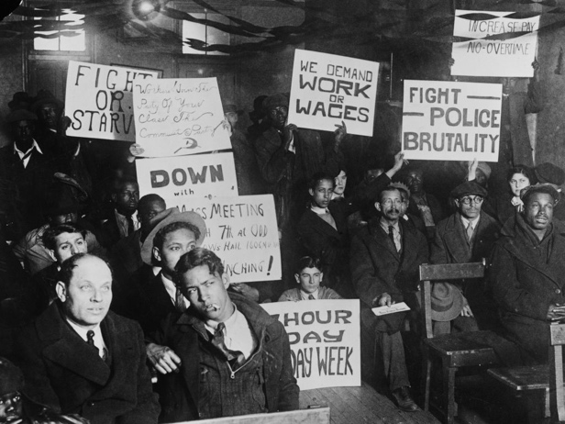

Document G: Then Image in Then/Now
Pecinovsky, T. (2020, August 11). "A forthright stand": Communists in the struggle for black lives. Communist Party USA. Retrieved February 25, 2022, from https://www.cpusa.org/article/a-forthright-stand-communists-in-the-struggle-for-black-lives/
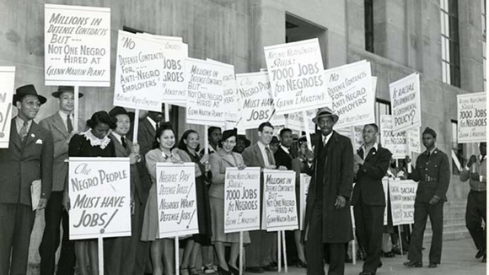

Document H: Now Image in Then/Now
Raising the minimum wage. National Employment Law Project. (2021, May 20). Retrieved February 25, 2022, from https://www.nelp.org/campaign/raising-the-minimum-wage/

