Are athlete protests effective at achieving social change?

Think-Pair-Share .

What are your thoughts? Why do you think the way you do? What questions do you have?

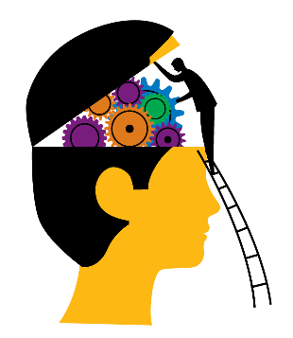

What are your partner’s thoughts? Why do they think that way?

Here, jot down some ideas you and your partner would like to bring into a group discussion.

