Stations Worksheet

Directions: You will choose groups of 3-4 to explore photos from the L.A. uprising using your worksheets to record and answer information about photos at each station. Stay at your station until you hear the timer and are told to move.

While examining the photos, think about how they portray the uprising, is it portrayed solely through violence, struggle, or a criminal?

Station 1

1. What is this image portraying?

This image portrays…

2. Does it portray the uprisings as violent or not?

This image portrays uprisings as…

3. What does the sign “It's a White Man's World” mean here?

It means white people have…

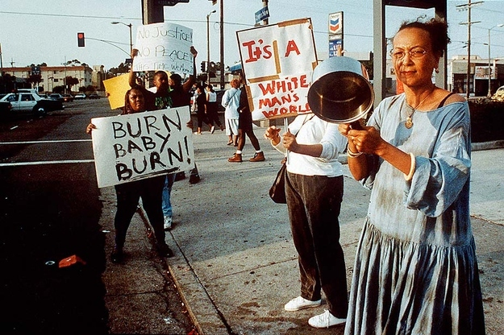

Station 2

1. What is this image portraying?

The image is portraying…

2. Does it portray the uprisings as violent or not?

It portrays the uprisings as…

3. What feeling does this image create?

This image creates feelings of…

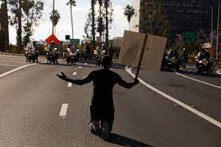

Station 3

Go to this link and read the article: https://www.picturingblackhistory.org/dont-call-it-a-riot

1. What is this article's purpose?

This articles purpose is…

2. In a few sentences what does it conclude about the LA Uprising?

It concludes that the LA Uprising was…

Station 4
1. What is this image portraying?

The image portrays…

2. Does it portray the uprisings as violent or not?

It portrays them as…

3. How does it portray the LAPD?

It portrays the LAPD as…

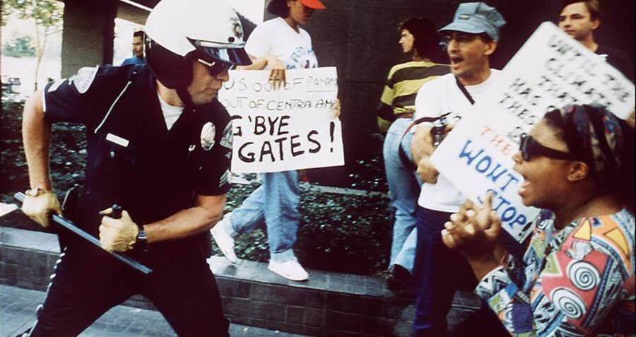

Station 5
1. What is this image portraying?

This image portrays…

2. Does it portray the uprisings as violent or not?

It portrays them as...

3. Why does the man's sign say “No Justice in AMERIKKKA?

It says it because…

